# Image Processing

有帮助：<https://www.tutorialspoint.com/dip/index.htm>

好视频：<https://www.youtube.com/watch?v=Q2aEzeMDHMA>

## Signals

Def: A function (X(t), X(t1, t2), X is called intensity) containing information about the behavior or nature of some phenomeno of interest. ex. price

image is an example of 2D signal!

Analog vs Digital Signals: analog is original, and a A/D box can transfer(process called sampling and quantization,将continous转换为discrete) analog into digital signal.

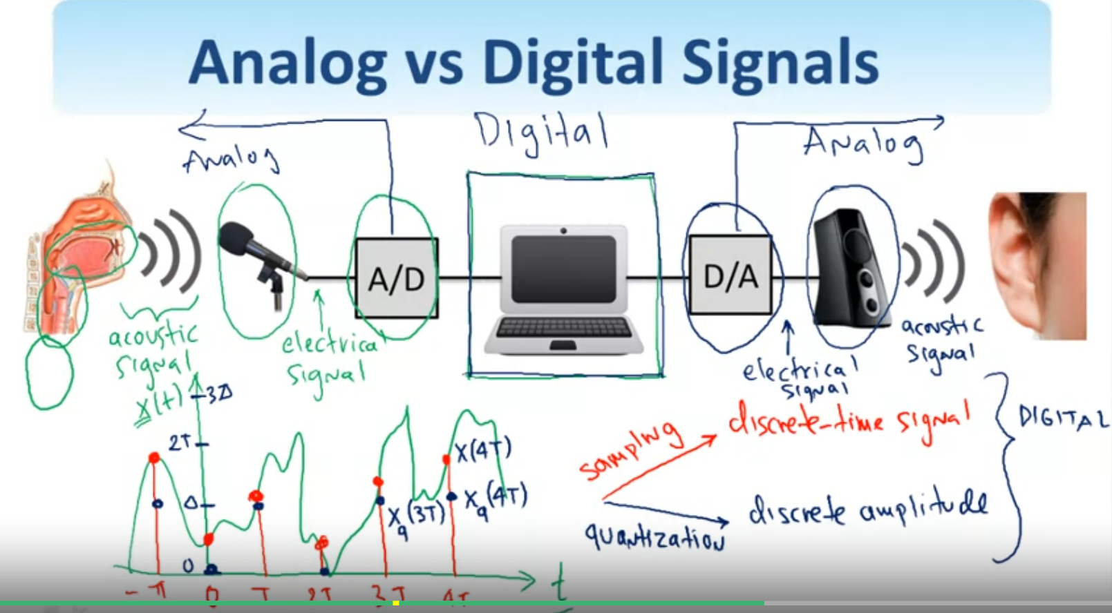

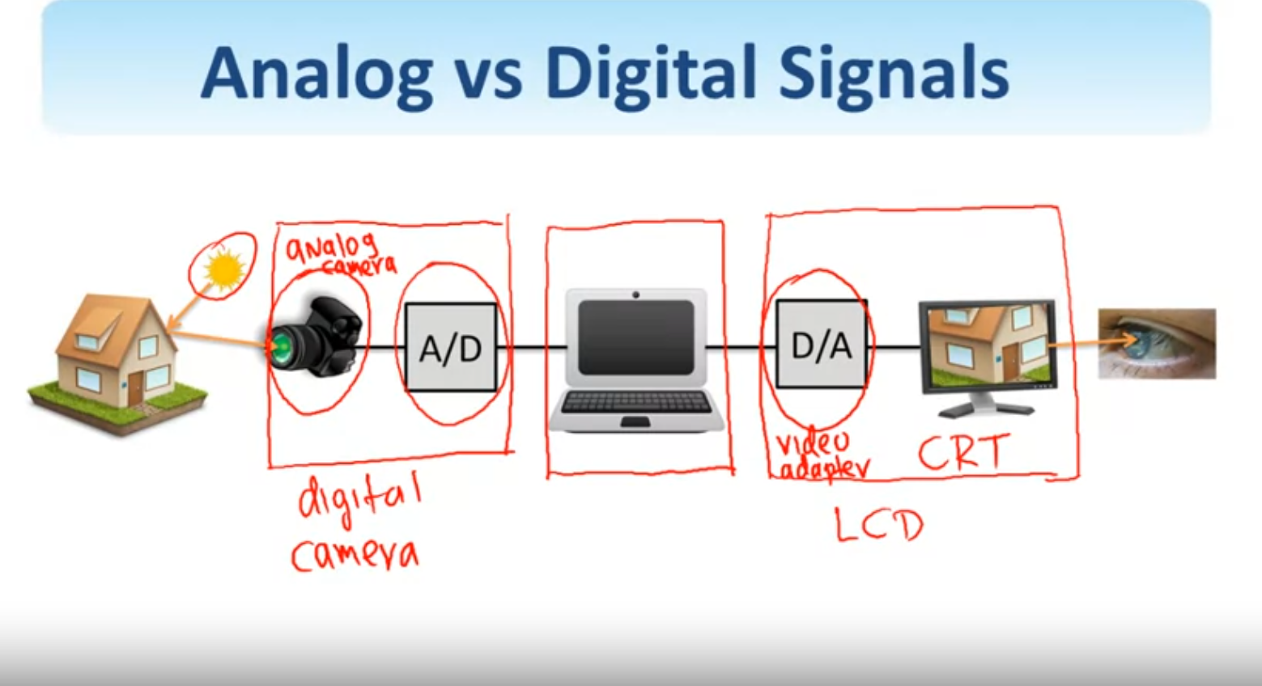

Sampling: down-size the image, ex:

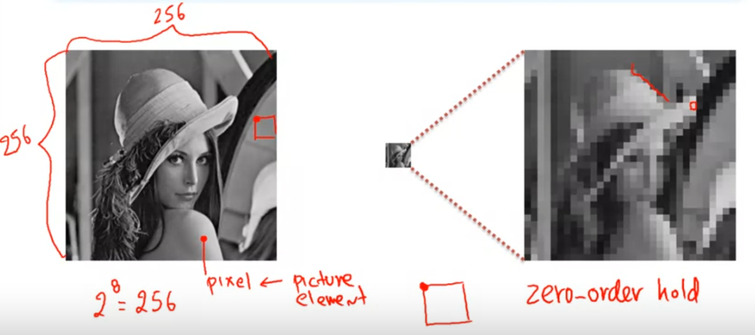

Quantization: down-size the bits to represent intensity(Quantization is not reversible), ex.

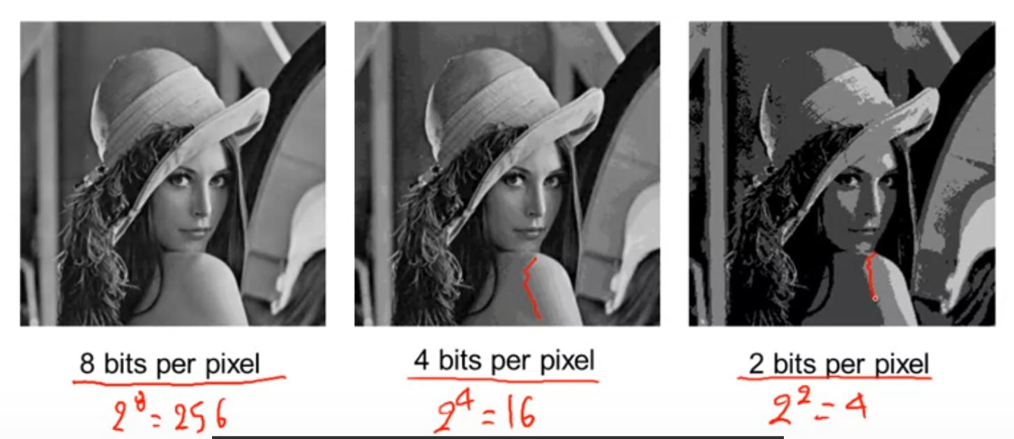

1D Signal: tones, speech, audio, etc (S(t), S(n))

2D Signal: text, grayscale, color, hyperspectral images, etc (S(x,y))

3D Signal: video, 3d volume, etc (S(x,y,t), S(x,y,z))

Multi D Signal: video of a volume, etc

Type of images:

Based on radiation from the EM spectrum, ultrasonic, electronic, synthetic

Classification of Images:

Reflection images(radar, sonar, laser), emission images(MRI), absorption images(x-rays)

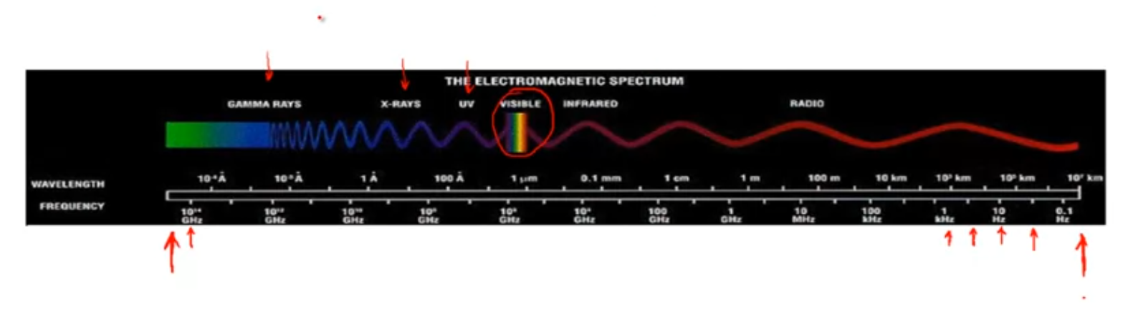

上图是EM spectrum，只有一小部分的波普是人眼可见的（可见光波普）

## Week1 Homework:

Given n*n binary image(each pixel can assume one of two values), how many possible images that can be formed?

2^(n*n)

Given 24 bit pixel image(each pixel has 24 bits, meaning each pixel can take 2^24 value), how many….

2^24^(n*n)

x-ray image is not digital image, because x ray image is formed on to a film directly...not in some digitally storeable format...so it is considered an analog image.

You have a 10-megapixel camera(1 megapixel = 10^6 pixels), how big would a 24bit-RGB color image be? (1 byte = 8 bits)

24bits = 3byte

each pixel takes 3 byte, total byte = 10*10^6 * 3 byte = 30 megabytes

<https://www.tutorialspoint.com/dip/concept_of_bits_per_pixel.htm>

## 2D and 3D Signals

Let x(n1, n2) be representation of signals, n1 and n2 can be any integer number from -inf to inf. For 1 bit image the signal x(n1’, n2’) is a number, but for RGB image x(n1’, n2’) will become a 3x1 vector.

For video, which is a 3d signal, x(n1, n2, n3) is the representation. n1,n2,n3 can be any integer number from -inf to inf. (n1, n2 will still be width and height of image, n3 is represent discrete values of time domain)

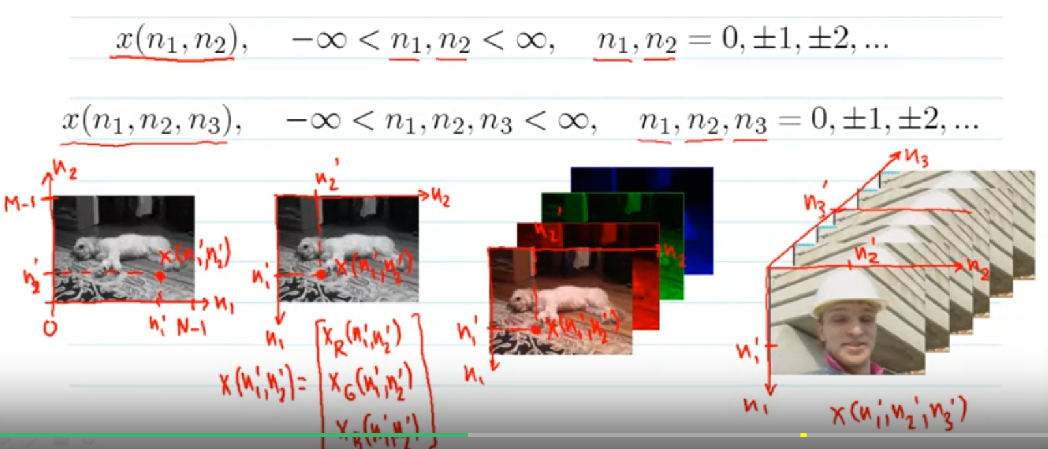

Discrete Unit Impulse:

delta(n1, n2) = 1 for n1=n2=0; 0 otherwise

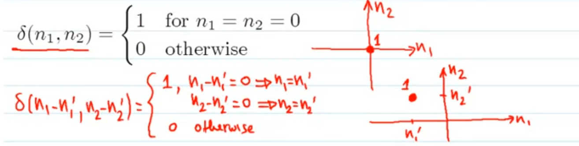

Separable signals:

g(n1, n2) = f1(n1) * f2(n2)

for example, f1(n1) = delta(n1) meaning all value on n2 domain is 1 and 0 otherwise, f2(n2) = delta(n2) meaning all value on n1 domain is 1 and 0 otherwise, g(n1, n2) = delta(n1) * delta(n2) = delta(n1, n2). This example showing discrete unit impulse is separable!

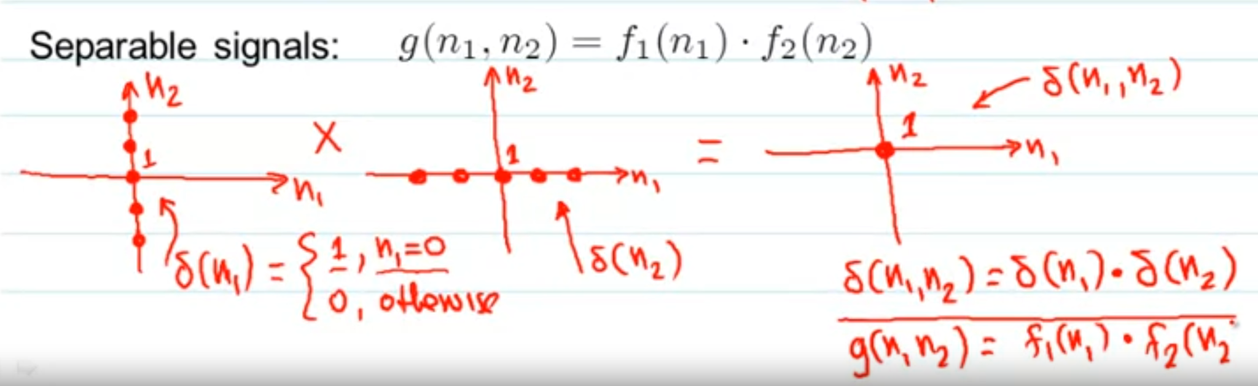

Discrete Unit Step:

u(n1, n2) = 1 for n1>= 0 and n2>=0; 0 otherwise

we say discrete unit step support in the first quadrant.

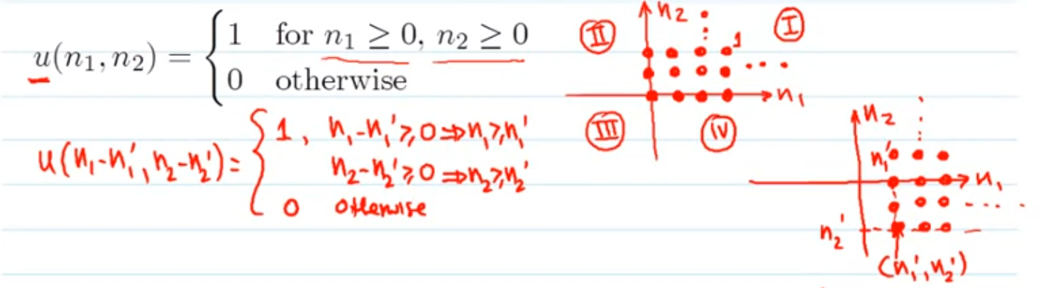

Is discrete unit step separable?

u(n1, n2) = u(n1) * u(n2)

u(n1) = 1 for n1>=0; 0 otherwise (support first, forth quadrant)

u(n2) = 1 for n2>=0; 0 otherwise (support first, second quadrant)

u(n1, n2) = support first quadrant only = discrete unit step, so it is separable!

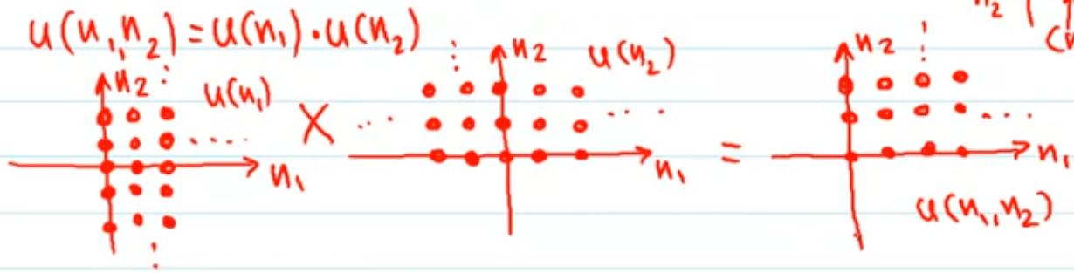

## Complex Exponential Sequences

x(n1, n2) = e^(j omega1 n1) * e^(j omega2 n2)

by Euler’s formula(e^ix = cos x + i sin x)

= cos(omega1 n1 + omega2 n2) + j sin(omega1 n1 + omega2 n2)

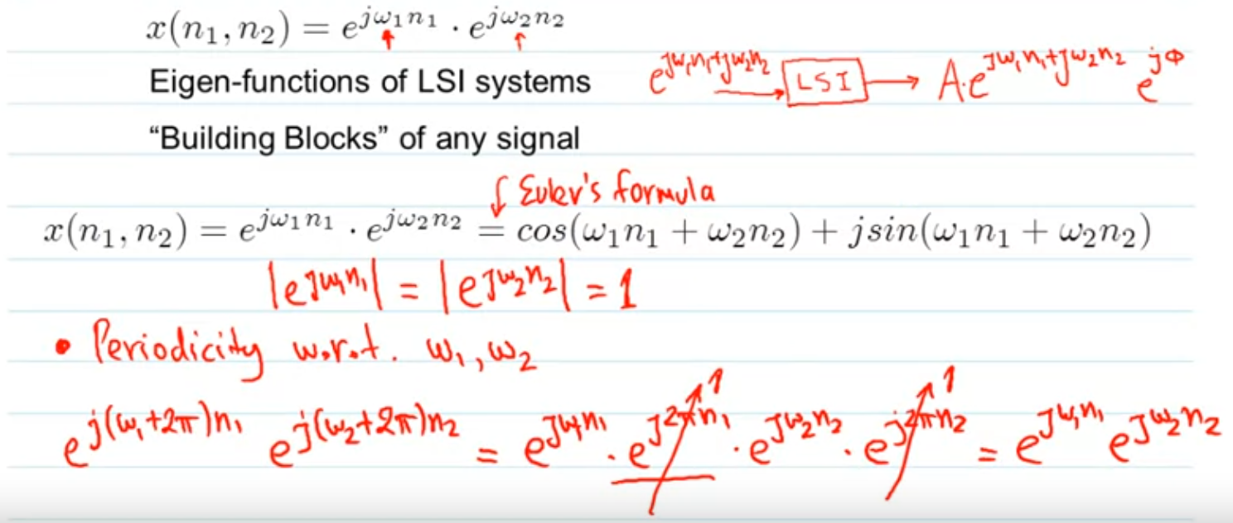

above prove that two-dimensional complex exponential is periodic with respect to frequency, with period 2pi in both the actions. (same for 1-dimensional CE or 3-dimensional CE or so)

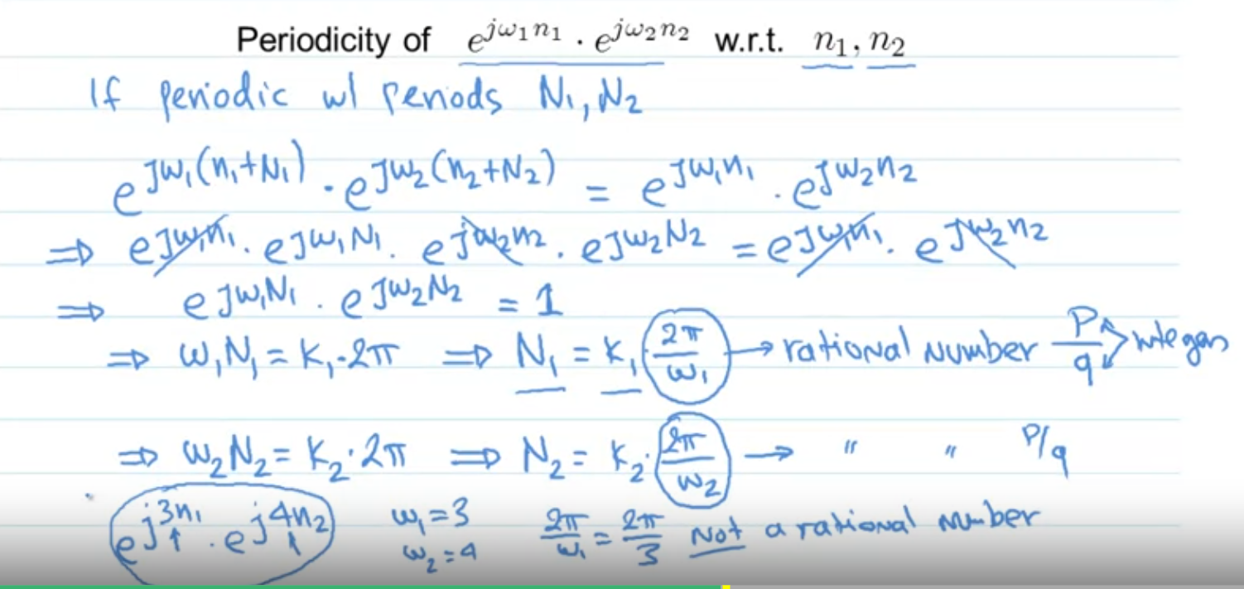

discreate complex exponential signal is not always periodic, it requires that N = 1 which in other word 2pi/omega must be a rational number s.t CES is periodic.

clear explanation: <https://www.coursera.org/learn/digital/discussions/forums/ad1CkCj3EeaZ8Apto8QB_w/threads/fMYySC2GEealng5zBIyoKQ>

1D discreate complex exponential signal (cos(omega n)):

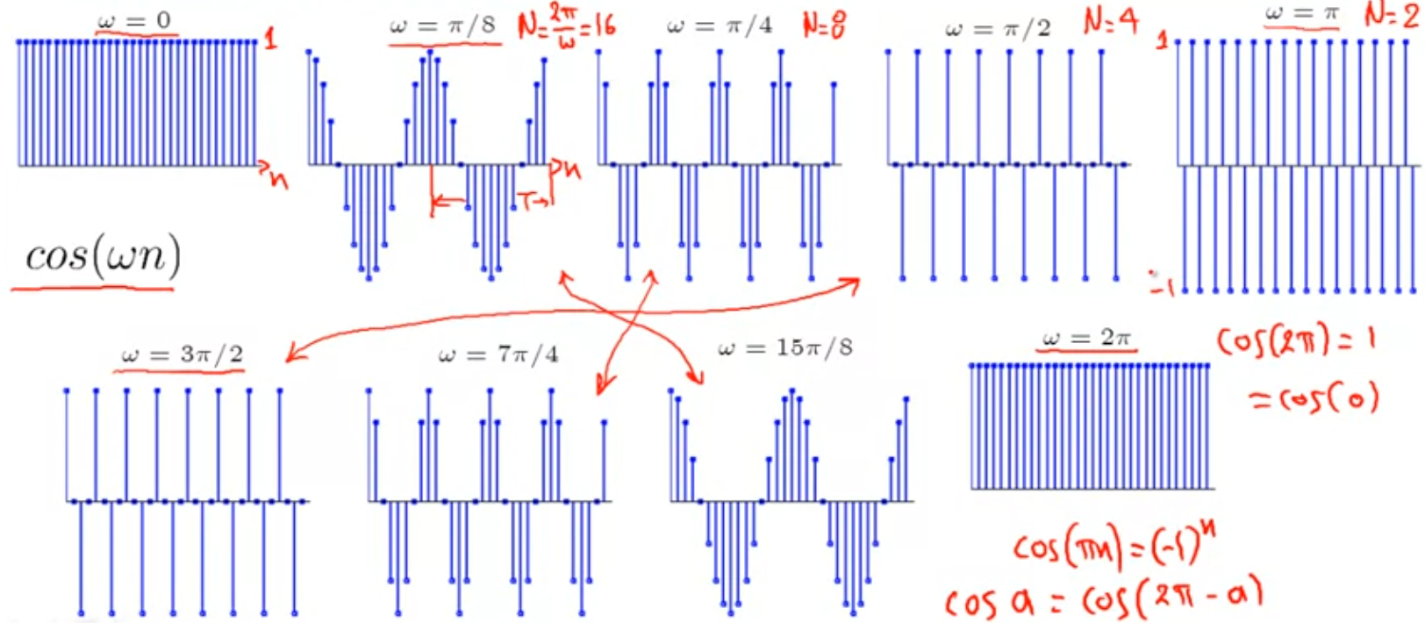

2D discreate complex exponential signal (cos(omega1 n1 + omega2 n2)):

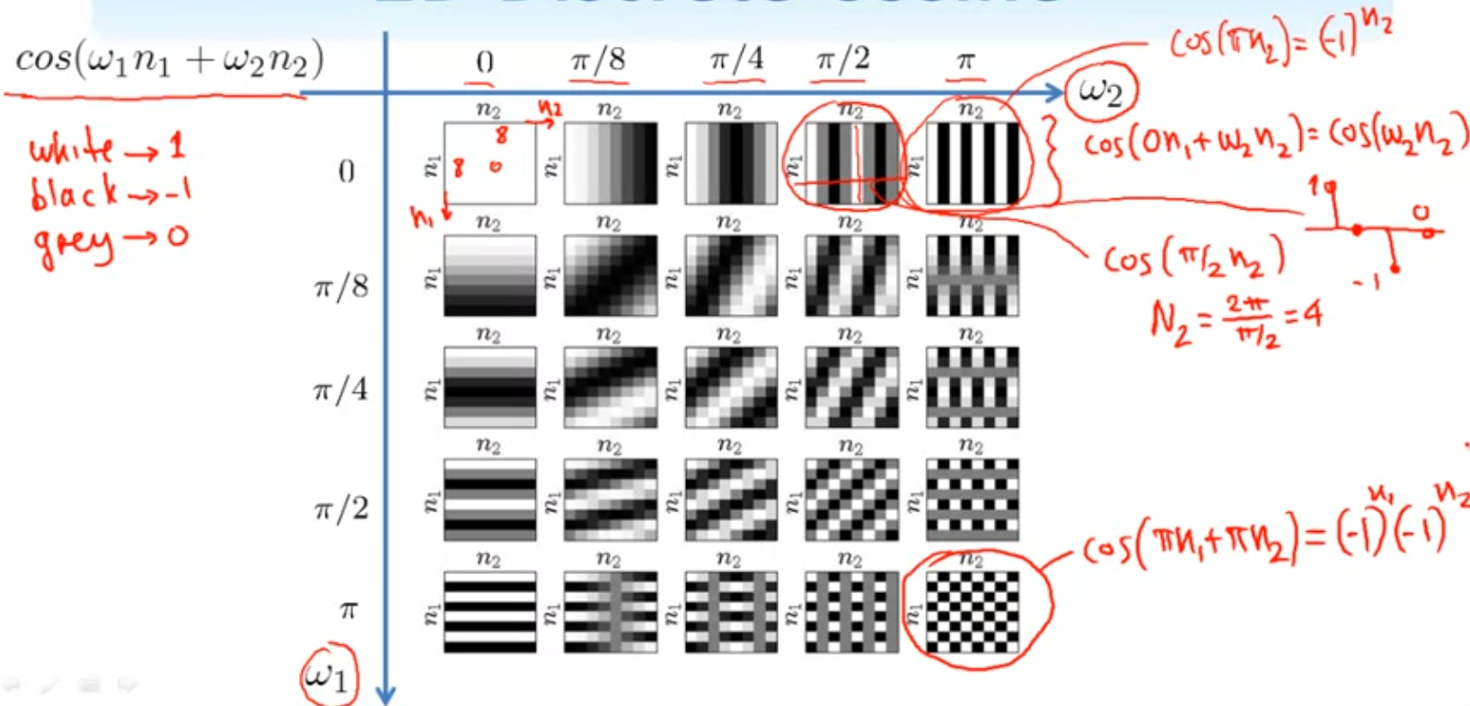

## Systems

A system is mathematical model that take input and transform into output.

2D systems:

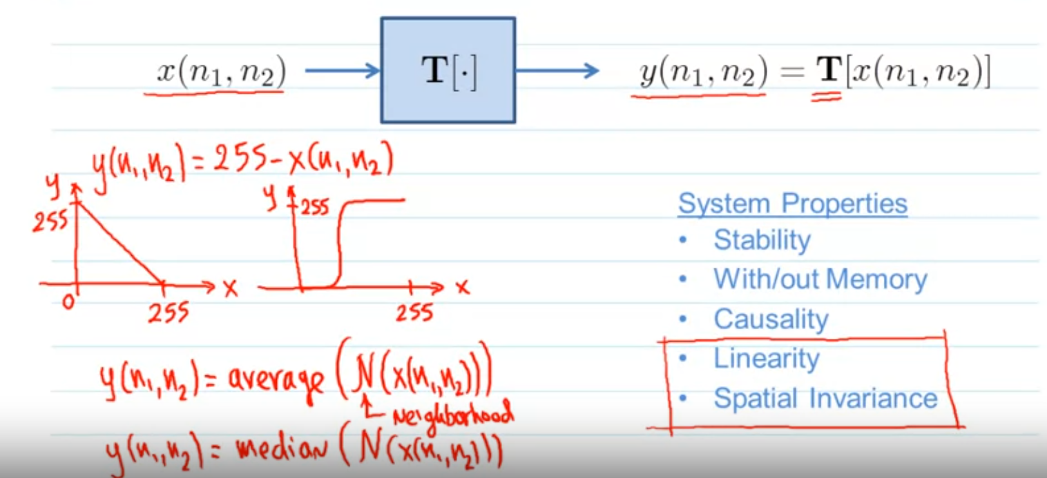

Linear Systems:

if T[alpha1 x1 (n1, n2) + alpha2 x2 (n1, n2)] = alpha1 T[x1(n1,n2)] + alpha2 T[x2(n1,n2)], then T[.] is linear.

For linear system, T[0] = 0. This can be used to prove if a system is non-linear, ex. take y(n1,n2) = T[x(n1,n2)] = 255-x(n1,n2) as example, then T[0] = 255 != 0 such that T[.] is non-linear.

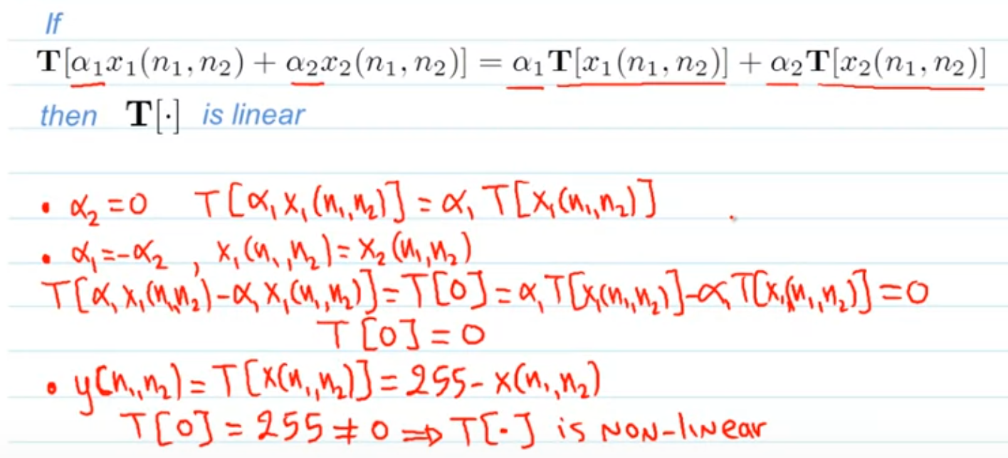

Spatially Invariant Systems:

if T[x(n1-k1, n2-k2)] = y(n1-k1, n2-k2), then T[.] is spatially invariant.

Take y(n1,n2) = T[x(n1,n2)] = 255-x(n1,n2) as example, T[x(n1-k1, n2-k2)] = 255-x(n1-k1, n2-k2)] = y(n1-k1, n2-k2), therefore T[.] is non-linear but spatially invariant.

<https://math.stackexchange.com/questions/2078597/spatially-invariant-systems>

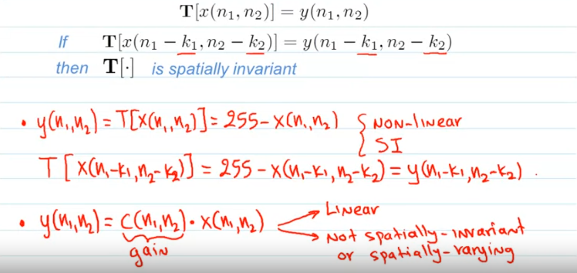

Linear and Spatially Invariant (LSI) Systems:

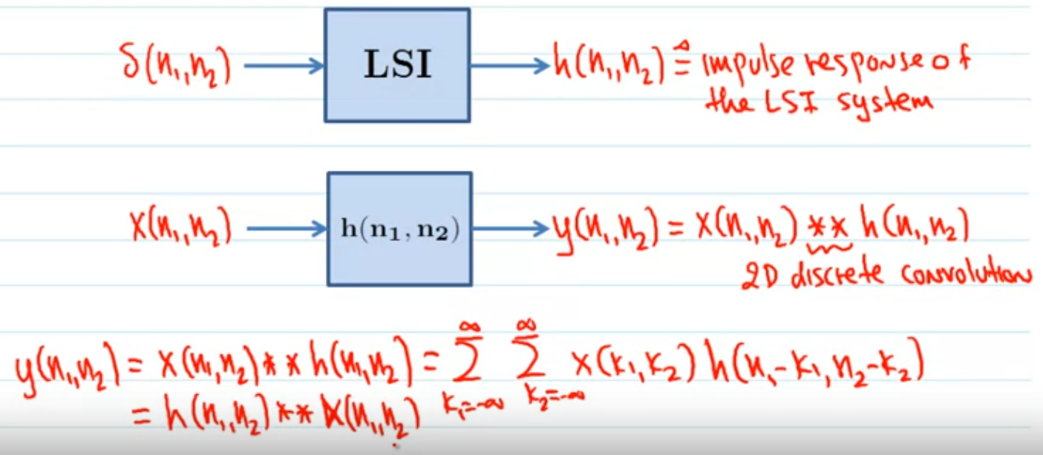

## 2D Convolution

Derivation of Convolution:

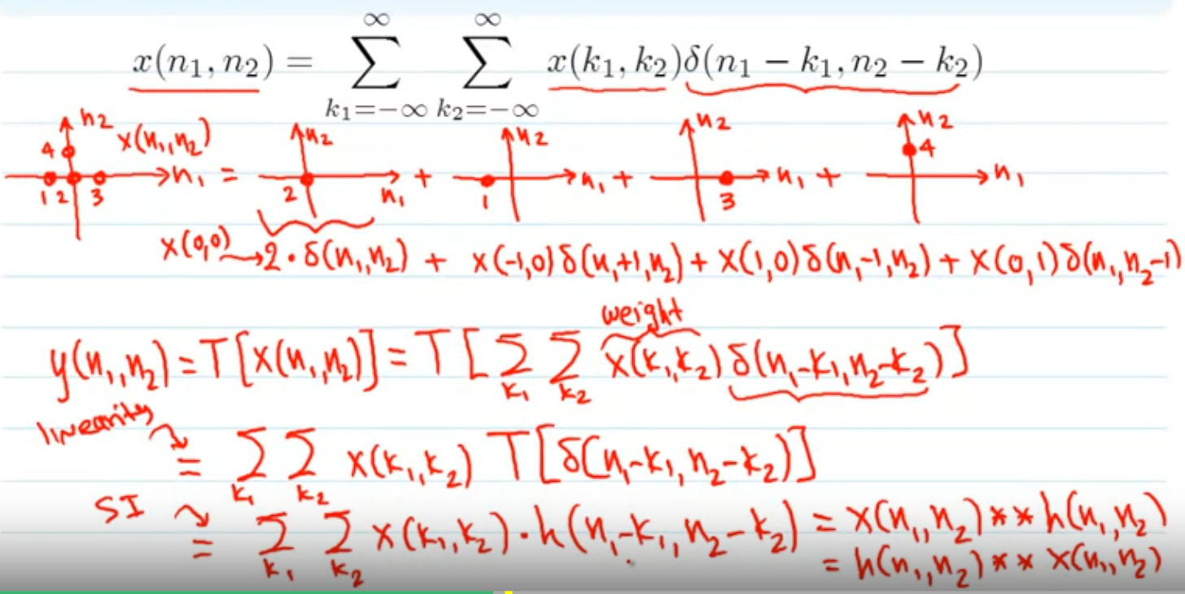

example of 2D convolution:

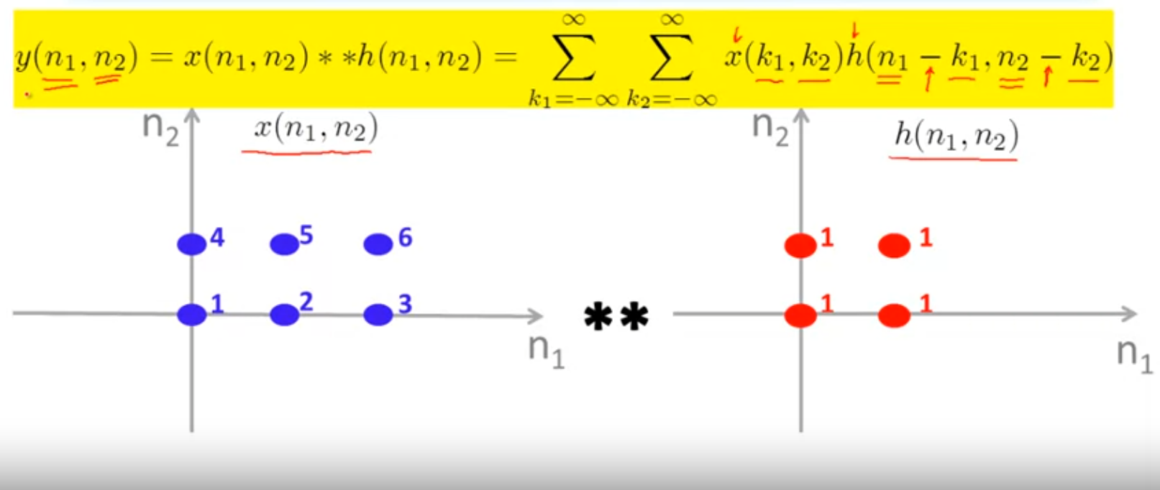

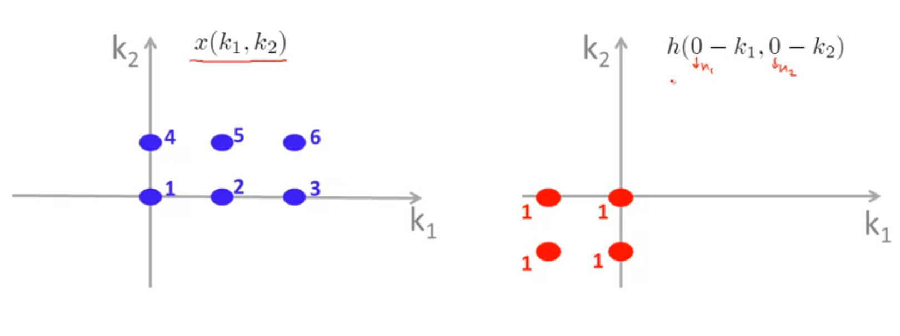

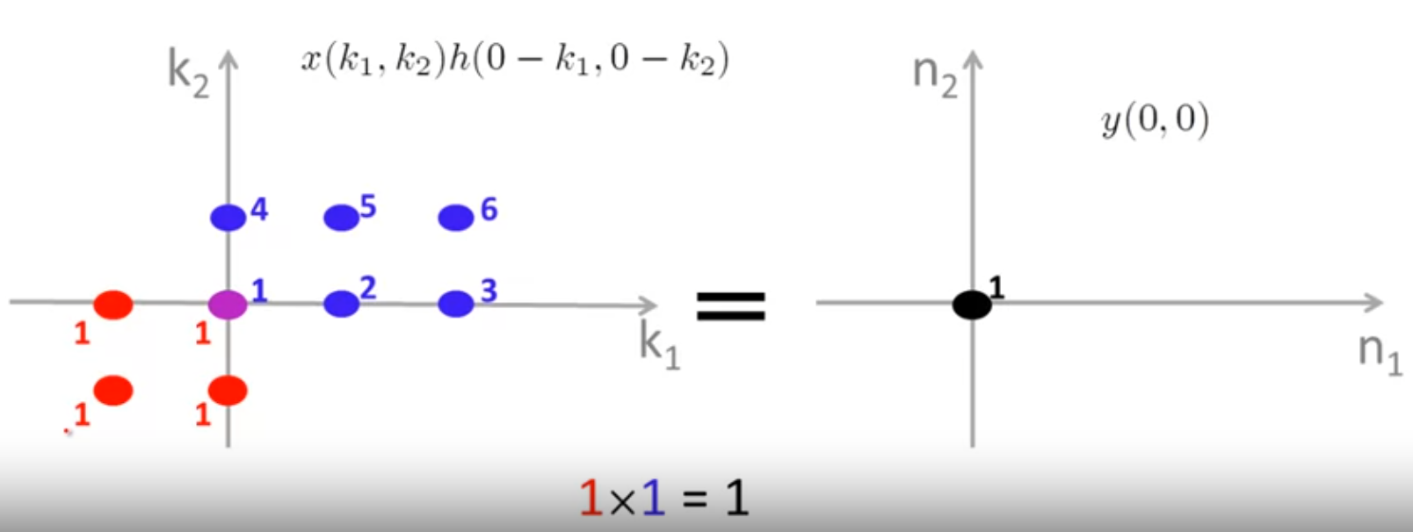

in above example, two pixel overlap, and y(0,0) is then 1x1 = 1

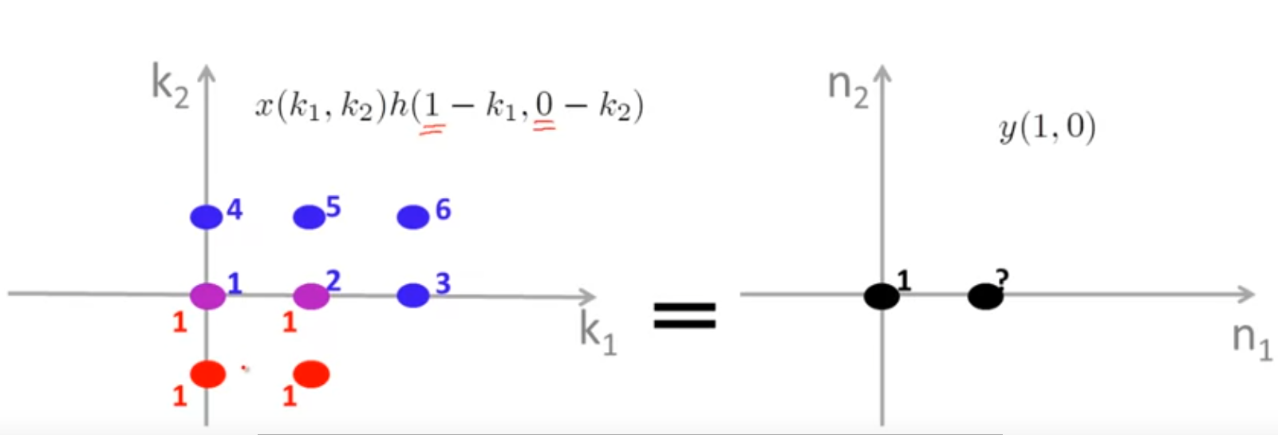

in above example, 4 pixels overlap, and y(1,0) then is 1x1 + 1x2 = 3

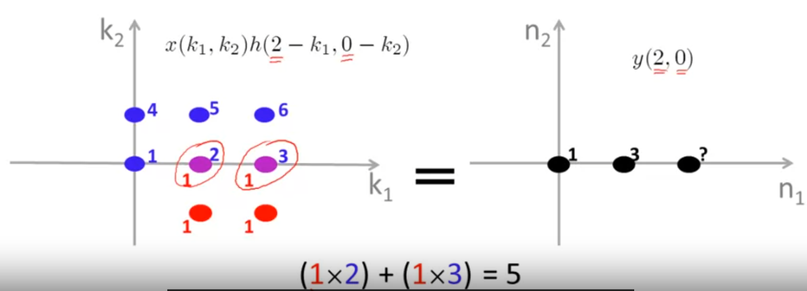

in above example, 4 pixels overlap, and y(2,0) then is 1x2 + 1x3 = 5

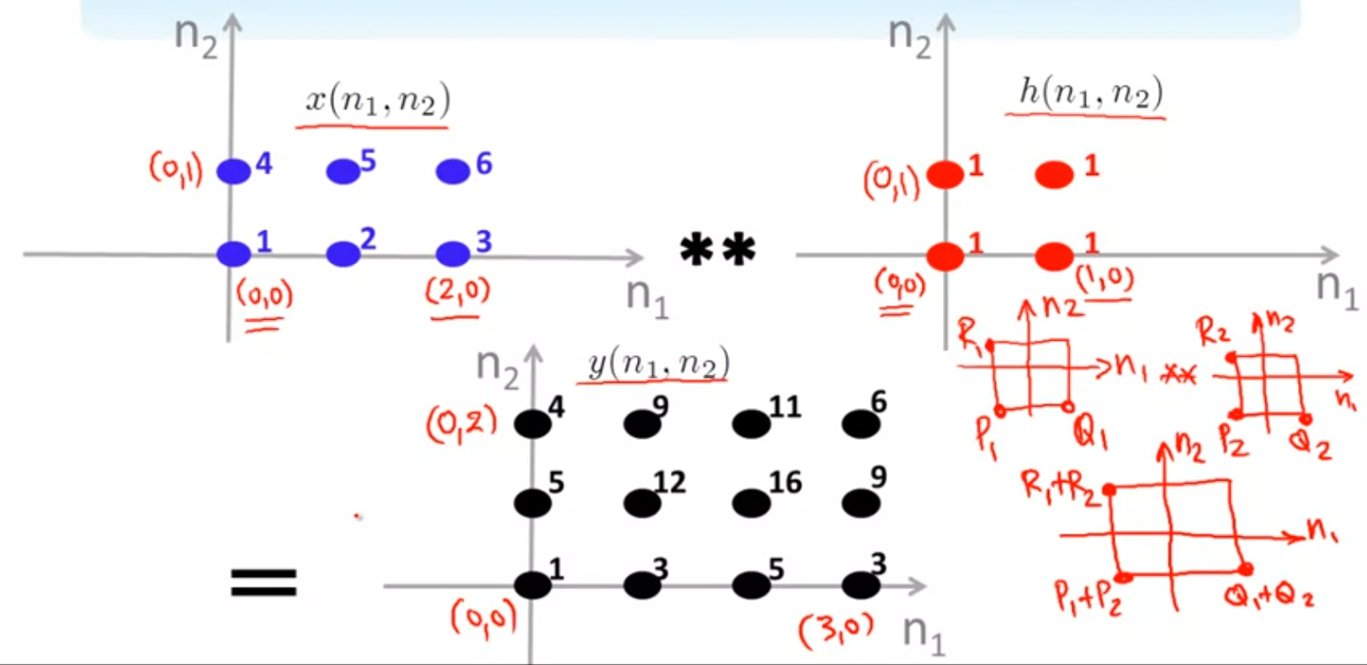

above is the convolution for all possible n1 and n2 (other value will not cause overlap), such that we could see the 4 points of y(n1,n2) can be written as R1+R2, P1+P2, Q1+Q2

## Filtering in the Spatial Domain

what is spatial domain: <https://medium.com/vithelper/spatial-and-frequency-domain-image-processing-83ffa3fc7cbc>

Boundary effects:

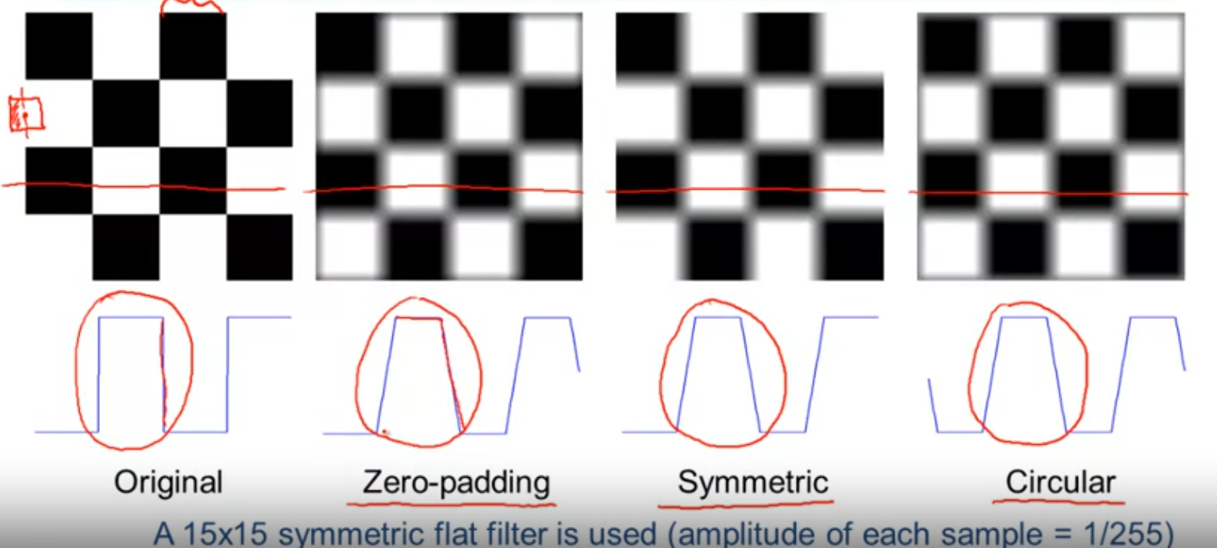

above is an example showing the 3 filters applied on original image.

## Week2 Homework

a linear shift-invariant system is fully characterizable by its impulse response.

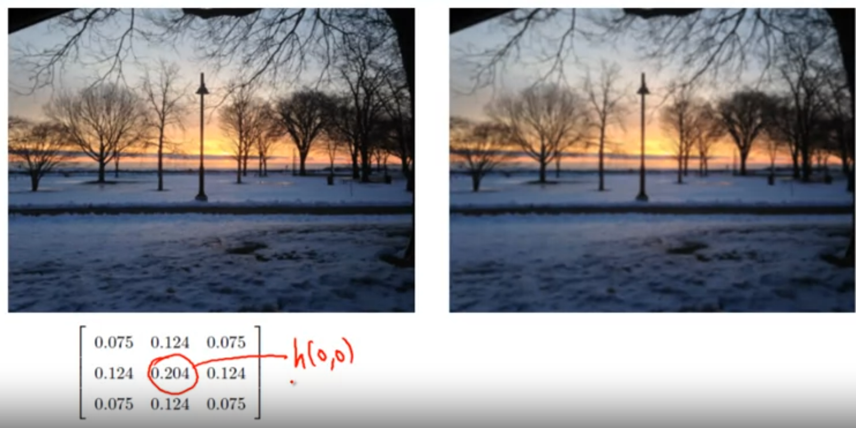

low-pass filter, used to blurrying image

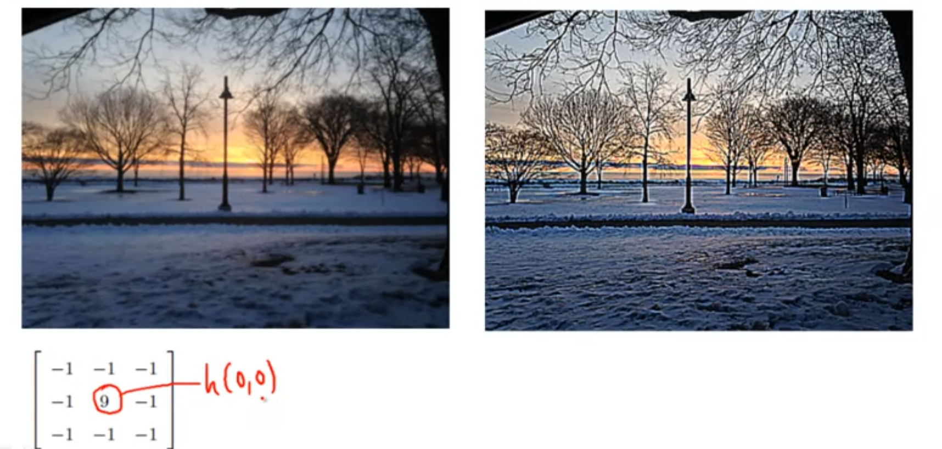

high-pass filter, used to sharping image

## Fourier Transform

sinusoid: f(x) = A sin(2pi ux + omega)

A = amplitude, u = frequency = 1/period, omega = phase(x axis move right negitive, move left possitive)

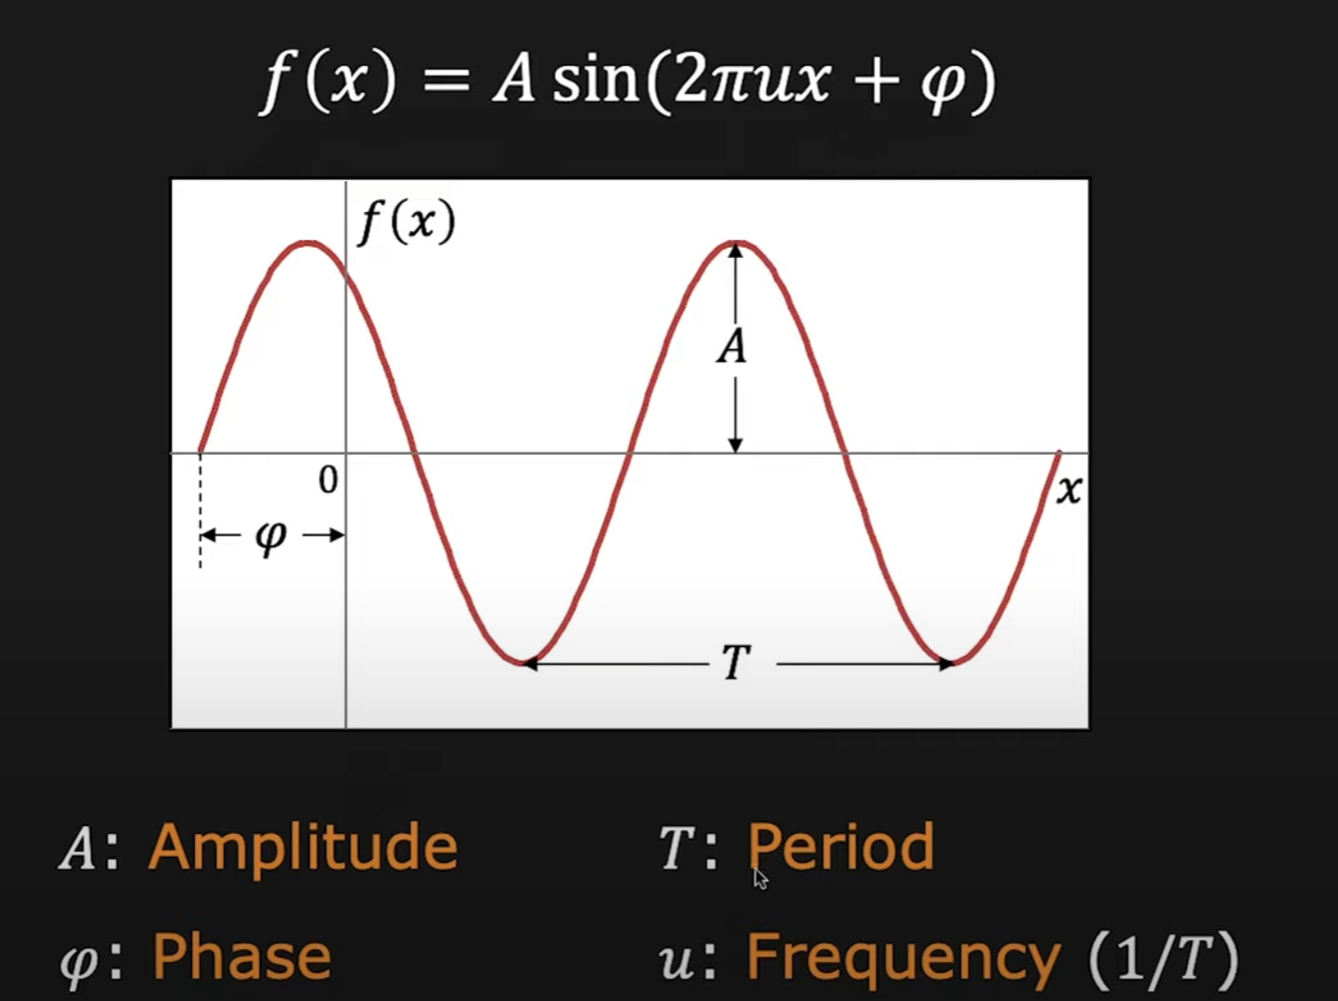

Fourier transform: any periodic function can be represented by combination of inf sinusoid without losing infomation: f(x) —> FT —> F(u)

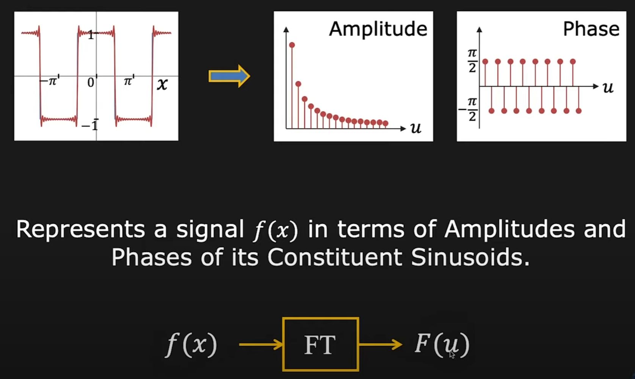

FT formula: F(u) = ∫ (-inf to inf) f(x) e^(-i 2pi ux) dx = ∫ f(x) (cos (-2pi ux) - i sin(2pi ux)) dx

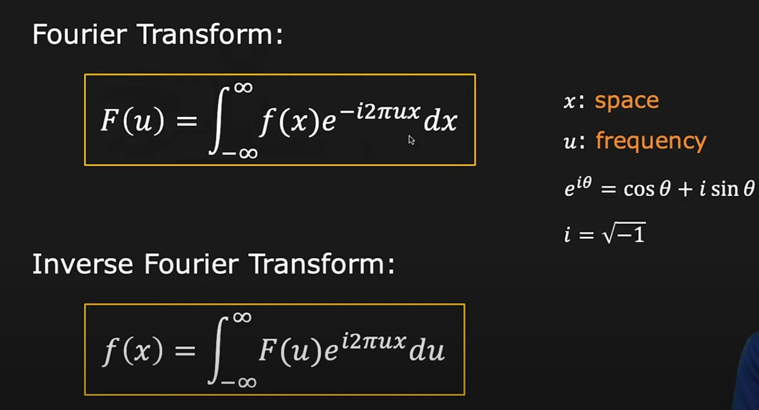

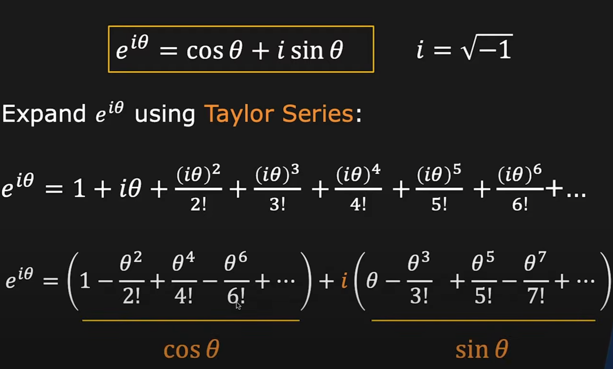

F(u) has two parts, real part and imaginary part, same thing for f(x)

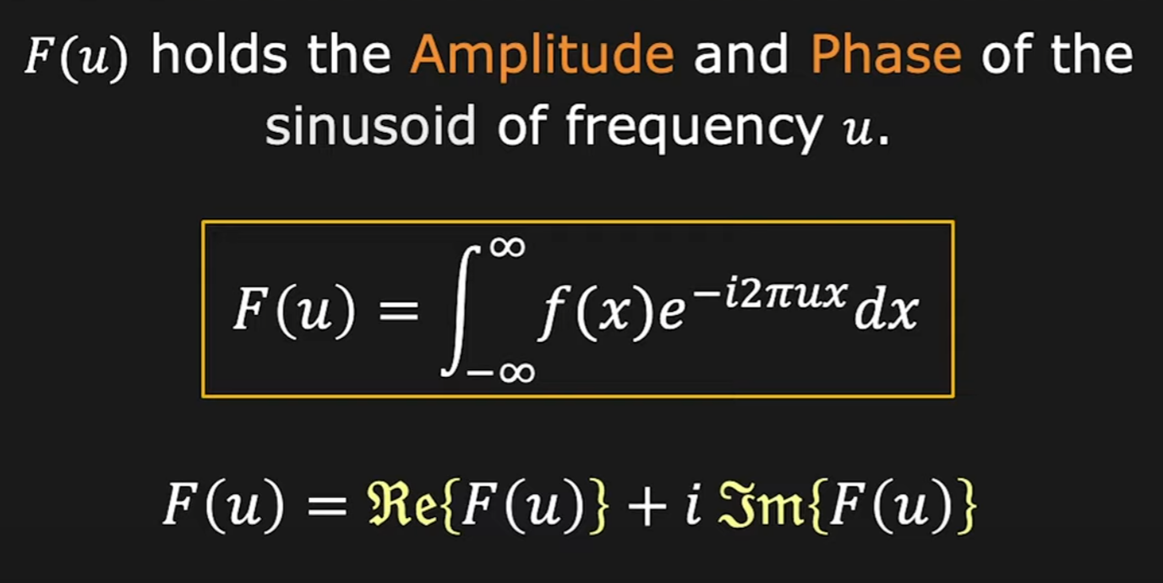

s.t. f(x) = fr(x) + i fi(x);

F(u) = ∫ [fr(x) + i fi(x)] [cos (-2pi ux) + i sin(-2pi ux)] dx

= ∫ (fr(x) cos(-2pi ux) + fi(x) sin(-2pi ux)) dx + i ∫ (fi(x) cos(-2pi ux) + fr(x) sin(-2pi ux)) dx

= Fr(u) + Fi(u)

<https://www.tutorialspoint.com/fourier-transform-of-complex-and-real-functions>

time domain vs frequency domain:

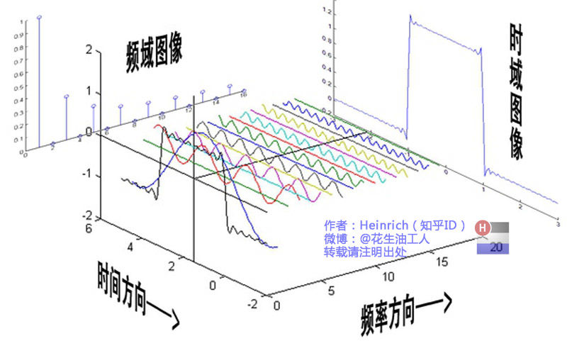

Property of FT:

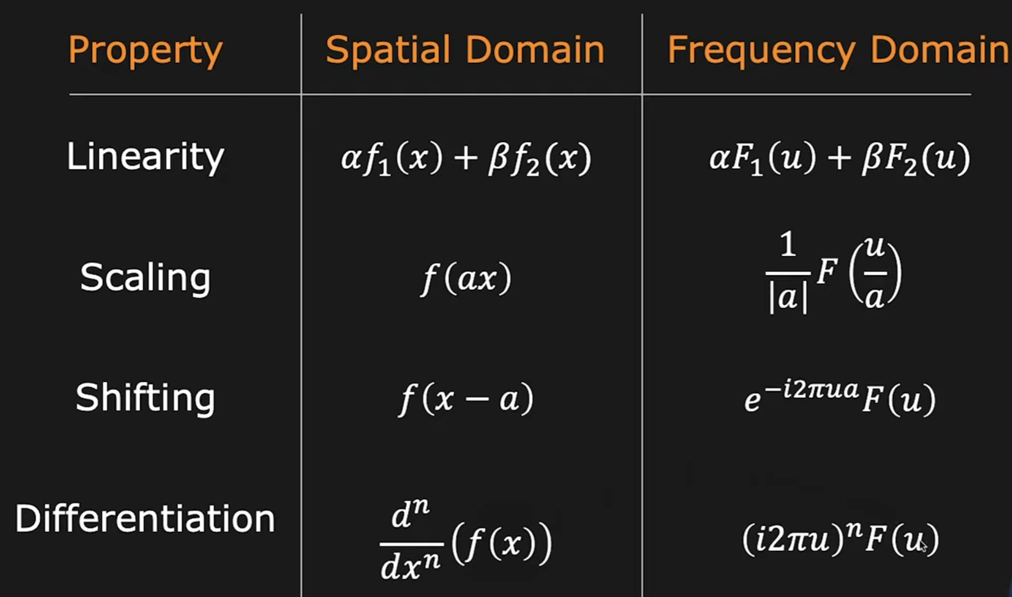

## 2D Fourier Transform

Eigenfunctions of LSI Systems:

x(n1,n2) ** h(n1,n2) = h(n1,n2) ** x(n1,n2), s.t

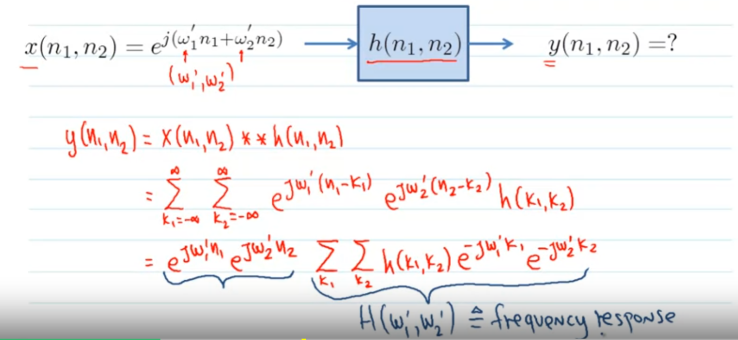

2D Fourier Transform:

X(omega1, omega2)

= sum(n1=-inf to inf) sum(n2=-inf to inf) [x(n1,n2) e^(-j omega1 n1) e^(-j omega2 n2)]

x(n1,n2)

= 1/4pi^2 (∫(-pi to pi) ∫(-pi to pi)) [X(omega1, omega2) e^(-j omega1 n1) e^(-j omega2 n2)]d omega1 d omega2

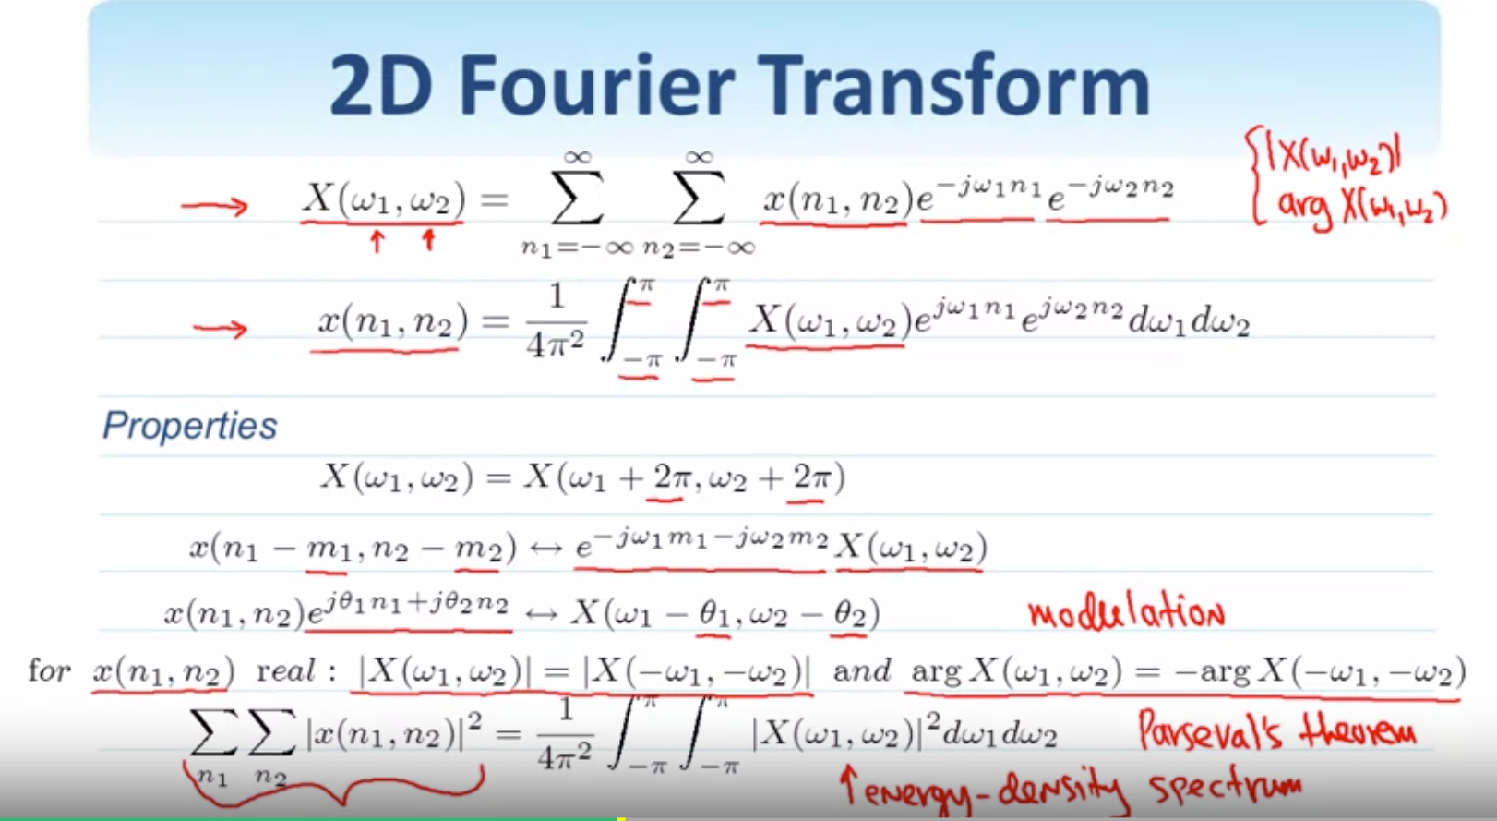

example1:

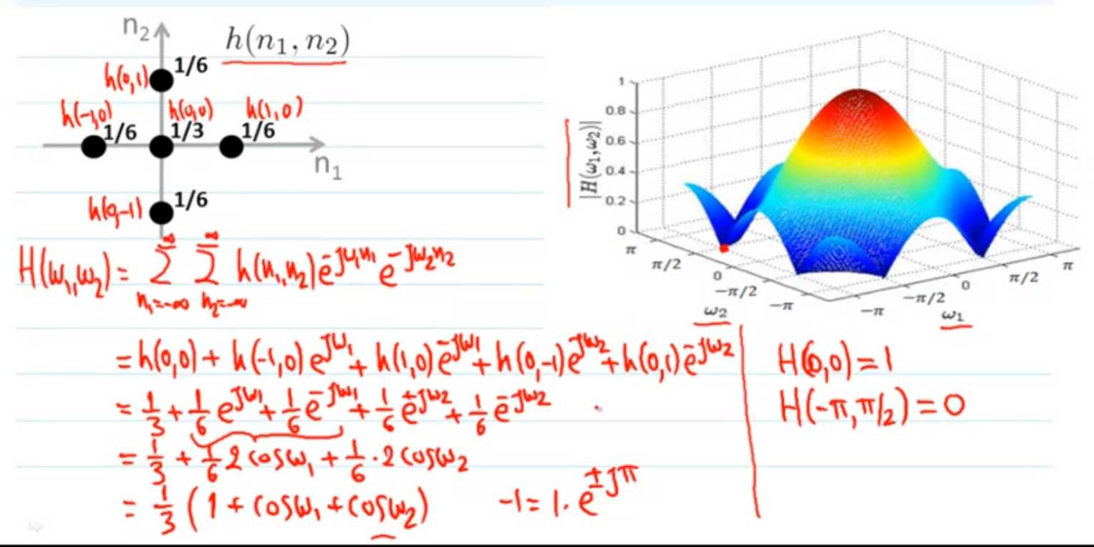

⅙(e^(j omega1)) + ⅙(e^(-j omega1)) = ⅙(cos(omega1) + j sin(omega1)) + ⅙(cos(omega1) - j sin(omega1)) = ⅙( 2 cos(omega1)) this is by Euler’s formula

example2:

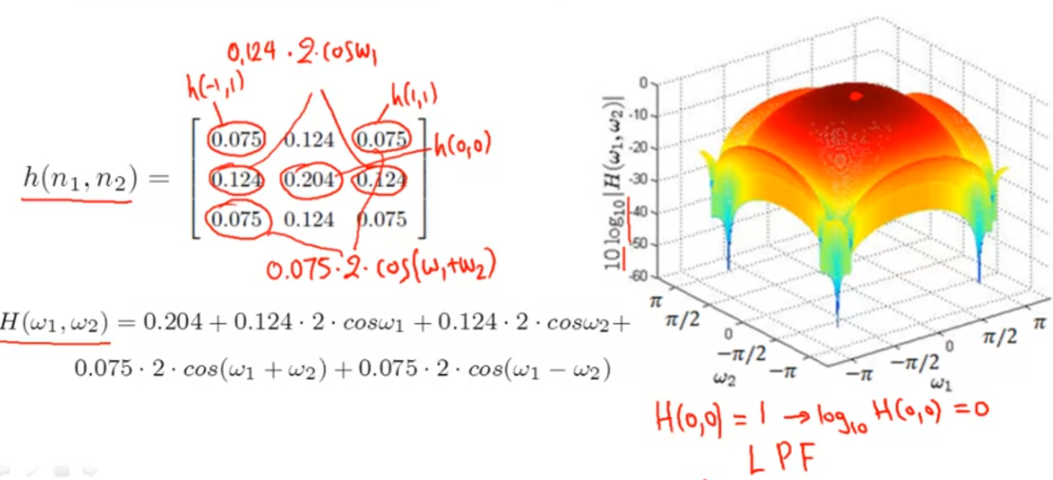

above one is a low-pass filter, and the vector for each element in matrix is

h(-1,1) h(0,1) h(1,1)

h(-1,0) h(0,0) h(1,0)

h(-1,-1) h(0,-1) h(1,-1)

example3:

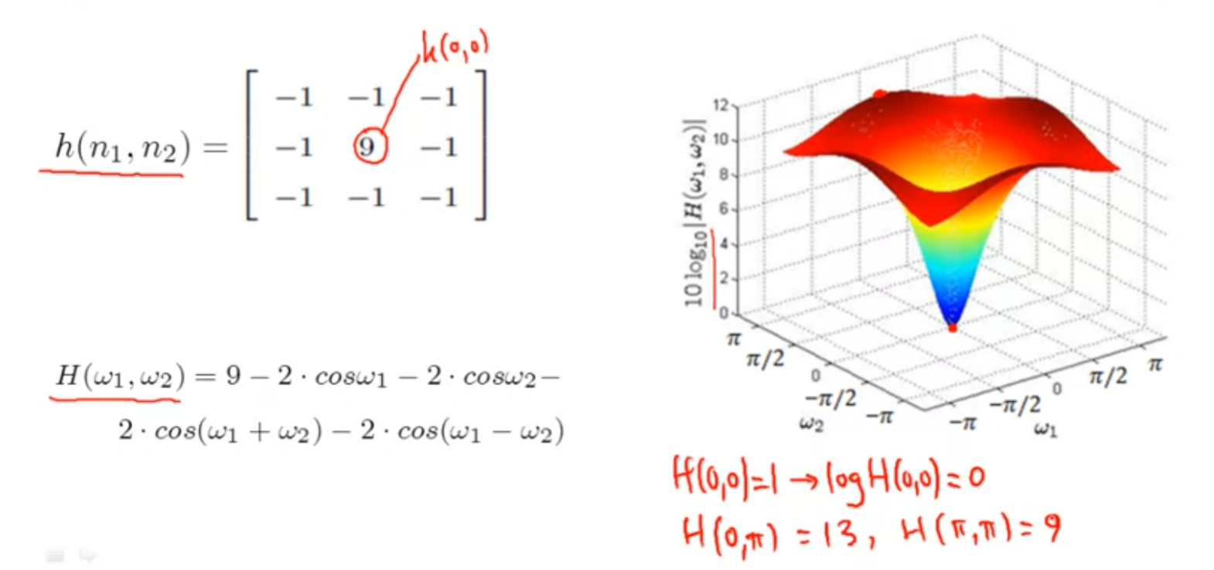

above is a high-pass filter

The Convolution Theorem:

if y(n1,n2) = x(n1,n2) ** h(n1,n2), s.t

Y(omega1, omega2) = X(omega1, omega2) . H(omega1, omega2)

proof:

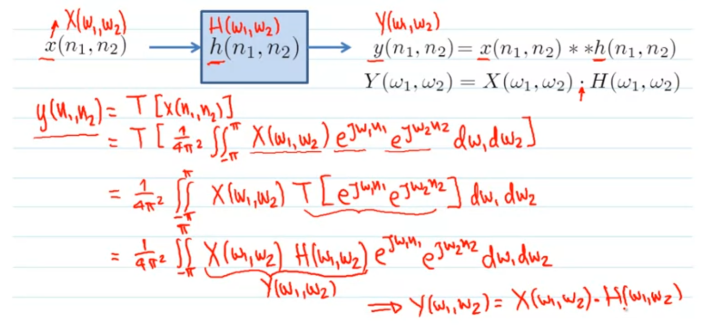

on step3, because before we said e^(j oemga1 n1) e^(j omega2 n2) is the eigenfunction of LSI system (which is T[.]) s.t T[e^... e^...] = H(omega1, omega2)

on step 4, by Fourier transfer rule, X(omega1,omega2) H(omega1,omega2) = Y(omega1, omega2). Thus it proof the convolution theorem.

## Sampling

Sampling is used to process analog signal into digital signal.

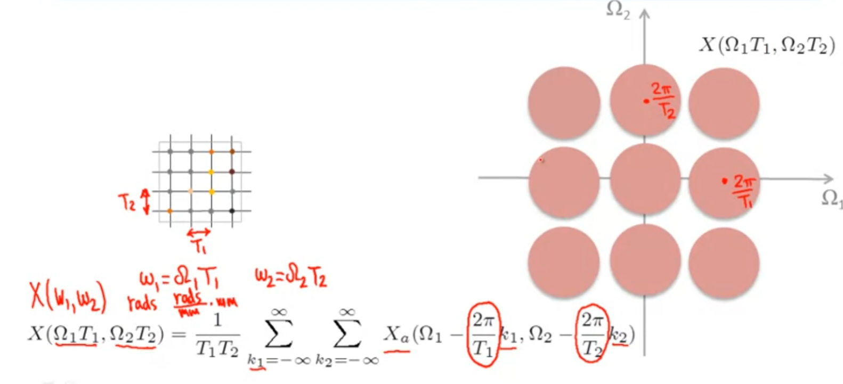

omega1 = big omega1 T1, omega1 is frequency(radians), big omega1 is radians/unit distance, and T1 is sampling with size = unit distance, s.t omega1 = omega1(radians/unit distance) * T1(unit distance) = radians(frequency)

Critically sampled:

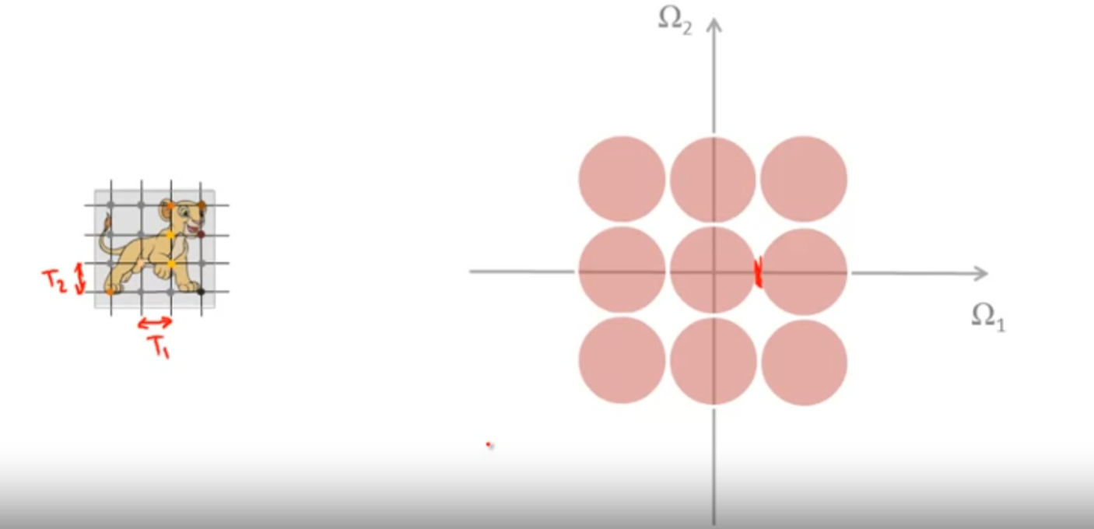

if the size of T is just right, when fourier transfer create a discrete signal (right side), each spectra just touch each other without overlapping, this will not losing any information even go back from discrete to continuous (recover to original signal).

Over-Sampled:

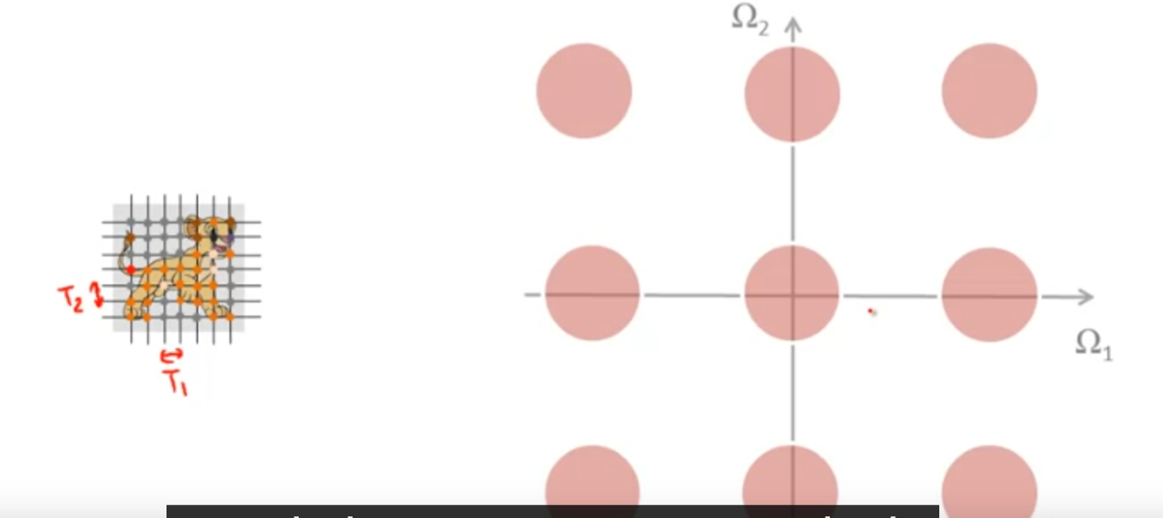

if T is too small, then it will cause over-sampled

Under-sampled:

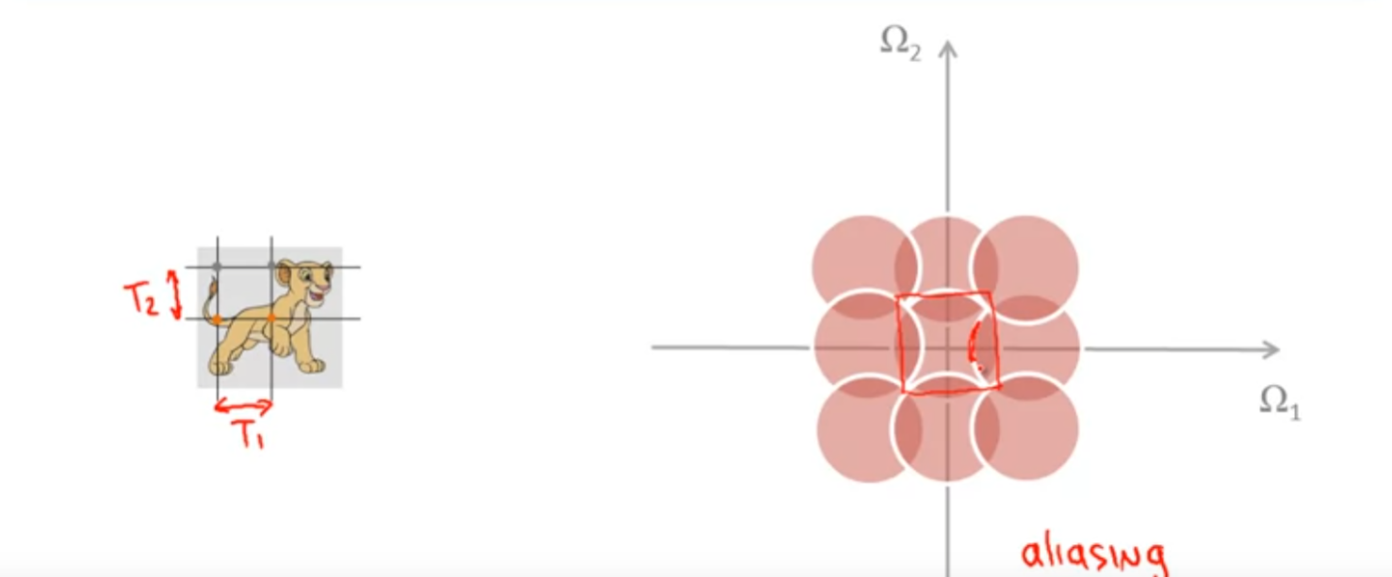

if T is too big, under-sampled will caused, and in this case, it is not possible to go back to original signal(information will lose), this is called aliasing.

Then what samplings periods T1 and T2 should equal to?

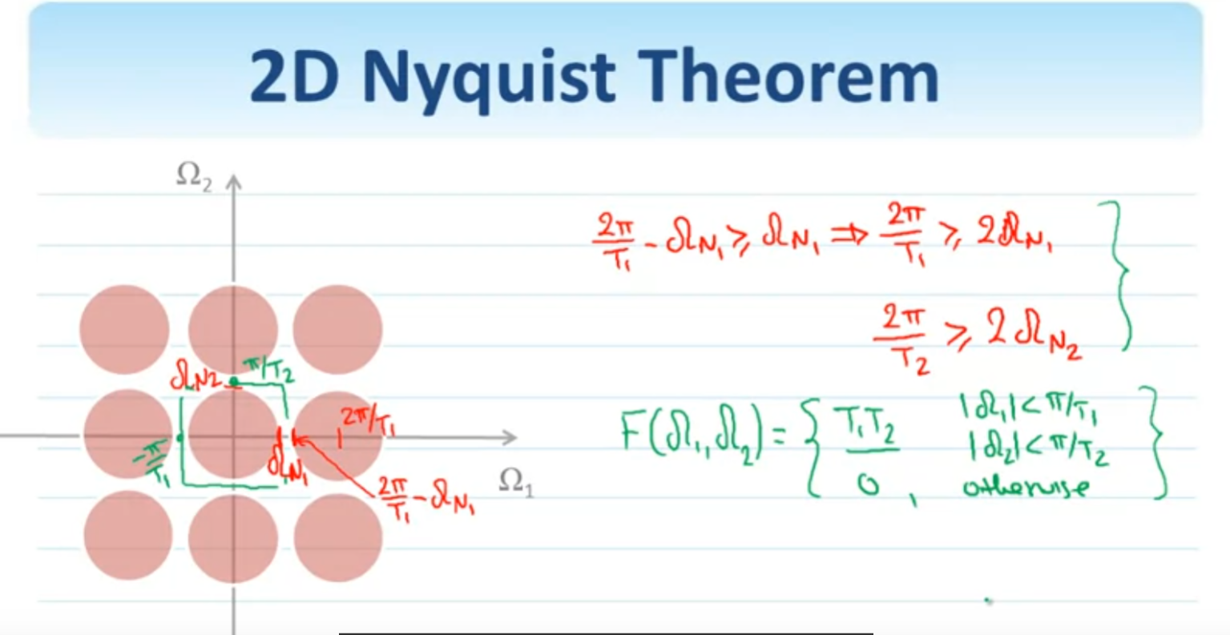

if above pic, 2pi/T1 is the sampling frequency(T1 is sampling size, and 2pi/T1 = the frequency of sampling), so if two red conditions are satisifed(the sampling frequency must be at least two time of maximum frequency), then the discrete signal after Fourier transfer will not cause aliasing. And also we could use the filter like green to recover the analog signal from discrete signal!

example of critically sampled:

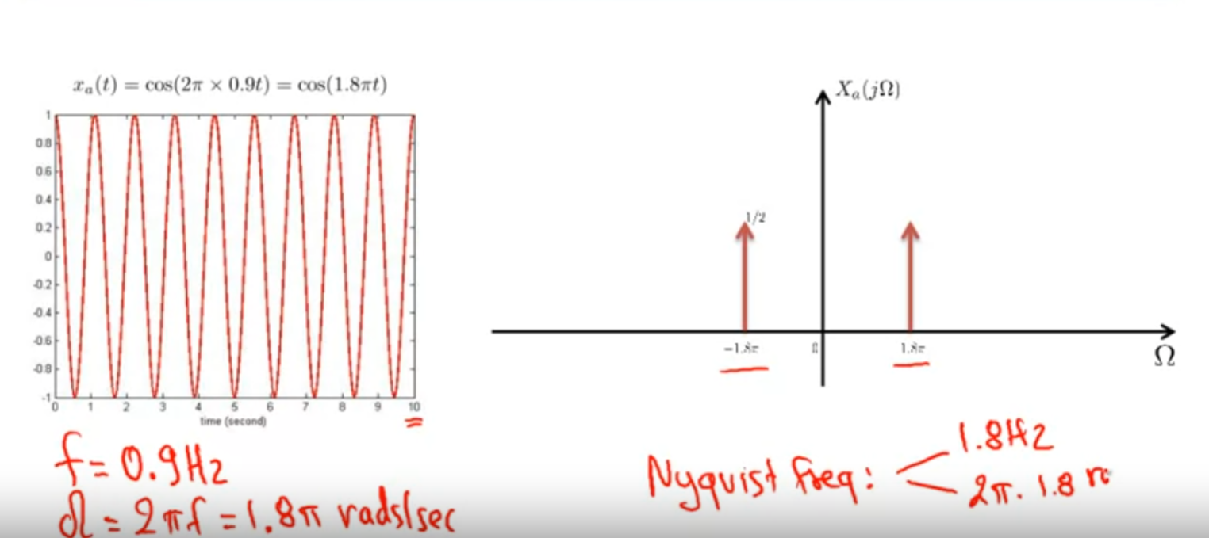

regular frequency f = 0.9Hz, angular frequency omega = 2pi f = 1.8pi rads/sec, the Nyquist frequency is then 2*f = 2*0.9Hz = 1.8Hz, or 2 * omega = 2pi * 1.8radias/second

example of over-sampling: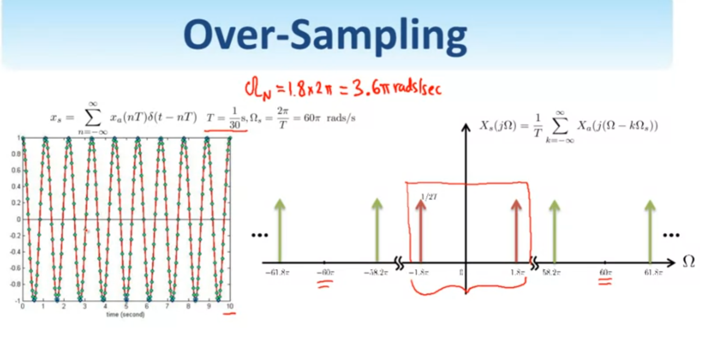

Nyquist frequency only need 3.6pi radias/sec, but we use 60pi rads/s, it caused over-sampling

example of under-sampling:

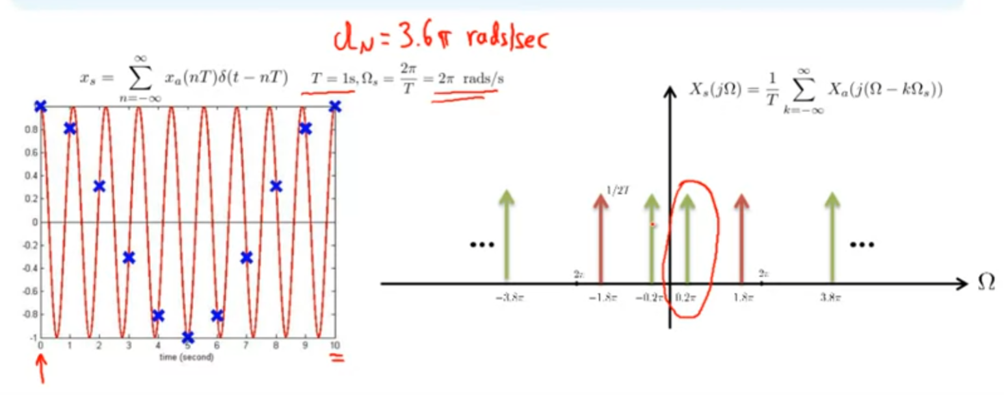

## Discrete Fourier Transform

The discrete Fourier transform (DFT) can be viewed as a sampled version of the Fourier transform on a sampling grid that is uniform. Continued FT is not computable but DFT is computable.

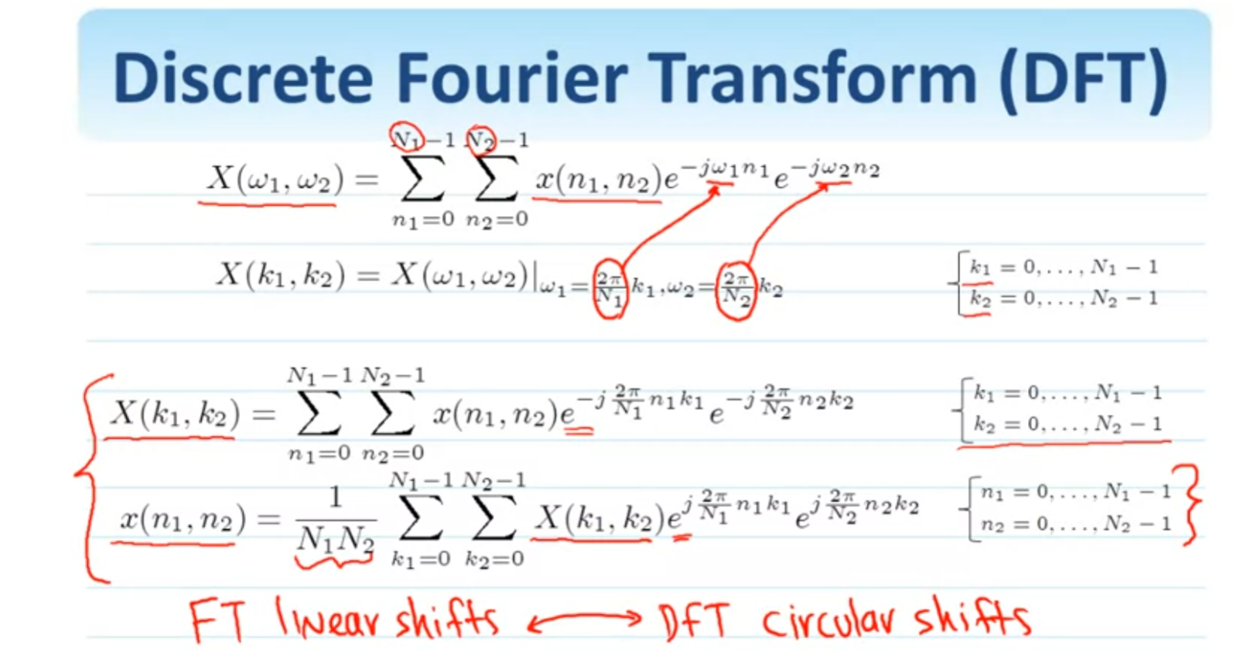

red two formula are the discrete fourier transform(upper one is DFT, below one is reverse DFT)

FFTs:

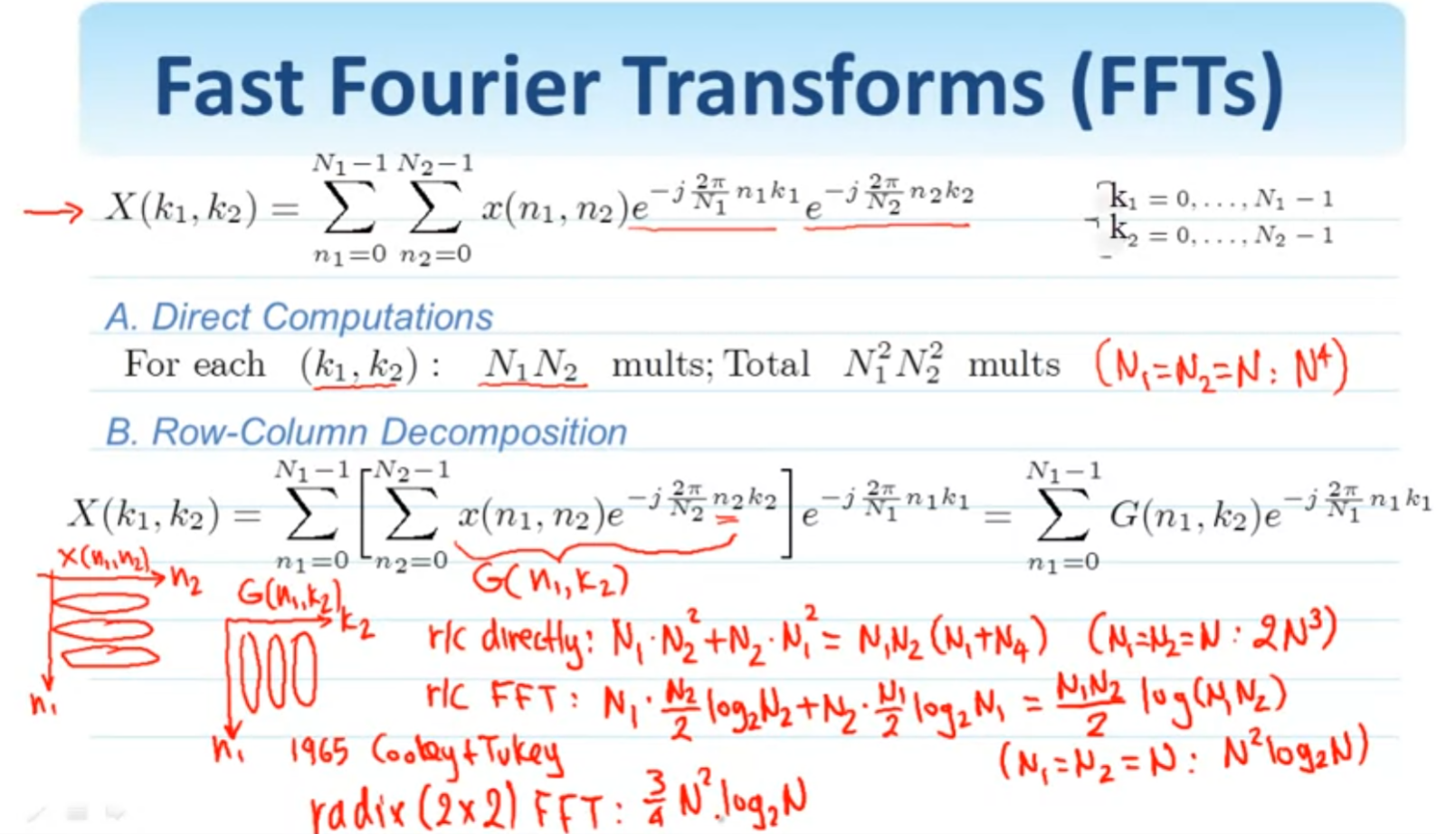

example of DFT:

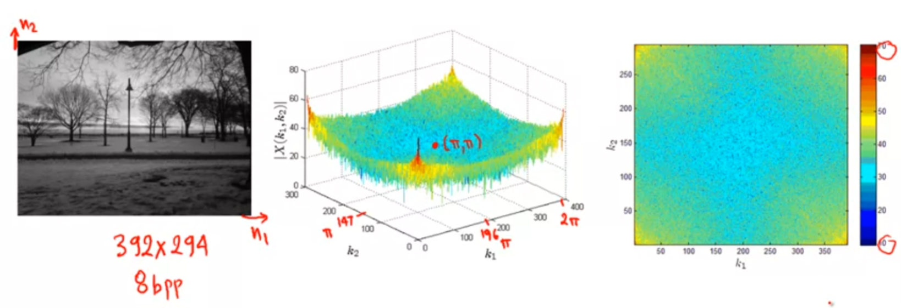

## Filtering in the Frequency Domain

2D circular convolution:

x(n1,n2) —> T[h(n1,n2)] —> yL(n1,n2) = x(n1,n2) ** h(n1,n2),

and then we find the DFT of impulse response:

X(k1,k2) —> T[H(k1,k2)] —> Y(k1, k2) = X(k1, k2) . H(k1, k2)

we would like to find relationship between frequency domain and spatial domain, the relationship is then circular convolution:

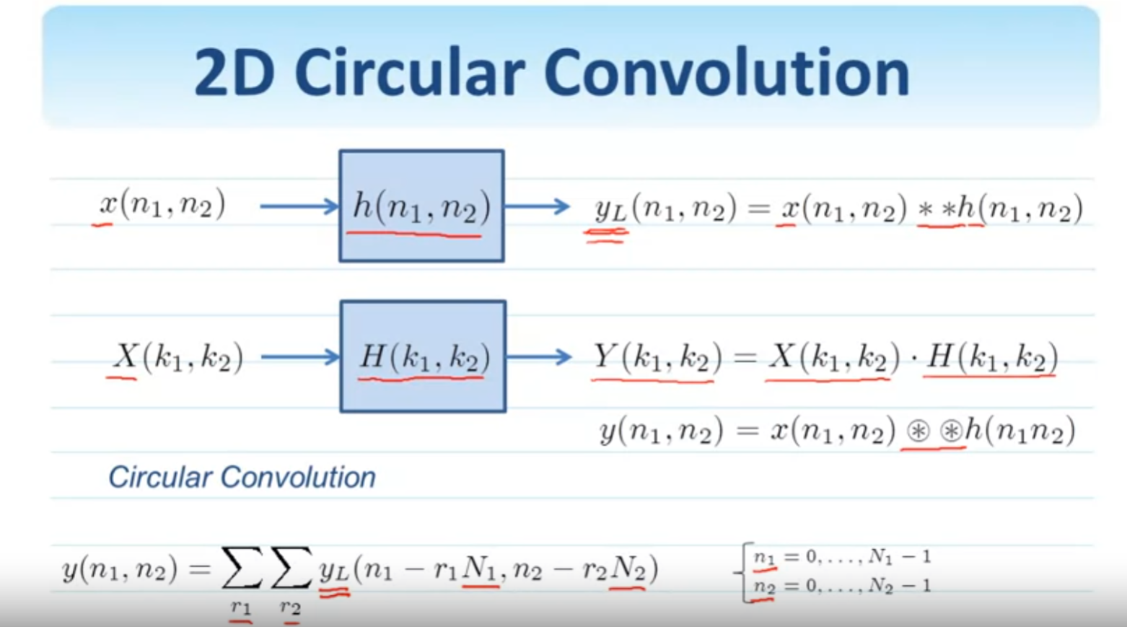

Use of DFT for filtering:

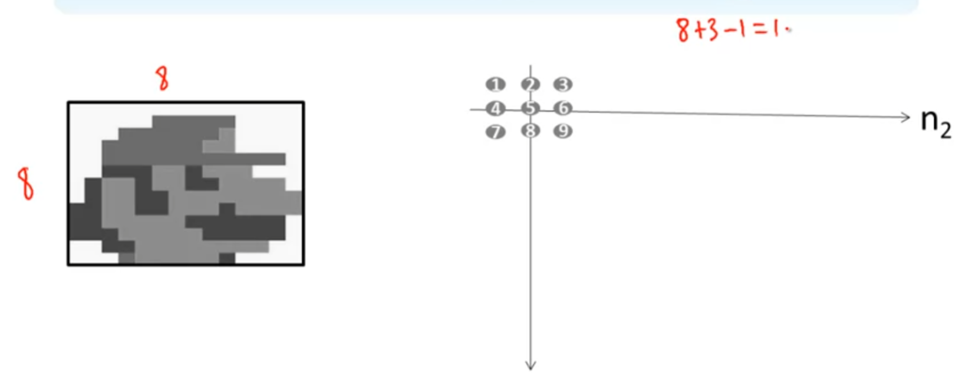

the result of convolution of this 8x8 image with 3x3 impulses points will be 8+3-1=10, a 10x10 image.

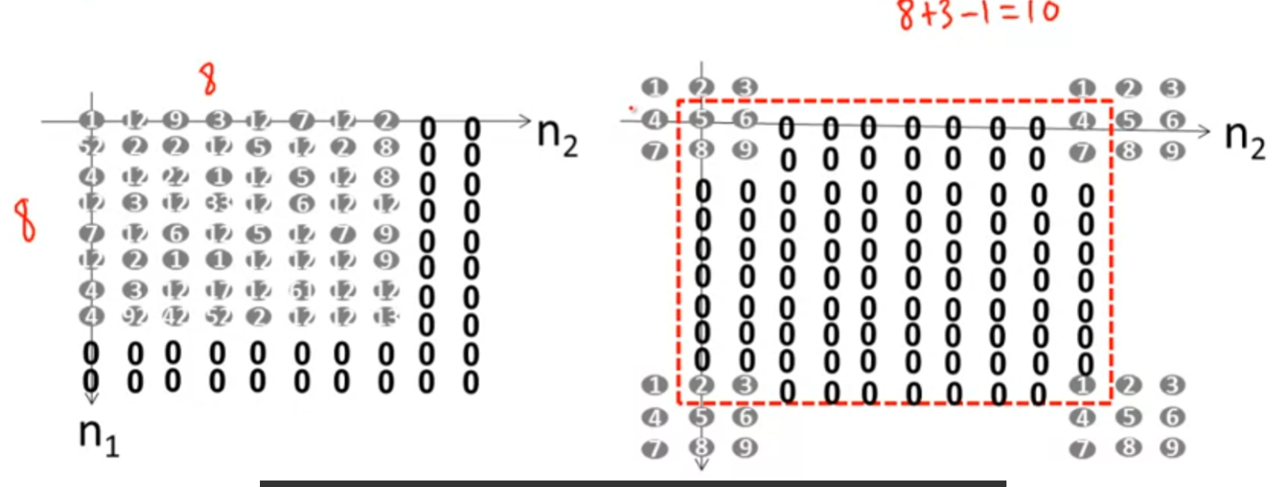

next, make 8x8 image to a 10x10 image by add 0 column and row, also we know after DFT the image will look like right side, so copy the 3x3 impulses points and make all elements between 0.

then multiply them and take the result of the multiplication and bring it back to the spatial domain through an inverse DFT and that will give the linear convolution of the two signals.

Advantages of frequency domain filtering:

they can process each frequency individually.

## Change of Sampling Rate

Down-sampling:

given an 8x8 image, we would like to down size by 2, which is 4x4 image. one way is to remove every other row and column:

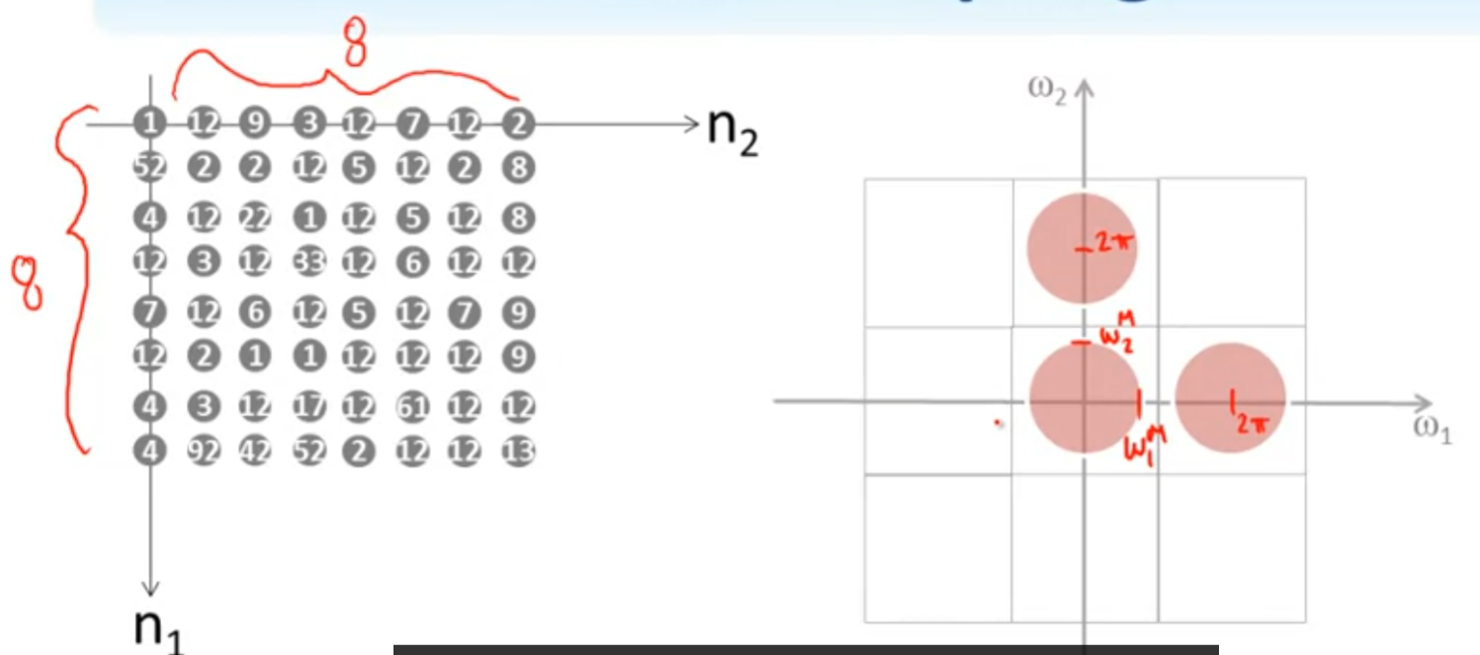

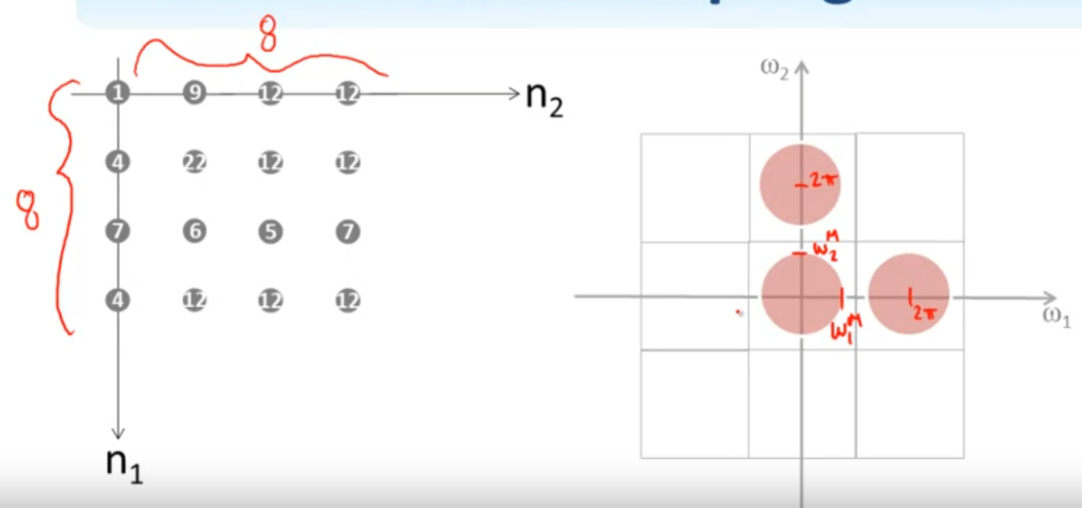

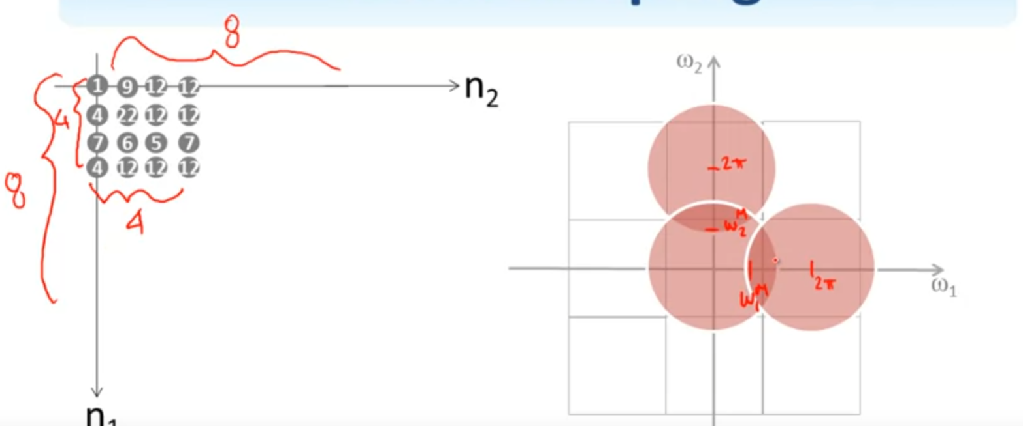

therefore, end up with 4x4 image, but aliasing caused, meaning some information lost.

in order to avoid aliasing when down-sampling, need do a low-pass filtering before down-sampling!

up-sampling

want make a 4x4 image into 8x8 image, the way is to add 0 every other column and row

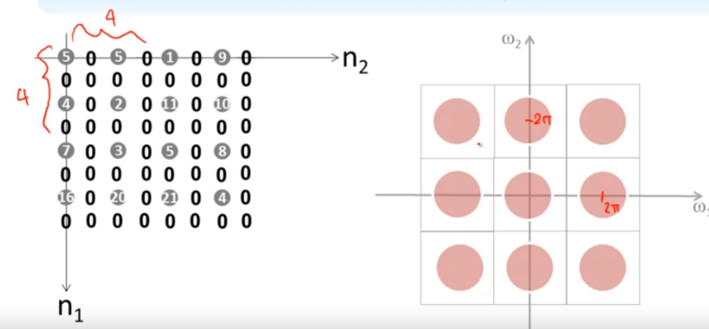

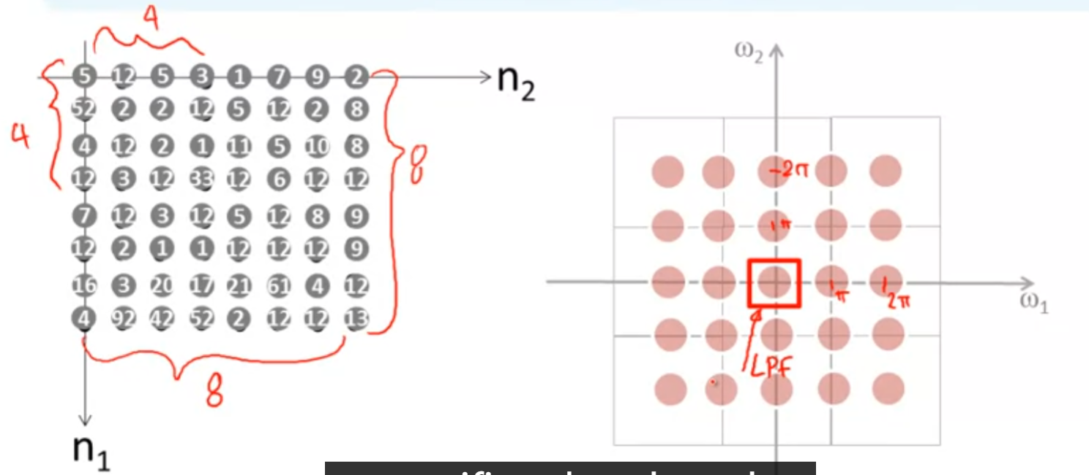

this will still reqired the low-pass filtering the spectrum after up-sampling

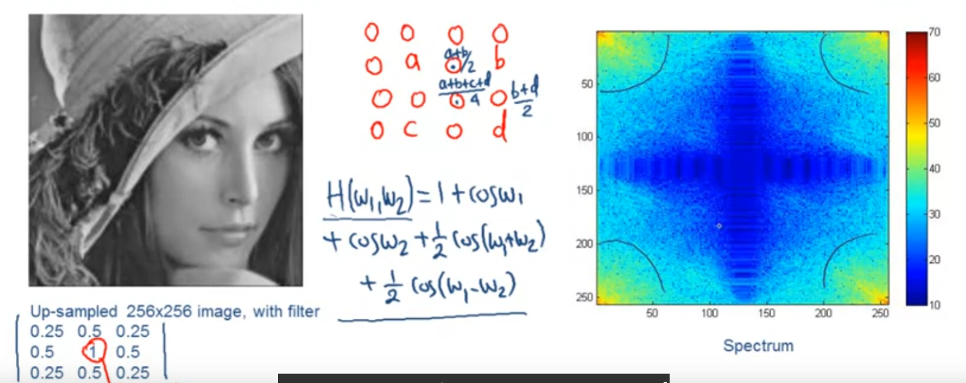

this is the up-sampled image with low-pass filter.

## Week3 Homework

Fast Fourier Transform speeds up the computation of the Discrete Fourier Transform of a signal by compromising the accuracy of the result. (statement is false!)

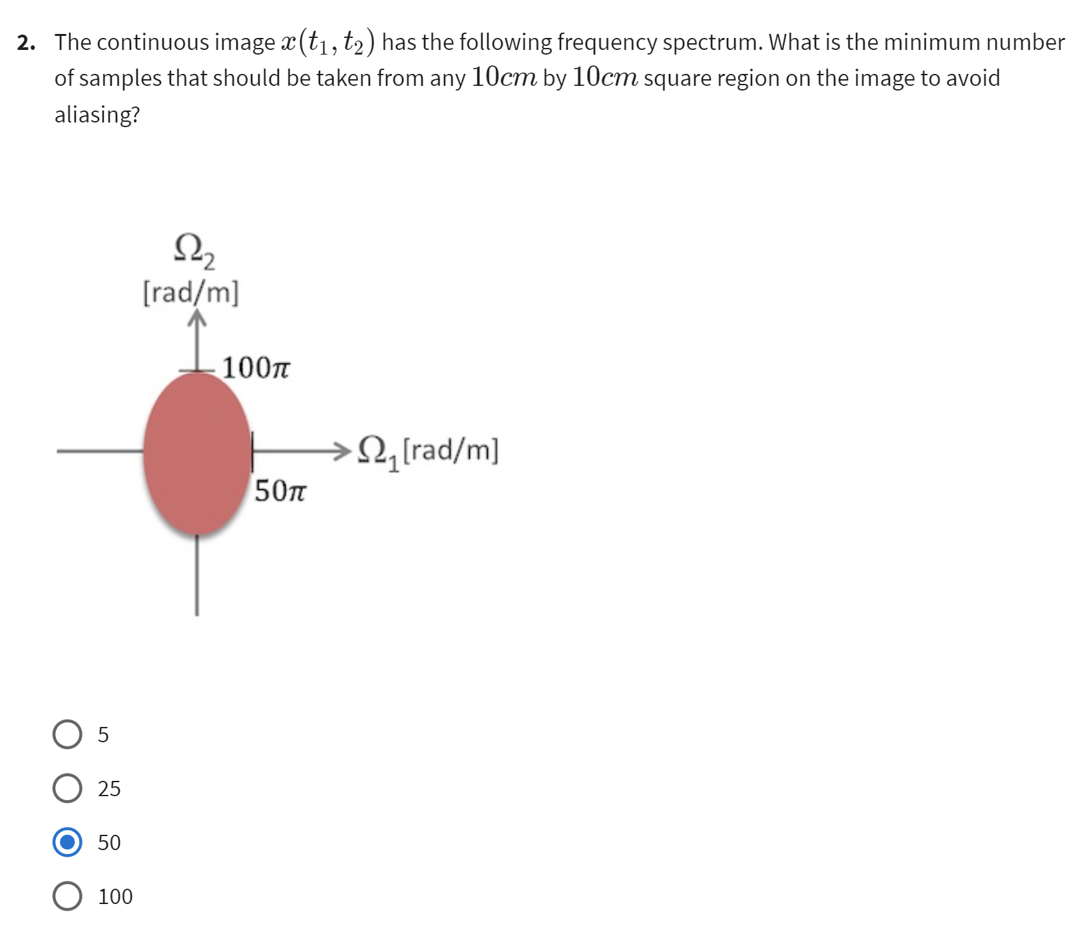

omega1 = 50pi / m, by Nyquist theorem, 2pi/T1 >= 2omega1, s.t 2pi/T1 >= 100pi/m = 100pi/100cm = 1pi/cm, T1 >= 2cm

omega2 = 100pi/m, 2pi/T2 >= 2omega2 = 200pi/m = 2pi/cm, s.t T2 >= 1cm

(10cm/2cm)*(10cm/1cm) = 50

matlab算任何FT的X(n1,n2)的时候，需要计成X(n1+1,n2+1)才是正确答案（因为matrix column row从1开始算起）

## Motion Estimation

2D vs 3D motion:

if we only have one camera, there is no possible to know the corresbonding 3D object from a 2D image on the plane. Unless we have more than one cameras. So therefore we could only deal with the estimation of the 2D motion.

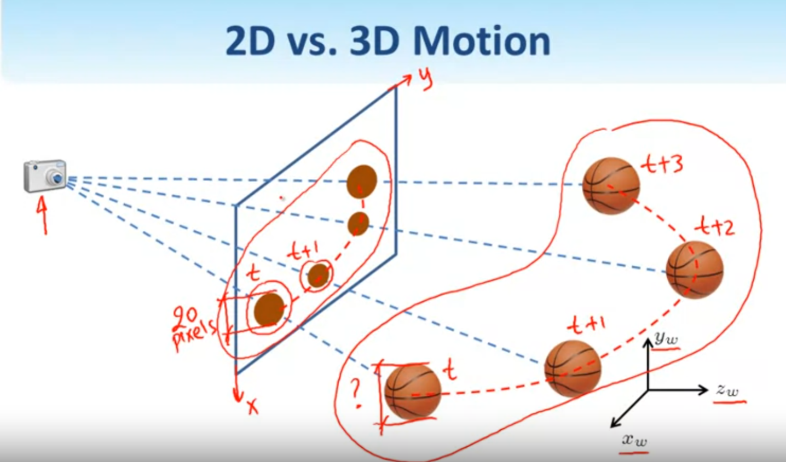

Basic idea:

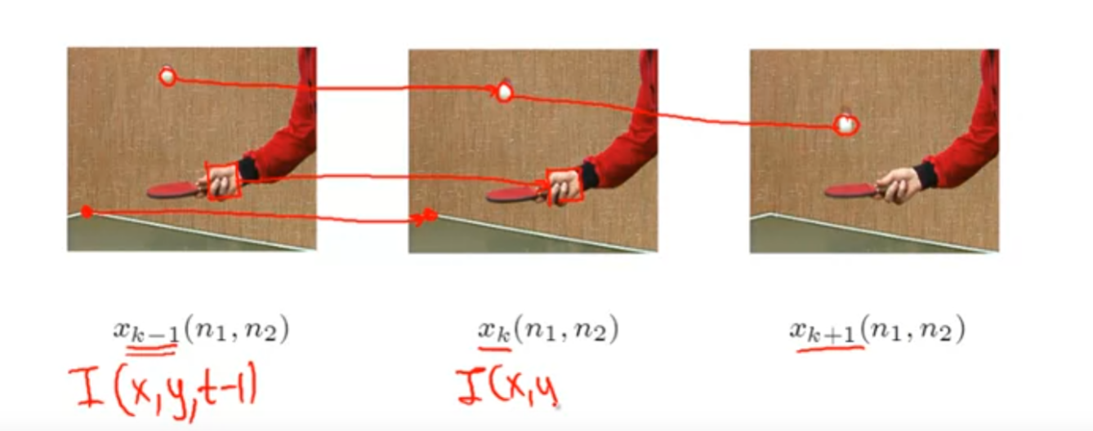

wish to declare the motion between xk-1 to xk to xk+1, only care about the pixel movement

True motion vs Optical flow:

true motion meaning the object on the image is moved, optical flow means the pixel changed but the object is not move. If the object moved from one position to another position we say that it is non-zero true motion, if pixels on the object changed(light and shadow) then we say that it is non-zero optical flow.

Some motion estimation applications:

Object tracking, human computer interaction(HCI), temporal interpolation, spatio-temporal filtering, compression

## Phase Correlation

Classification of Motion Estimate methods:

Direct methods(computer optical flow in the scene): phase correlation, block matching, spatio-temporal gradient

Indirect methods(first find the features in the two frames then match the features directly which will estimate the motion): Feature matching

example of phase correlation:

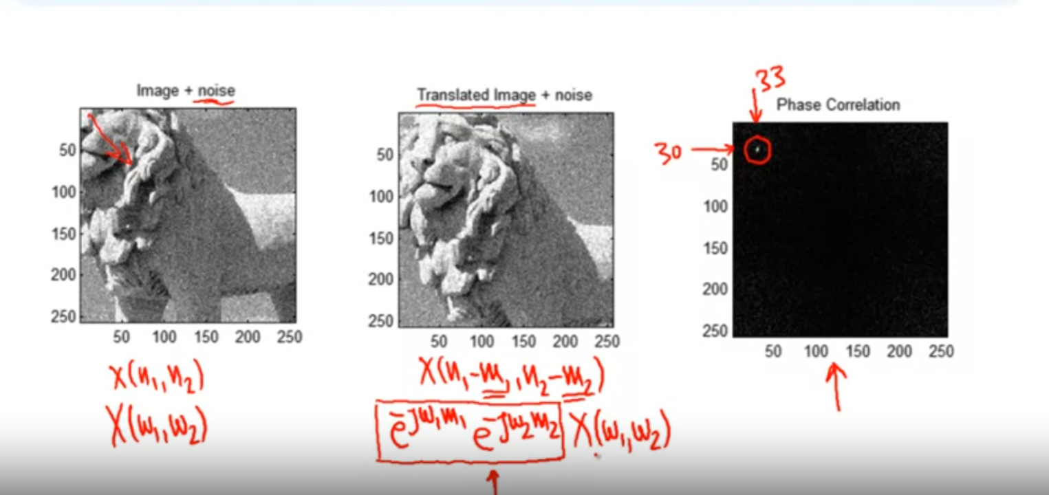

by Fourier Transform we know that both images are related in frequency domain so if the formula for the first image is X(omega1, omega2), then the second one is e^... e^... X(omega1, omega2). And as we know a spatial shift in the image domain corresponds to a phase change, thus if we figure out the e^...e^... part then we know the spatial shift of image and can translate the second imege back to the original one.

Algorithm of phase correlation:

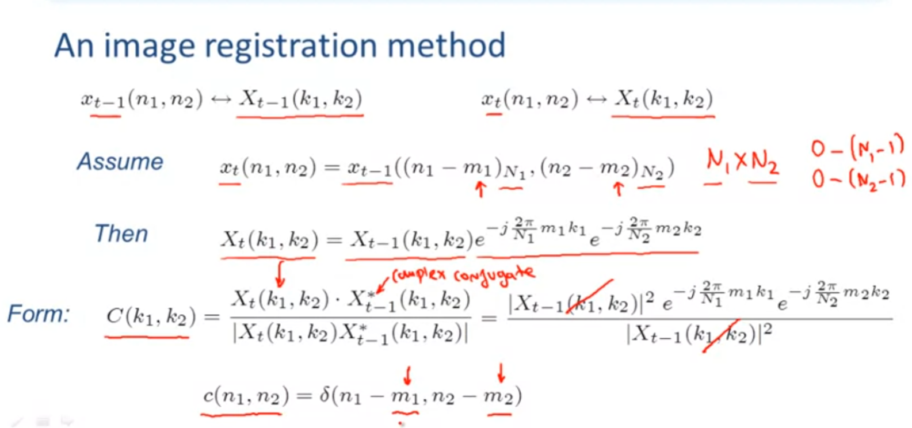

## Block Matching

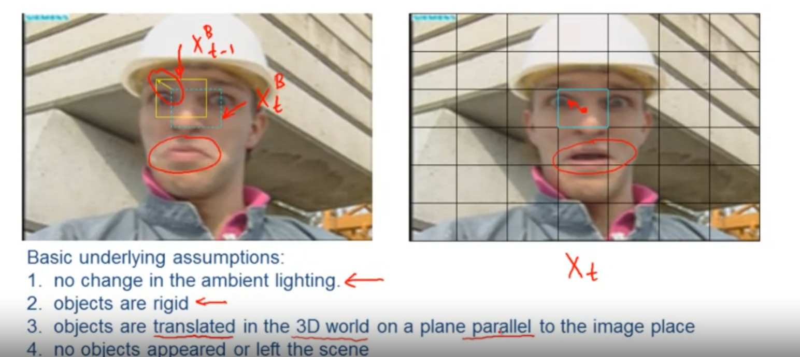

Find the best matching on the original image for the block(with blue border), e.x. find two best matchs(the yellow one), then link both block we got a motion vector between them.

But the matching process must applying under above 4 assumptions.(the object are rigid means they dont transform, like the mouth)

Matching Criteria:

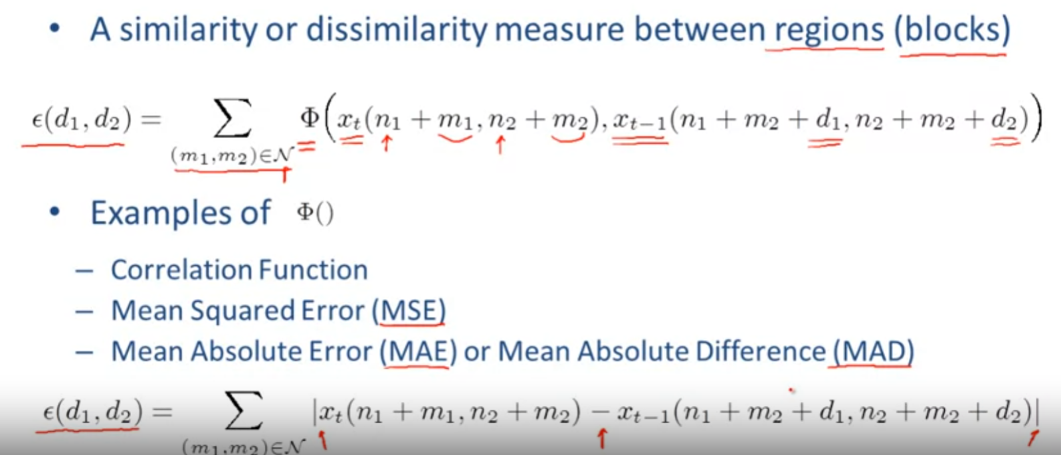

maximize the function to find similar block, or minimize to find dissimilar block. The result of block matching using different matching criteria will not always be different!

search region:

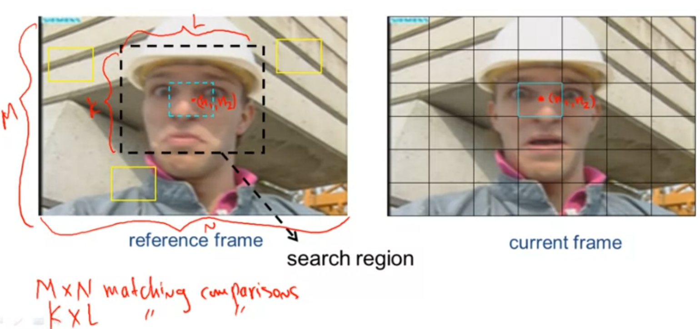

suppose the image is MxN, the matching comparisons region is MxN , but the search region can be smaller, KxL, with a search region, the computation amount will reduced.

2D logarithmic search(reduce the computation even with search region):

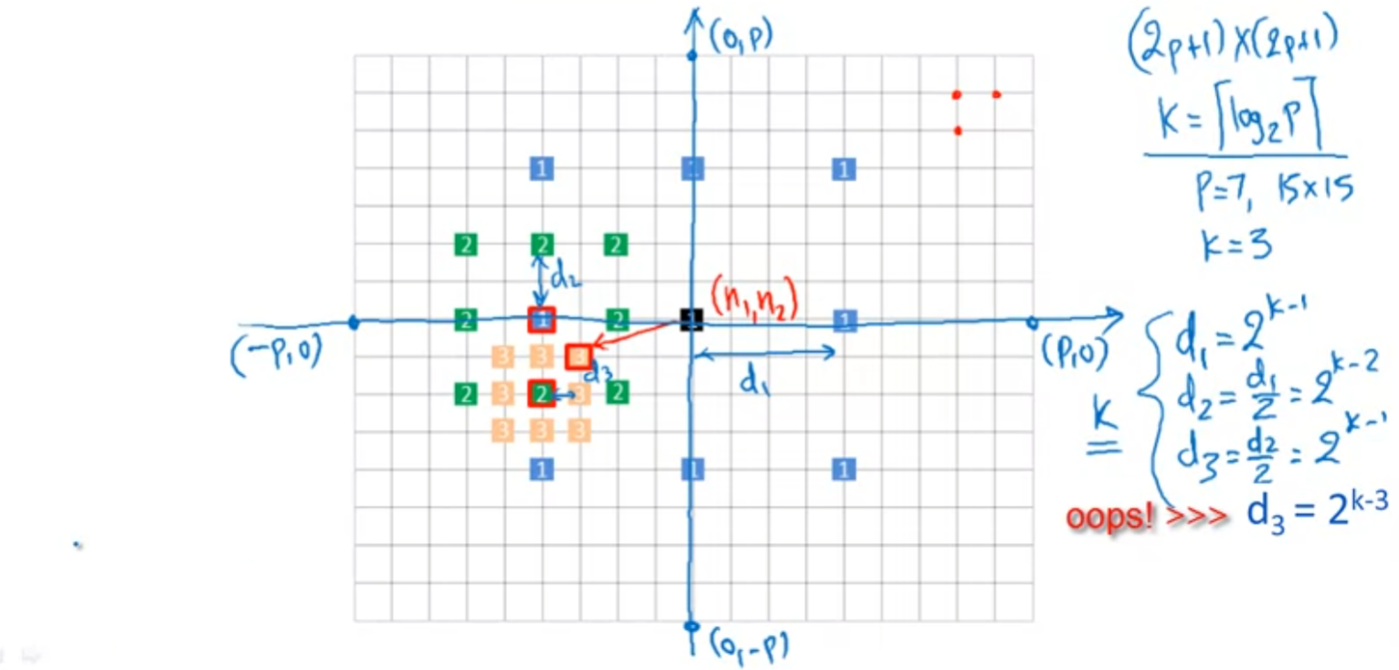

1. first we consider the 8 neighbors with distance d1 are all numbered 1(which shows in 8 blue 1 block)
2. then find the one blue block with the minimum error, for example the left one
3. then consider the 8 neighbors with distance d2 are all numbered 2
4. find the one green block with the minimum error, same thing with step 2
5. consider 8 neighbors with distance d3 are all numbered 3
6. repeat step 2 find the one yellow block with minimum error
7. then the motion vector centered (n1,n2) is the yellow 3 to the black 1

Global vs Local search

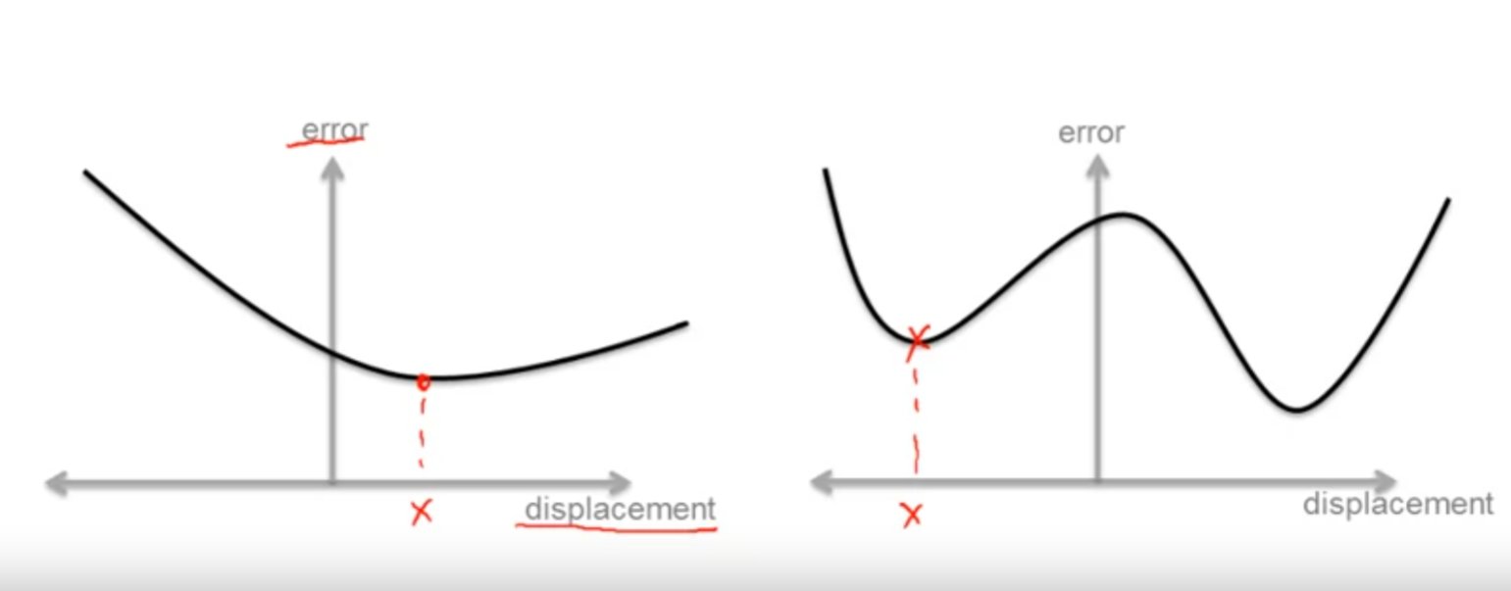

global search will always find a optimal solution(global minima), but it takes much longer time than local search(computation heavy), on the other hand local search spend less time but will not always find a optimal solution if one exists(sometimes it just find the local minima not the global minima, like right side figure shows).

Pixel Sub-sampling(reduce the computation):

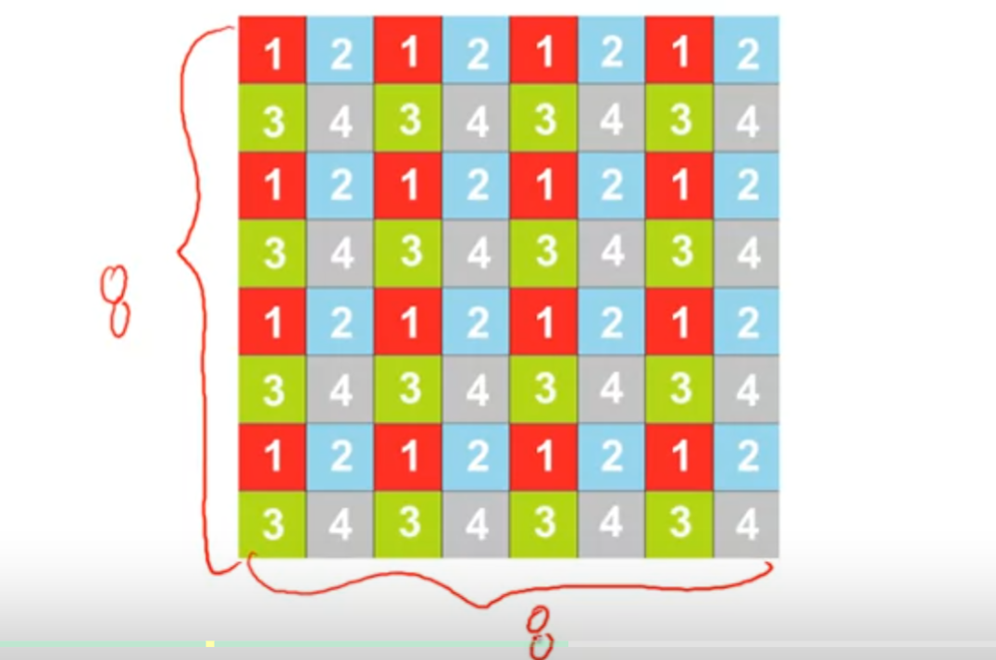

the pixel sub-sampling is another way to reduce the computation, but it sometimes failed.

Pixel Projection(reduce the computation):

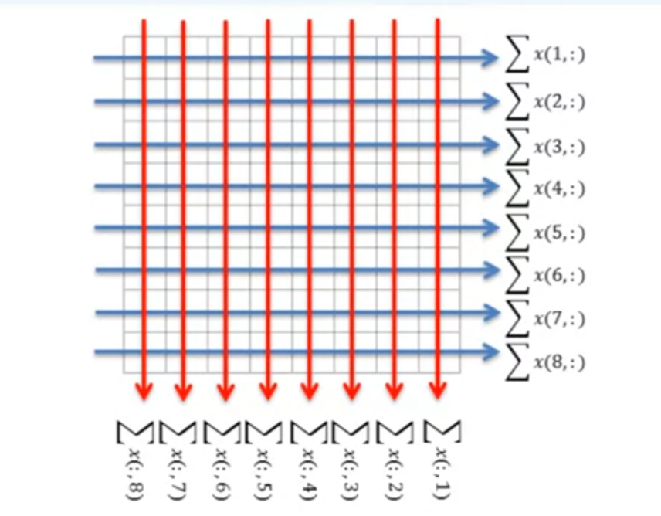

Hierarchical Motion Estimation:

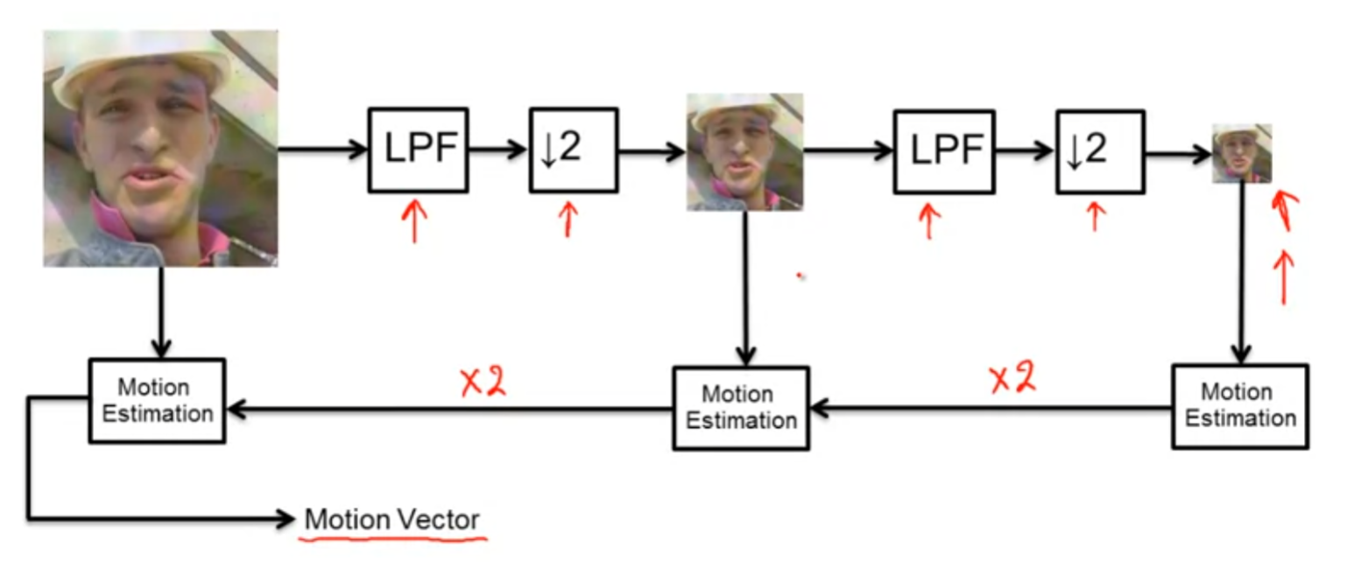

applying low-pass filter and down sampled by 2, and do it again, we got a smaller block, then use any of the search method(in this case, since the resolution is reduced we can use global search), and then the estimated vector will multiplied by 2 and by 2 to get the motion vector.

Sub-pixel motion estimation:

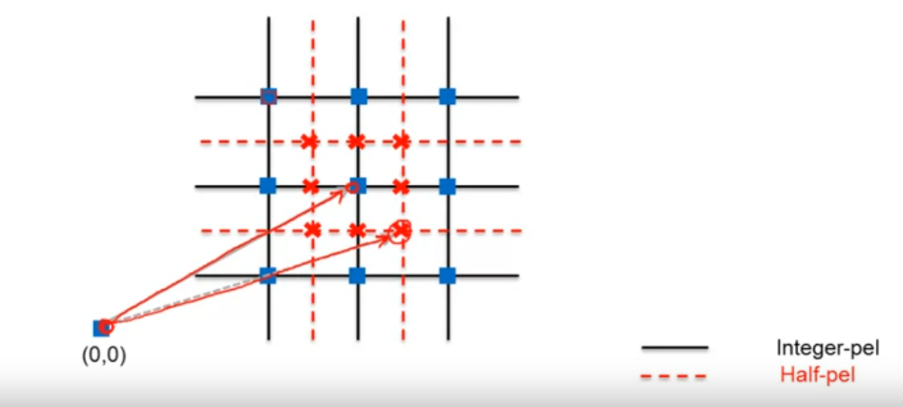

Experimental comparison:

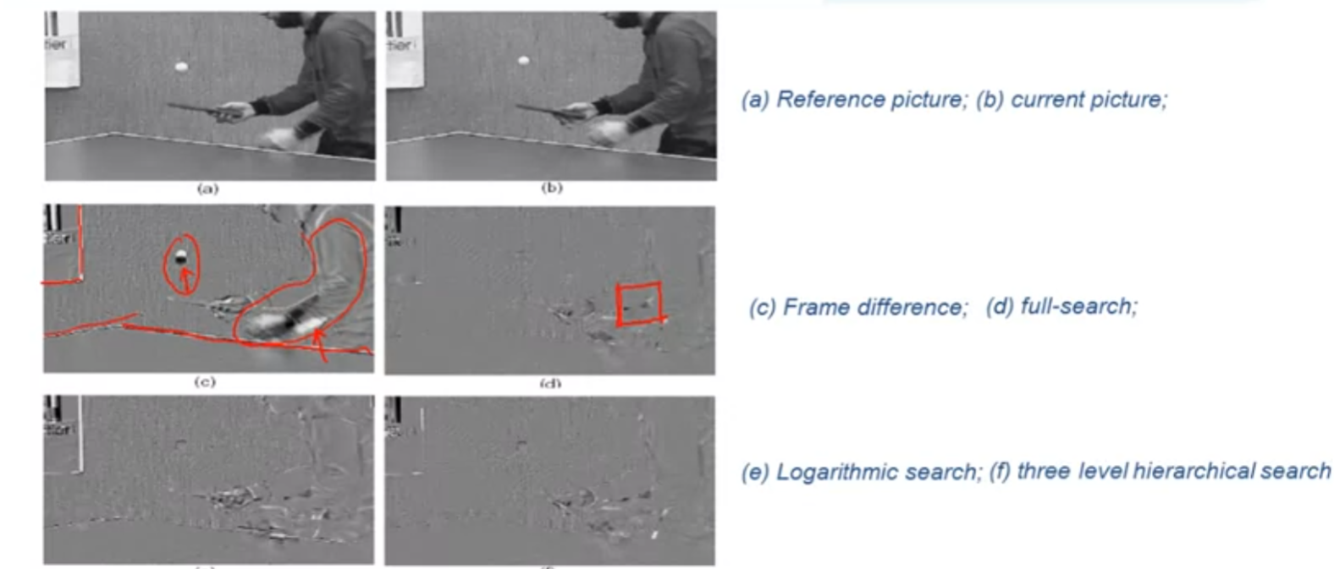

2D logarithmic search here feels a little bit three level hierarchical search is almost as good as global full-search.

## Spatio-Temporal Gradient Methods

Optical Flow approach:

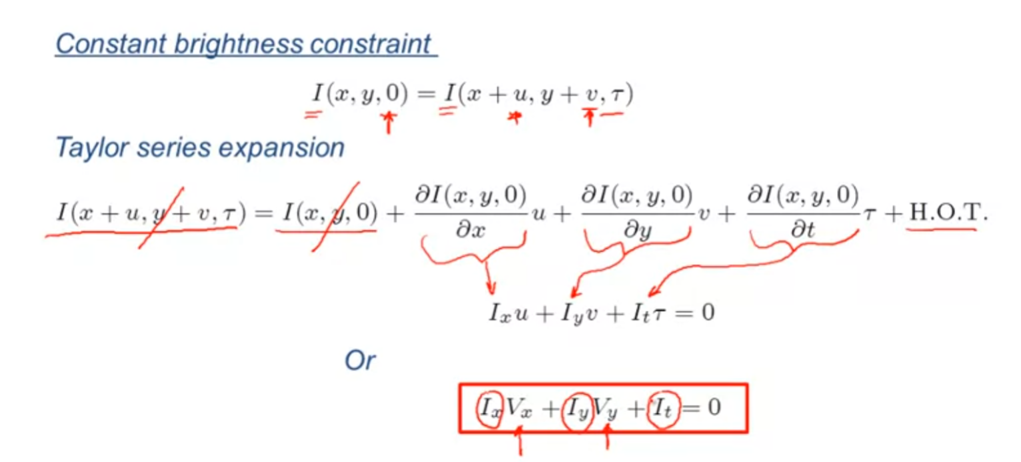

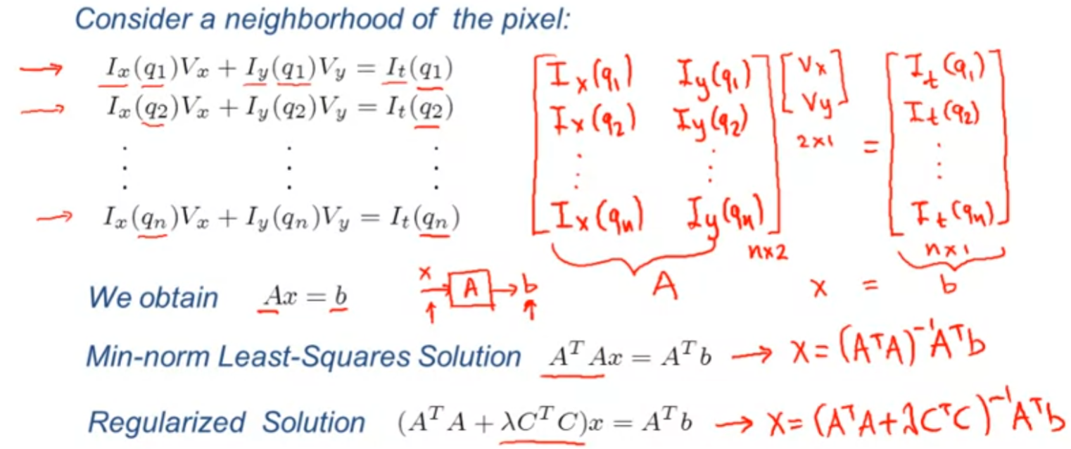

Pel-Recursive algorithms:

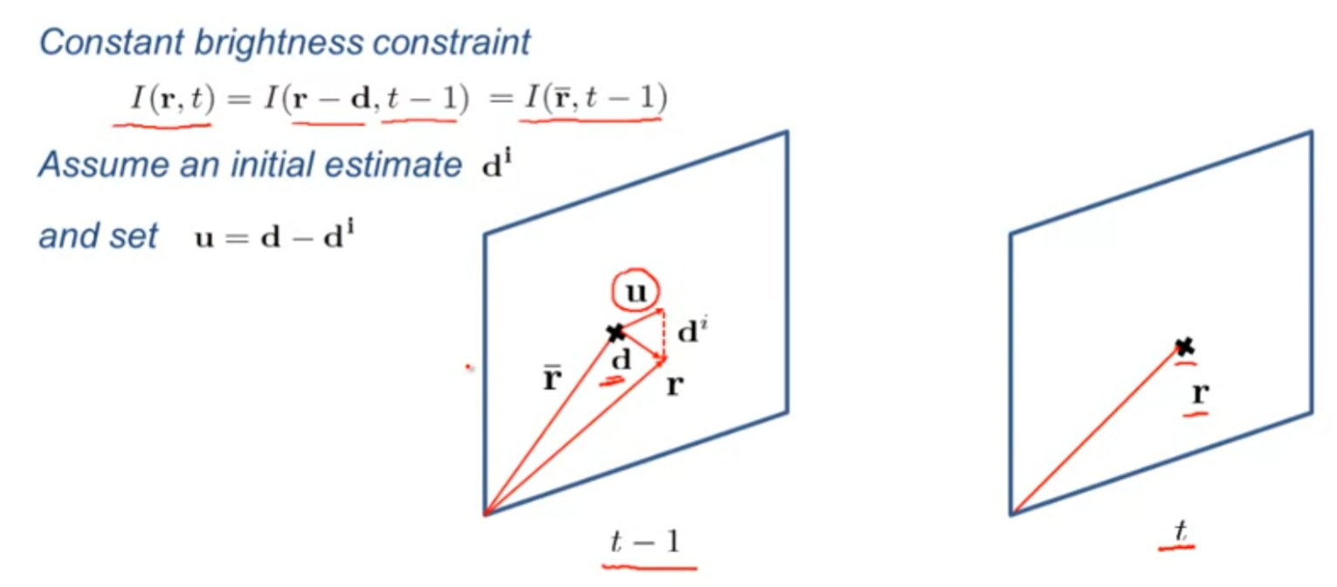

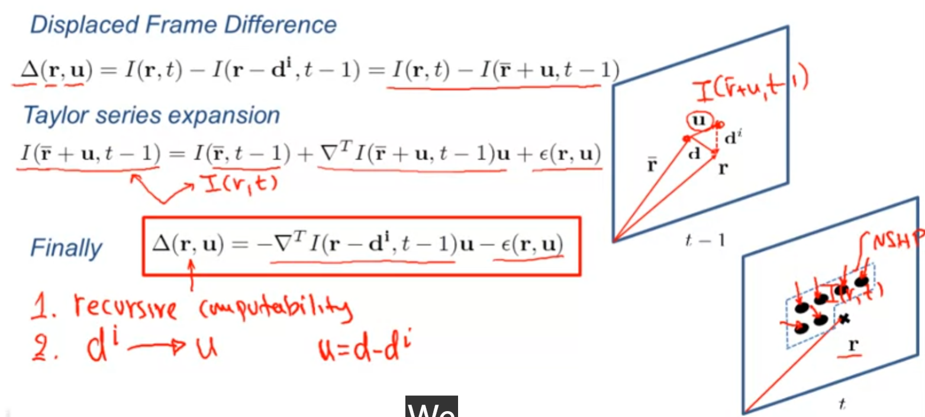

Frame difference - - DFD

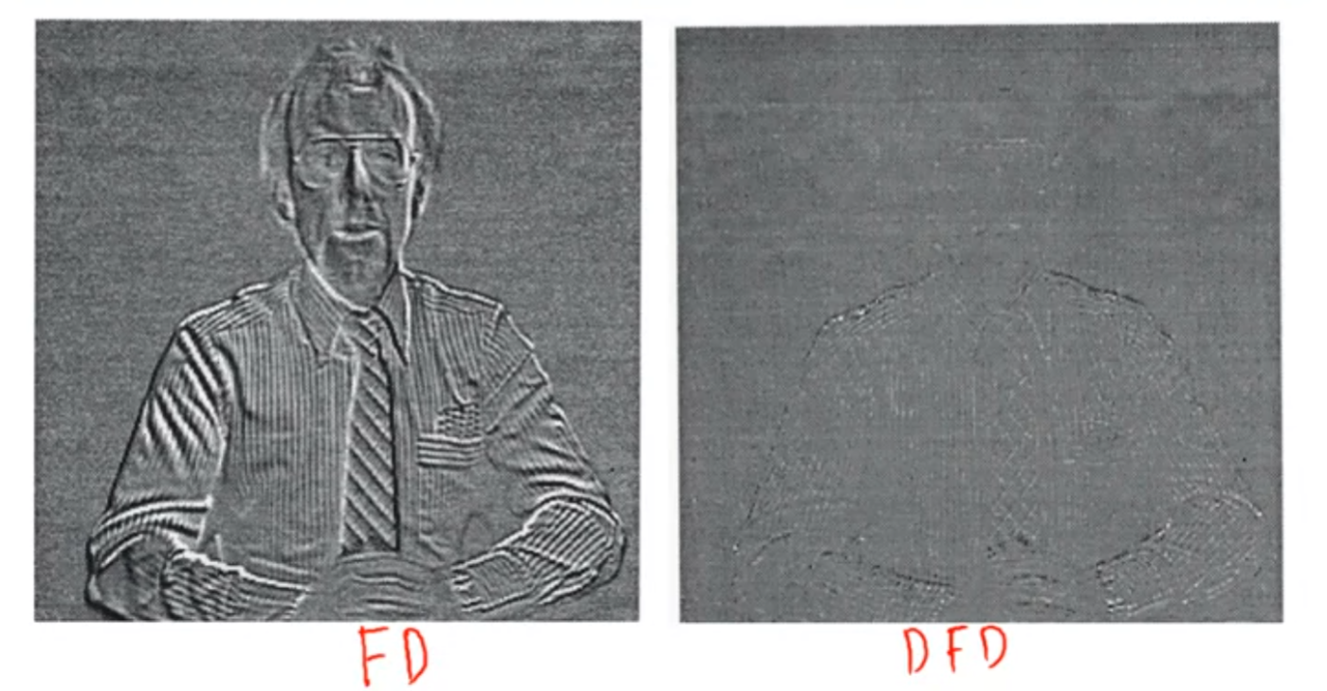

## Color Image Processing

importance of color:

color is a powerful descriptor that can be used for various tasks, e.g. segmentation, object detection, tracking, and identification. Human can distinguish thosands of color shades and intensities, as compared to about only two dozen shades of gray.

color specturm:

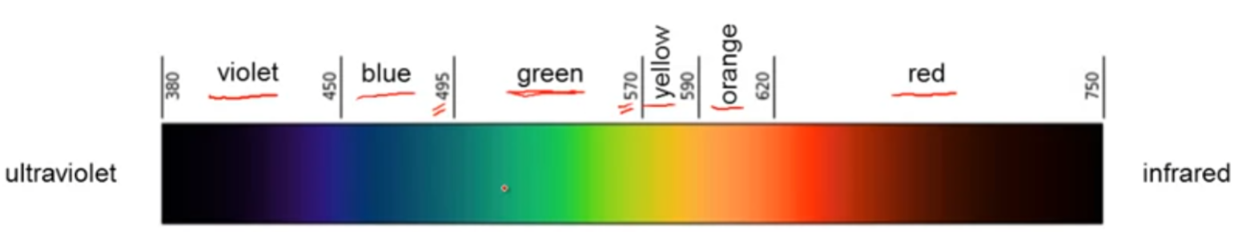

Light characterization:

achromatic light(attribute: intensity[meaning how much light])

charomatic light(attribute: radiance, luminance, brightness)

Light absorption by the human eye:

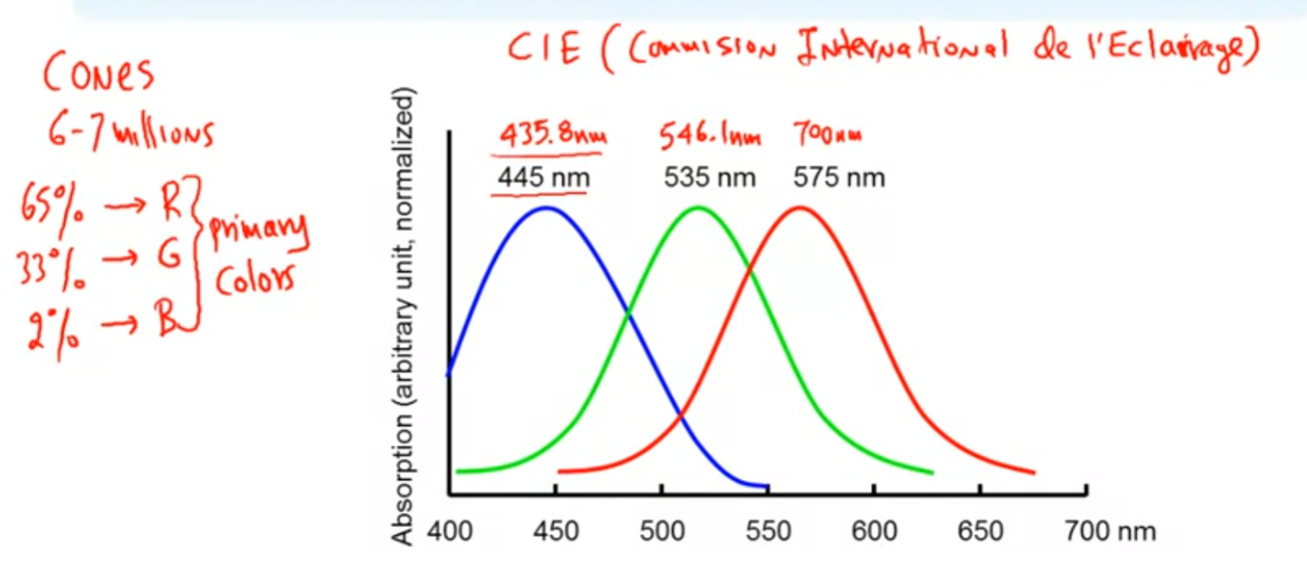

primary colors(RGB) and secondary colors(CMY):

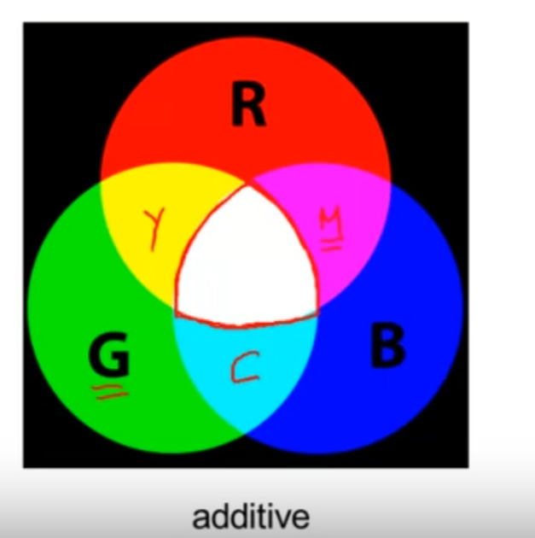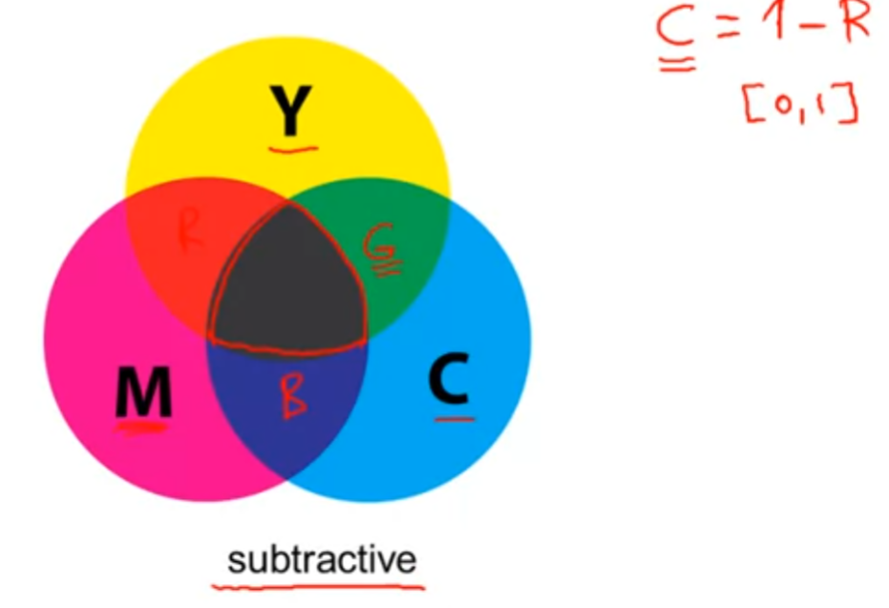

center color: white center color: black

Trichromatic coefficients:

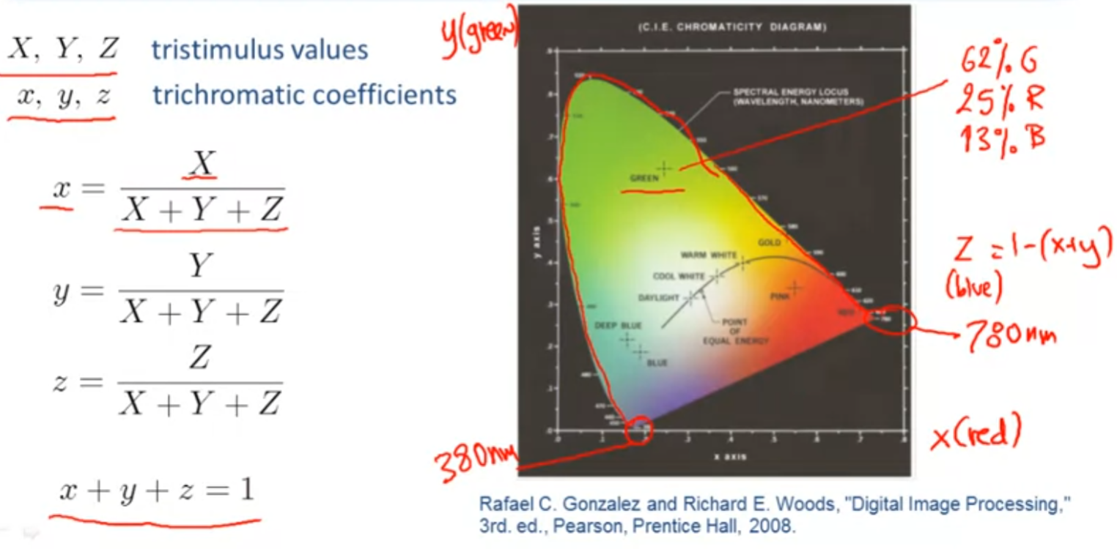

Color models:

They specify a coordinate system and a subspace within that system where each color is represented by a single point: RGB, CMY and CMYK, HSI, YUV/YCbCr

RGB:

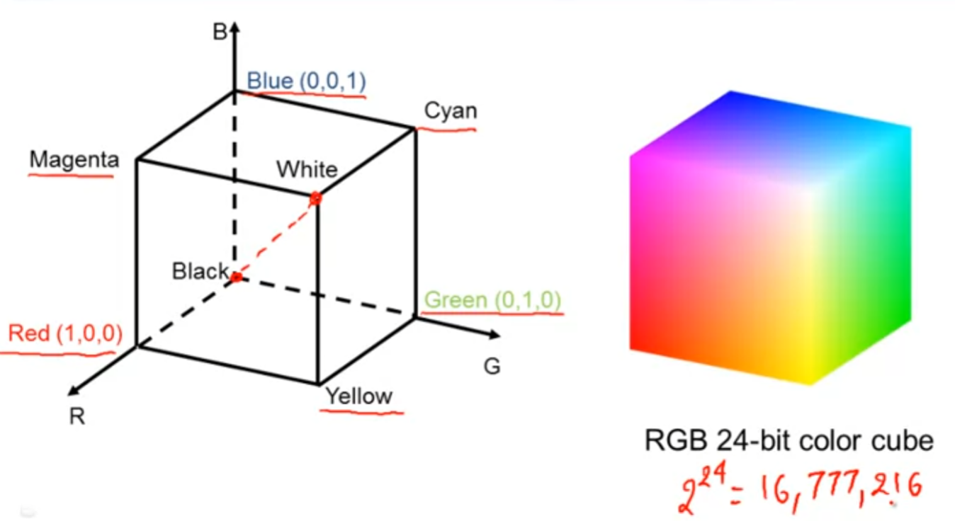

in RGB system, (0.5, 0.5, 0.5) is the mid point between black and white which is gray

CMY and CMYK:

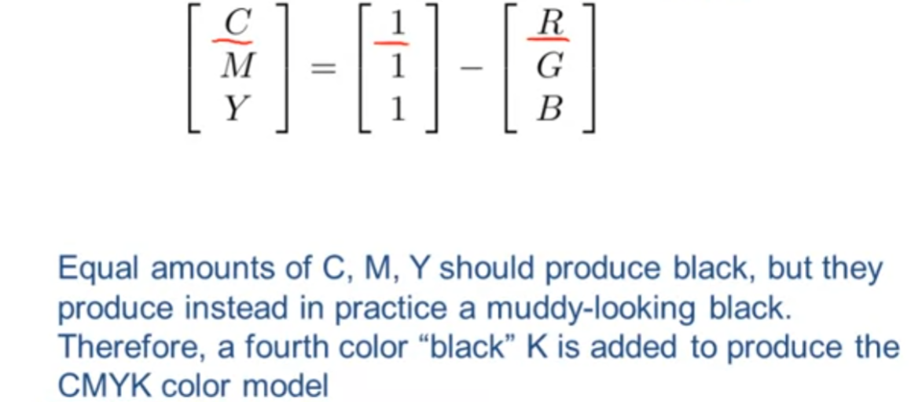

HSI:

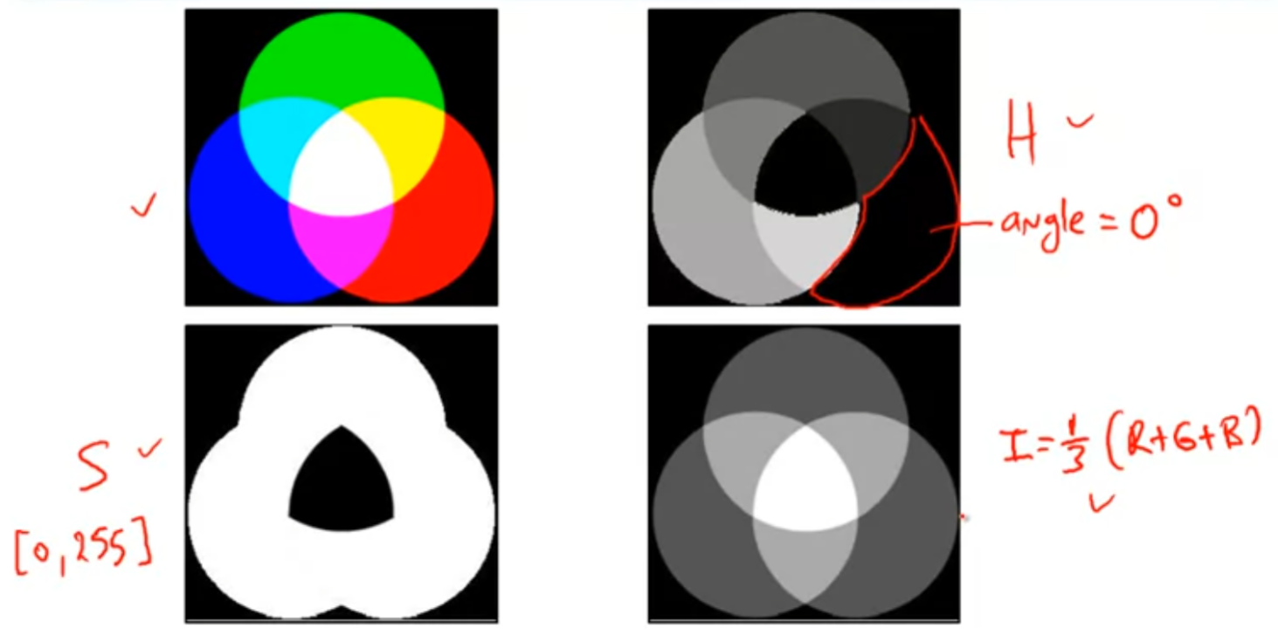

YUV/YCbCr:

YUV is used by the PAL, NTSC, and SECAM composite color video standards

YIQ is derived from the YUV color space

YCbCr is a scaled and offset version of YUV

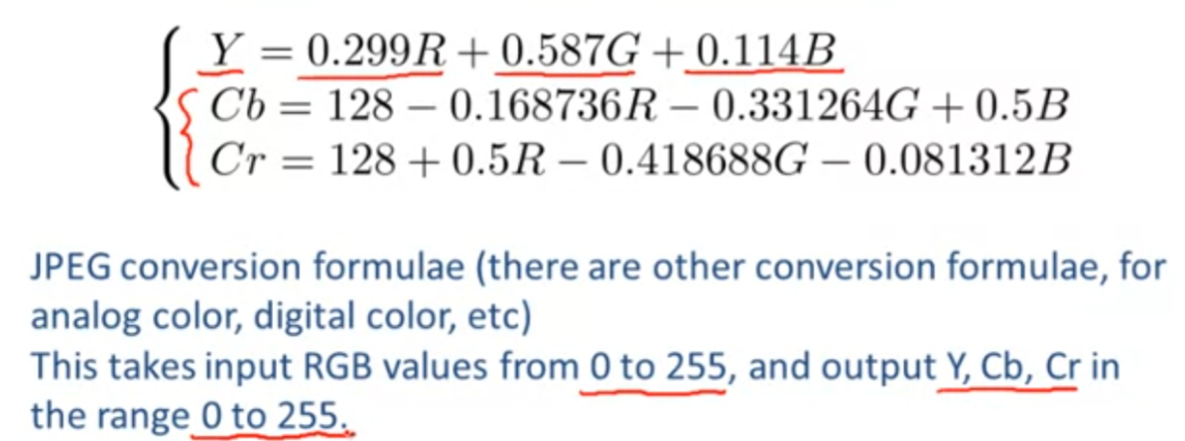

example of color spaces:

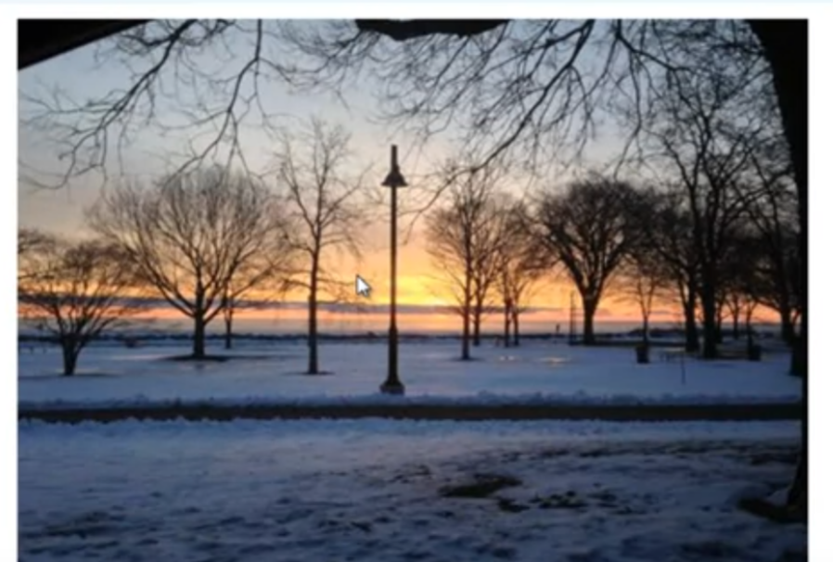

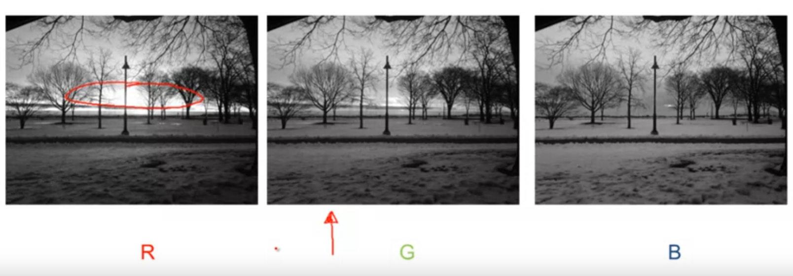

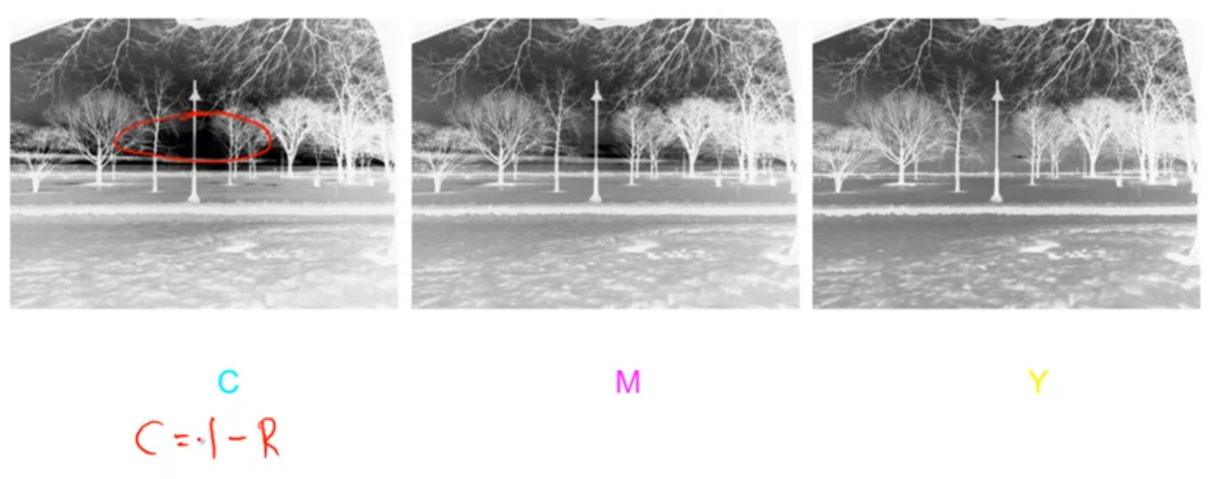

Step of color image/video processing:

1. choice of appropriate color space
2. independent channel processing
3. multi-channel processing

## Week4 Homework

1.

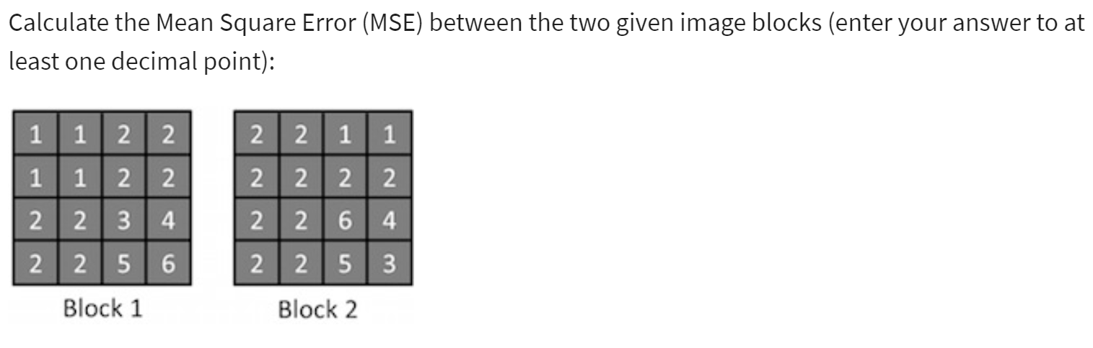

mse = 1/(N1*N2) * sum(sum((block1 - block2)^2))

2. Mean Absolute Error(MAE) = 1/(N1*N2) * sum(sum(abs(block1-block2)))

3. 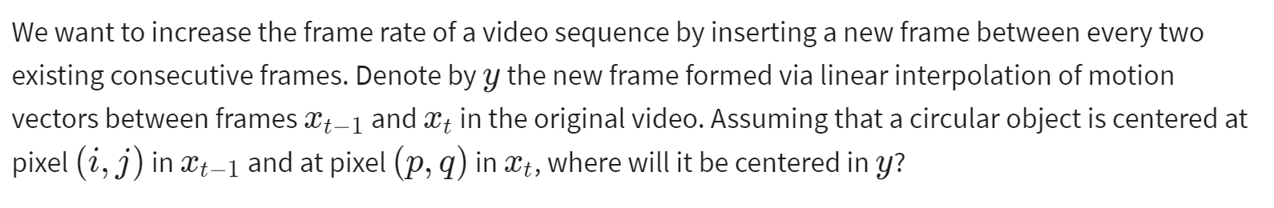

centered coordinate in y = ((p+i)/2, (q+j)/2)

## Enhancement vs Recovery

enhancement: the manipulation or transformation of an image, with the aim of increasing its usefulness or visual appearnce.

recovery: the modeling of a degradation the image is subjected to(which resulted in loss of information), and the removal of this degradation (or recovery of the information lost), based on an optimality criterion.

example:

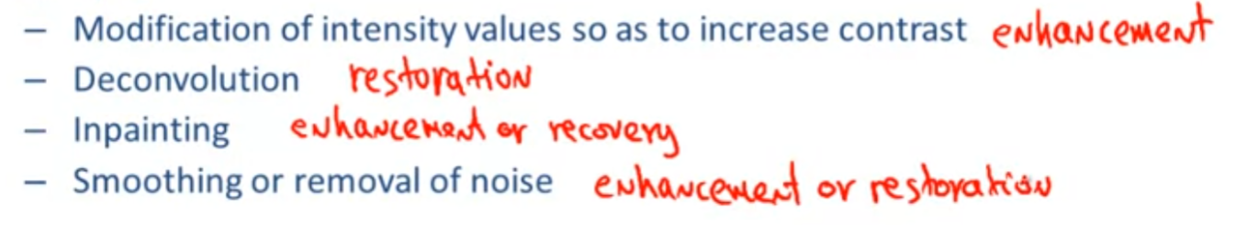

Image Enhancement:

Image enhancement are often subjective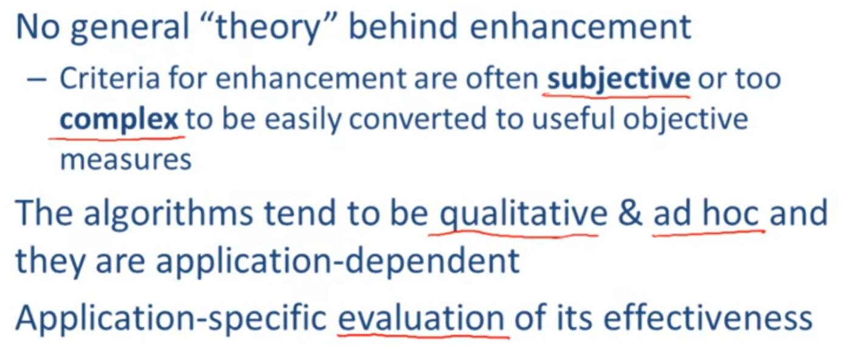

some of enhancement topics:

point-wise intensity transformations: log, power-law, piecewise linear

histogram processing

spatial filtering(LSI vs non-linear): smoothing, sharpening, homomorphic filtering

pseudo-coloring

video enhancement

## Point-wise Intensity Transformations

expressed by:

y(n1,n2) = Tpint[x(n1,n2)]

when y and x are vector, then y(n1,n2) = Tpint[x(n1,n2)]

when n is vector, then y(n) = Tpint[x(n)]

those point-wise transformations can be linear or piecewise linear or non-linear!

Intensity transformation:

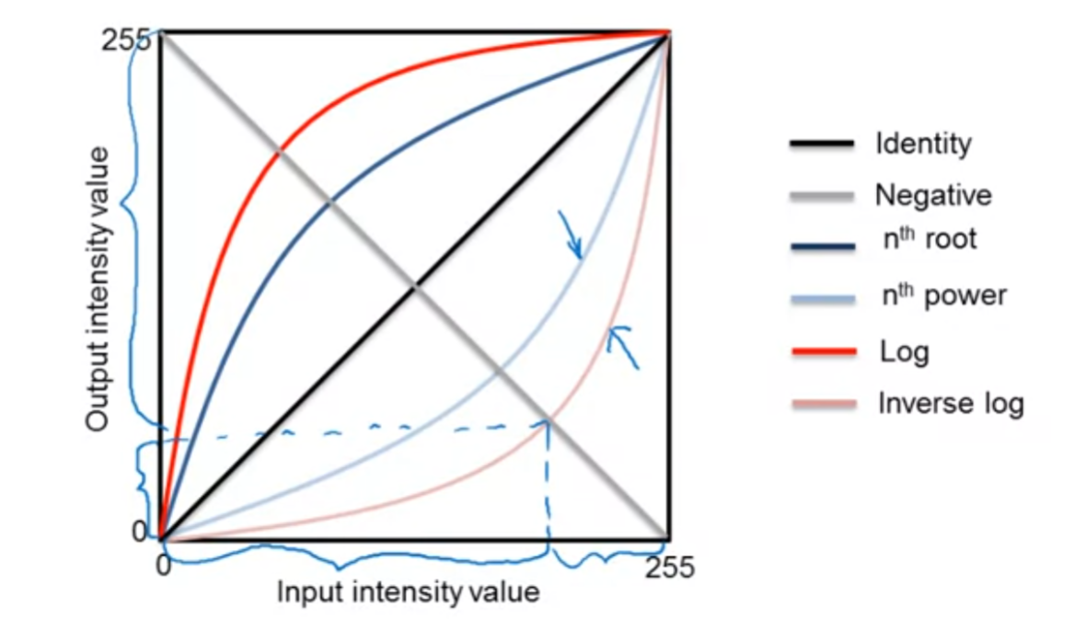

Negative transformation of image:

y(n) = -x(n)

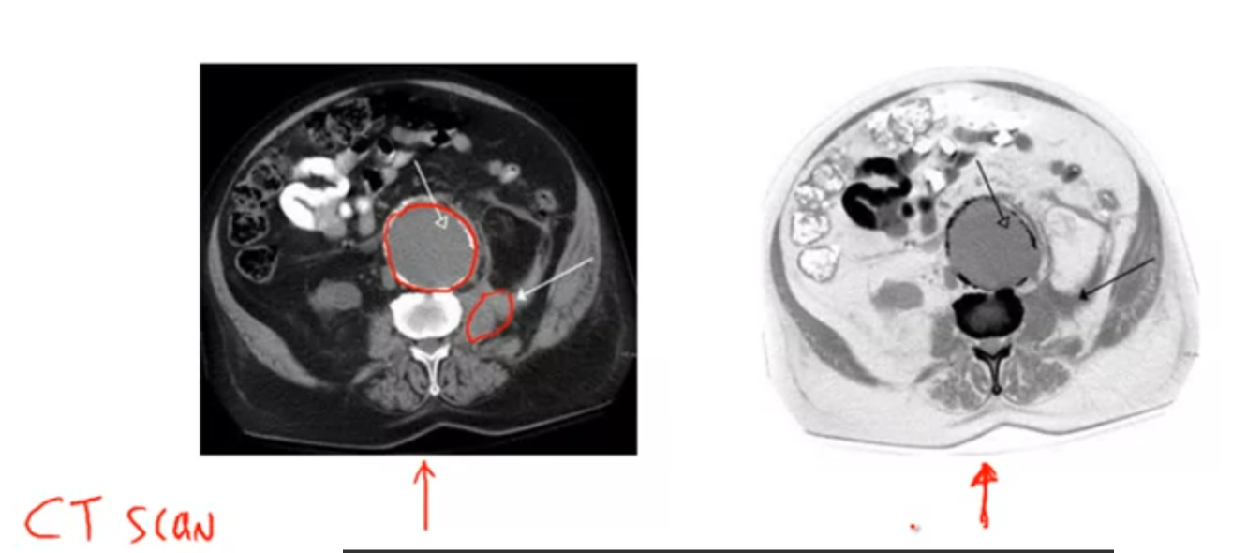

left is original, right is negative. In this case the negative one provides a better visualization of the condition of the red circles.

Log transformation:

y(n) = c * log(x(n) + 1)

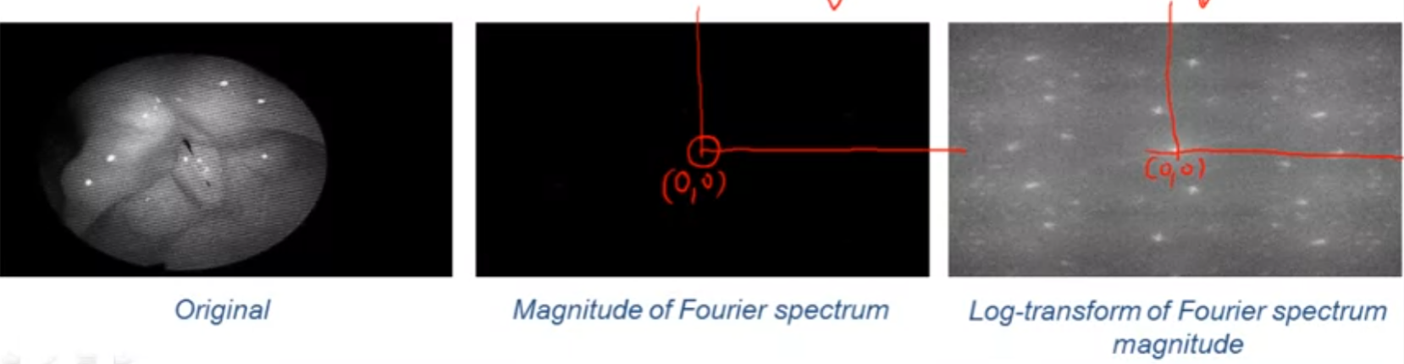

Power-law transformation:

output = c * input^gamma

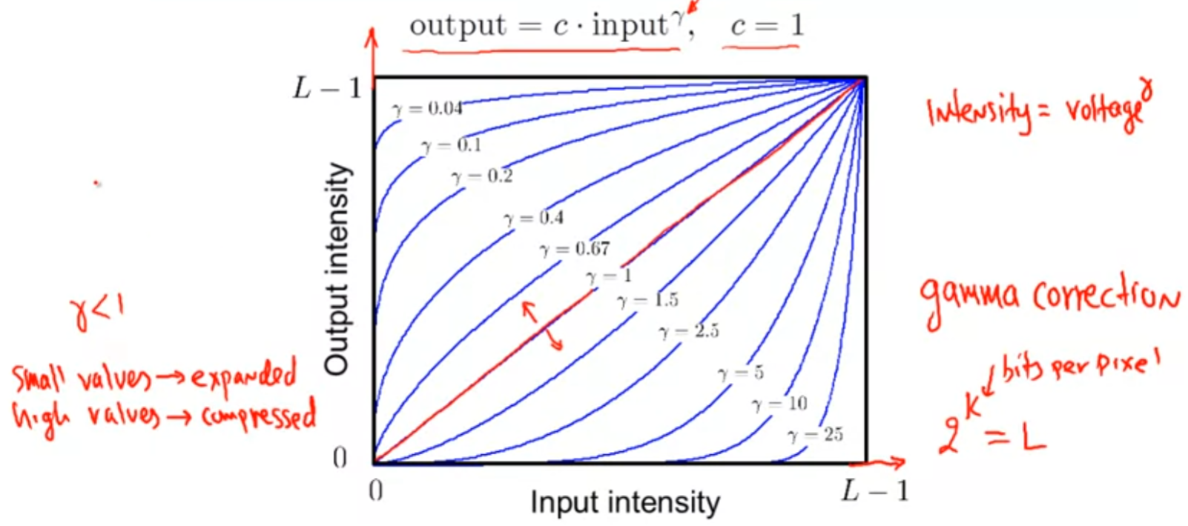

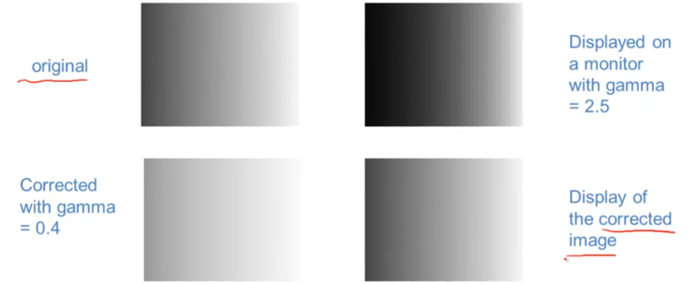

the challenge is to find the gamma that fits the monitor.

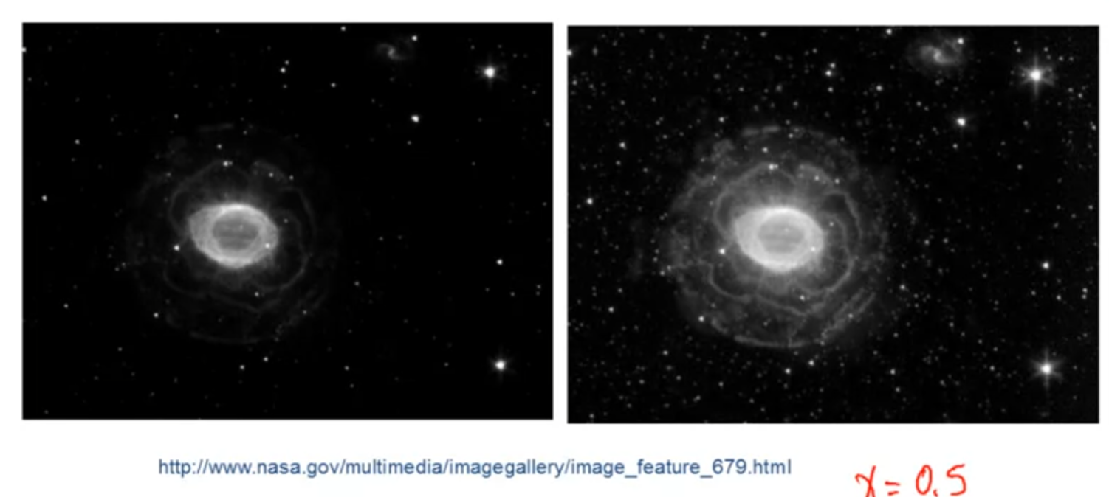

right one (power-law) clearly provides better visualization than original.

Contrast Stretching:

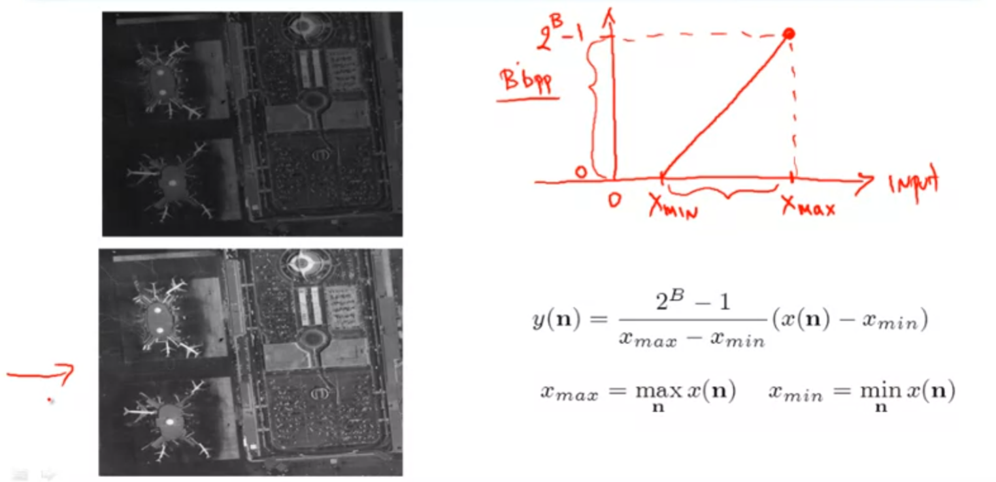

there is considerably more information that can be observed in the processed image.

Dynamic Range expansion:

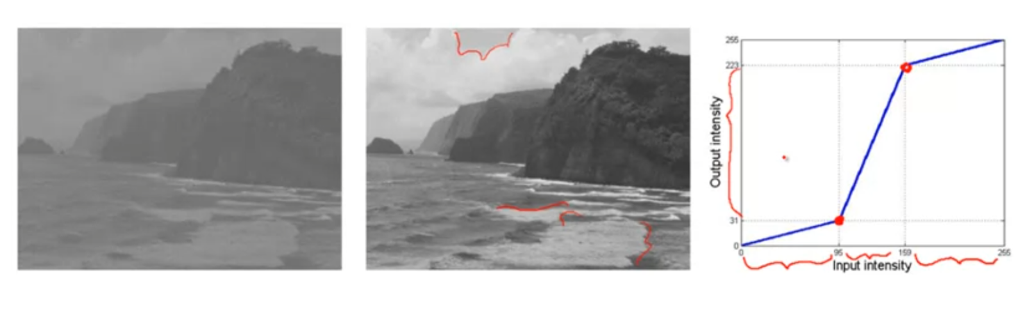

Intensity-level slicing:

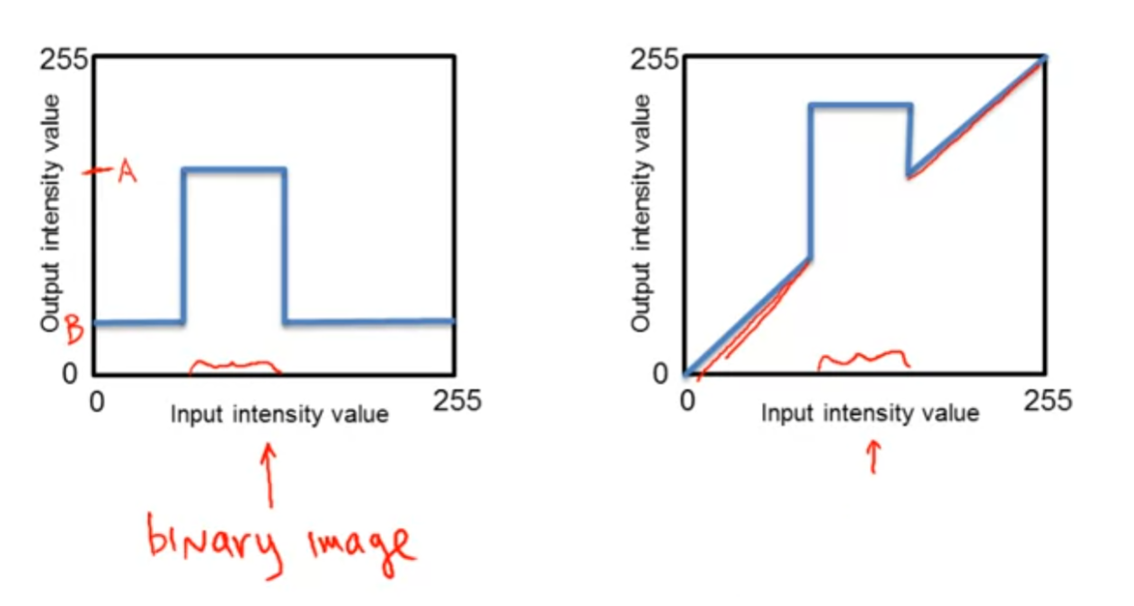

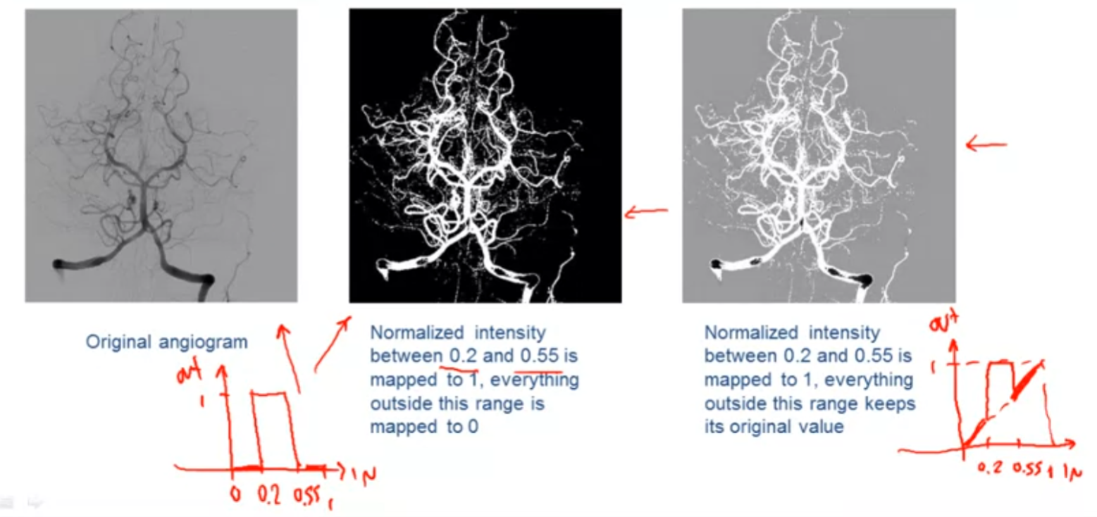

Bit-plane slicing:

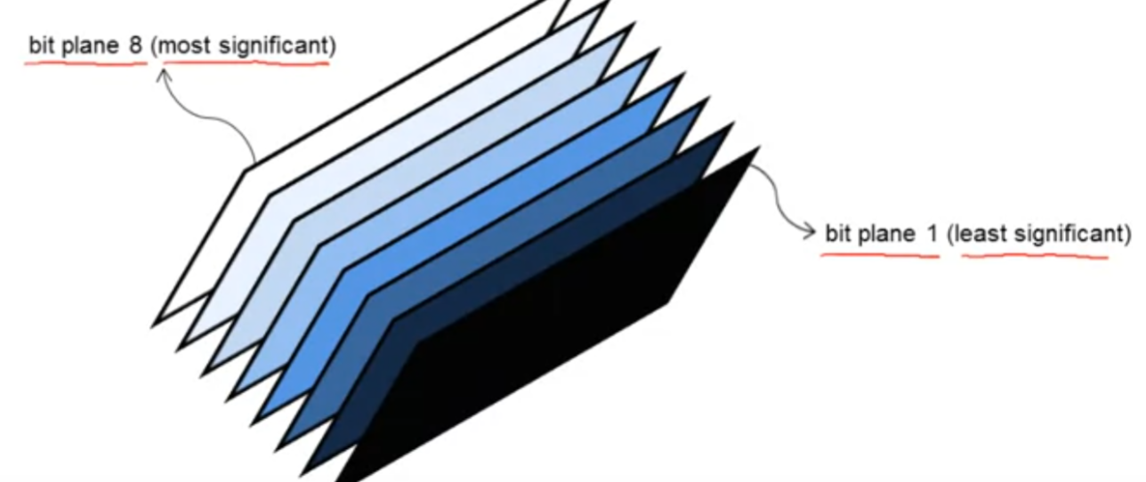

## Histogram Processing

Image Histogram:

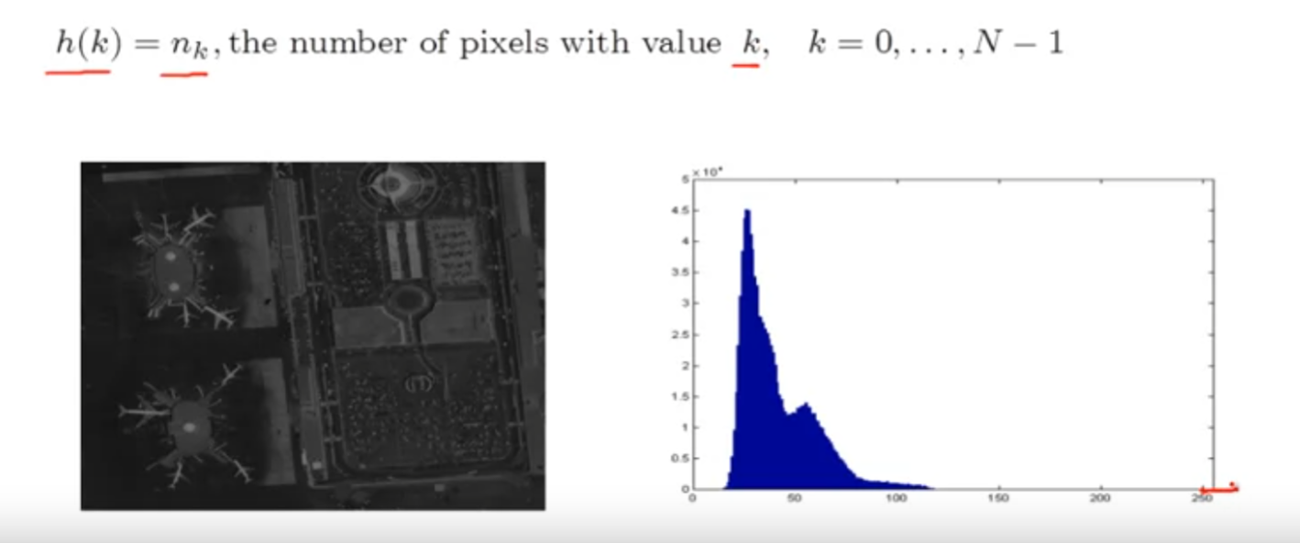

given a image we can count its value of all pixels, such data can be collect and summary and called histogram.

contrast stretching and histogram processing:

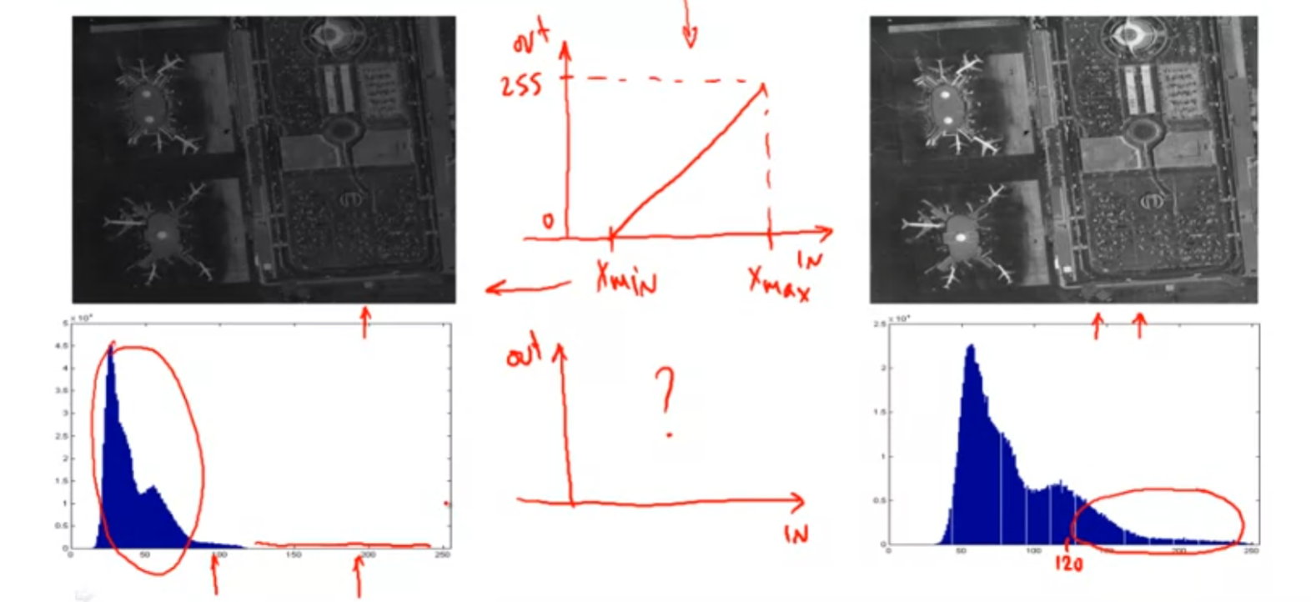

different between histogram processing and point-wise intensity transformation: histogram processing to processing the image through the evaluation of its histogram, not change the image by looking directly at the image itself like the point-wise intensity transformation.

Histogram equlization:

Objective: obtain a flat histogram, make image look neither too dark nor too bright

Step:

1. normalized histogram: px(i) = p(x = i) = ni/MN, 0<= i <= L-1 sum(i=0 to L-1) px(i) = 1
2. procedure: Px(i) = sum(j=0 to i) px(j), y~(n) = Px(x(n)), y(n) = (L-1) * y~(n)

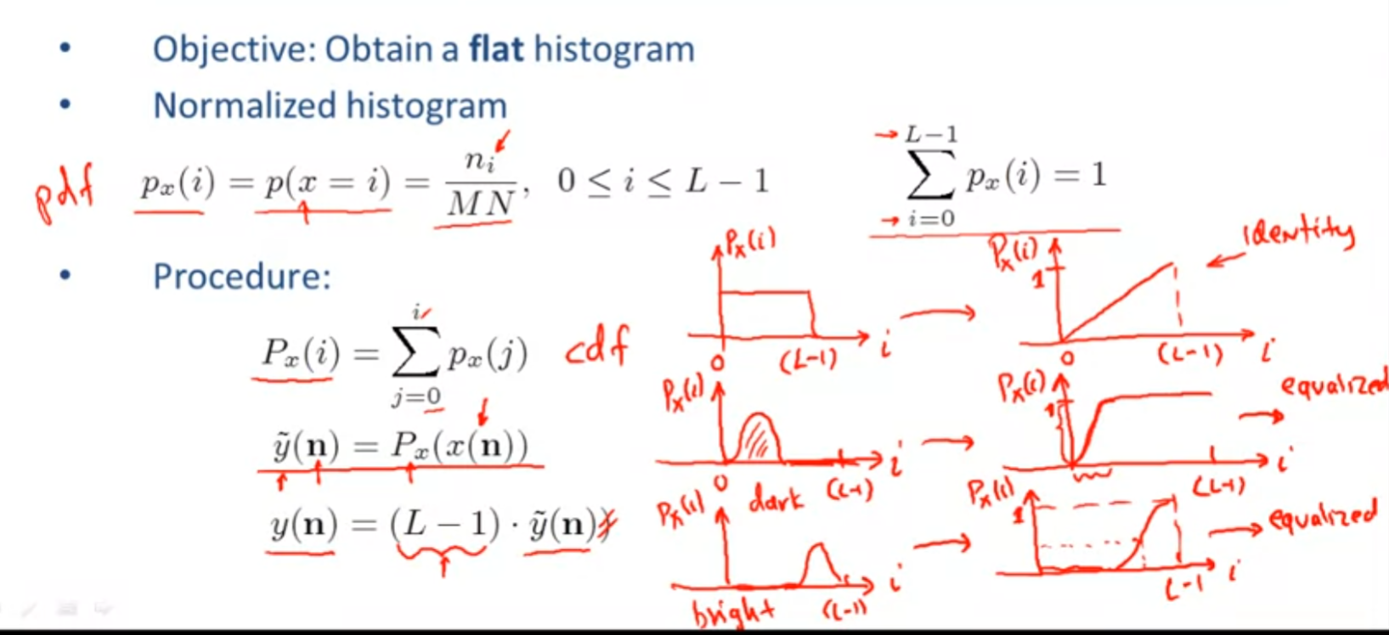

Contrast stretching vs Histogram equalization:

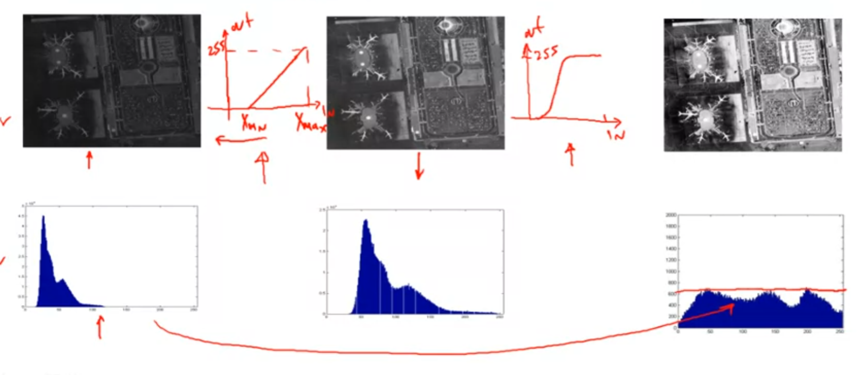

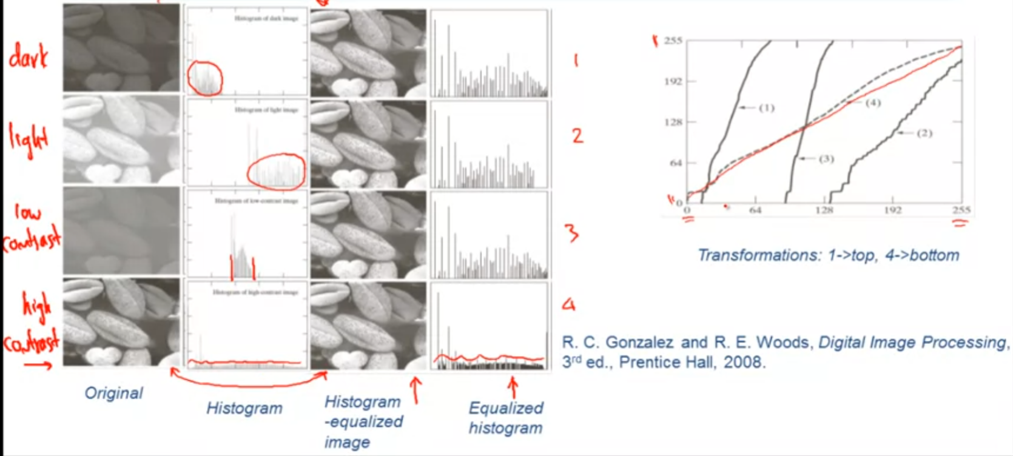

above is the example of histogram equalization.

Local Histogram Equalization:

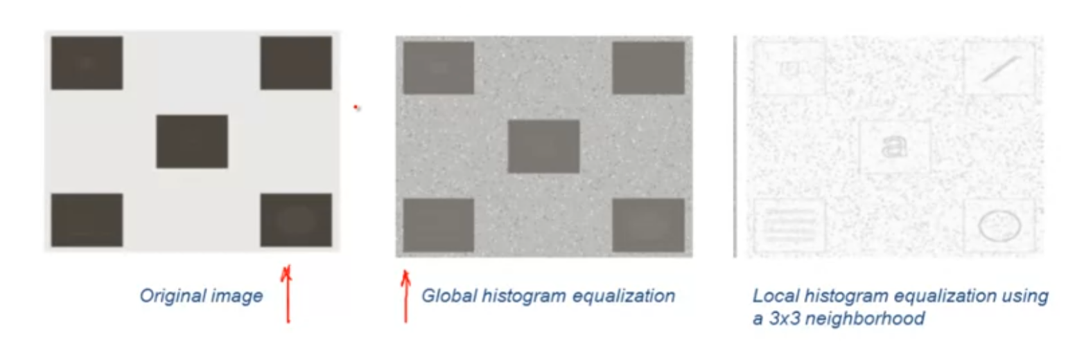

in this example the image applied with local histogram equalization process (right one) is obviously provides more visualization than the global histogram equalization(mid one).

## Spatial filtering(Linear Noise Smoothing)

Smoothing spatial filters

Objective: enhace image by reducing noise (additive broadband, salt and peper noise) that may be present.

LSI Systems: y(n1,n2) = x(n1,n2) + omega(n1,n2), we want to use the LSI system to filter the noise.

!At this point, we are approaching the noise smoothing problem as an enhencement problem!

Noise Smoothing in the Frequency Domain:

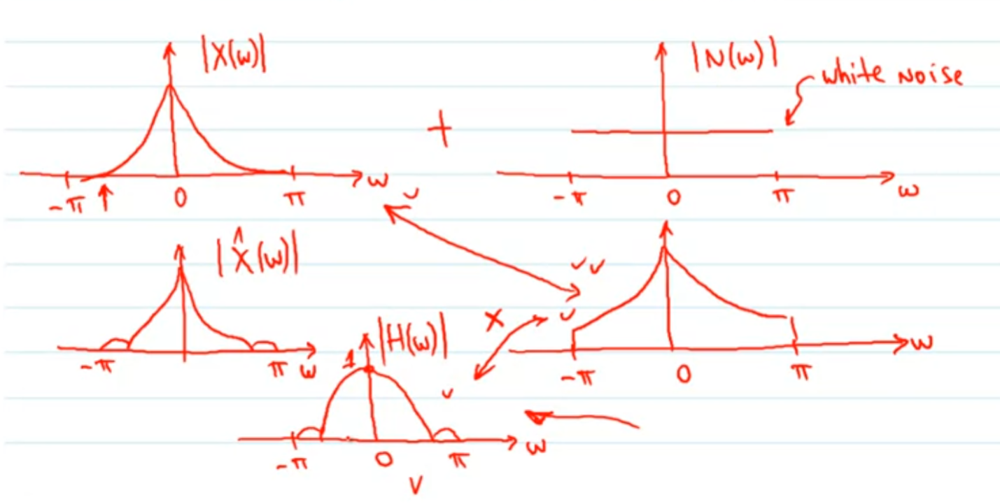

the objective of the smoothing process is to operate on the image+noise (image (2,2)) and obtain an estimate of the original image (image(1,1), the one without noise), the filter helps to do so is considered as a low-pass filter.

example:

Original image

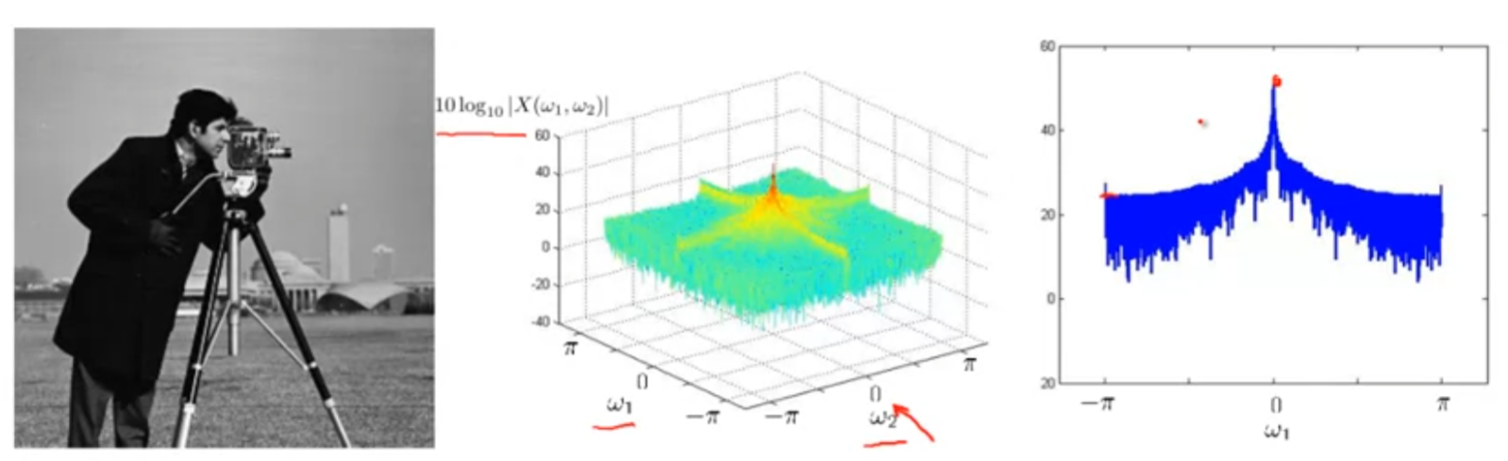

Noisy image

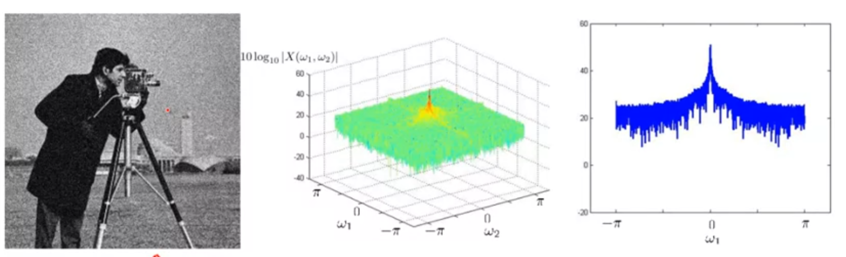

Flat filters:

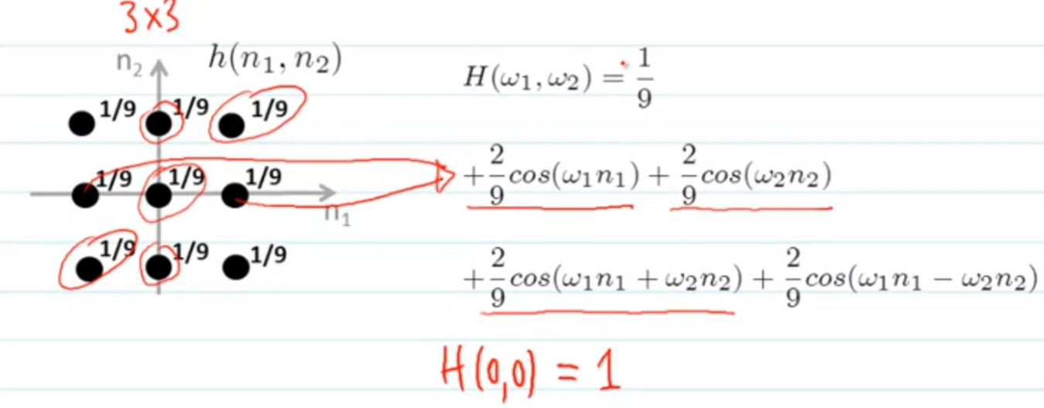

Flat filters in frequency domain:

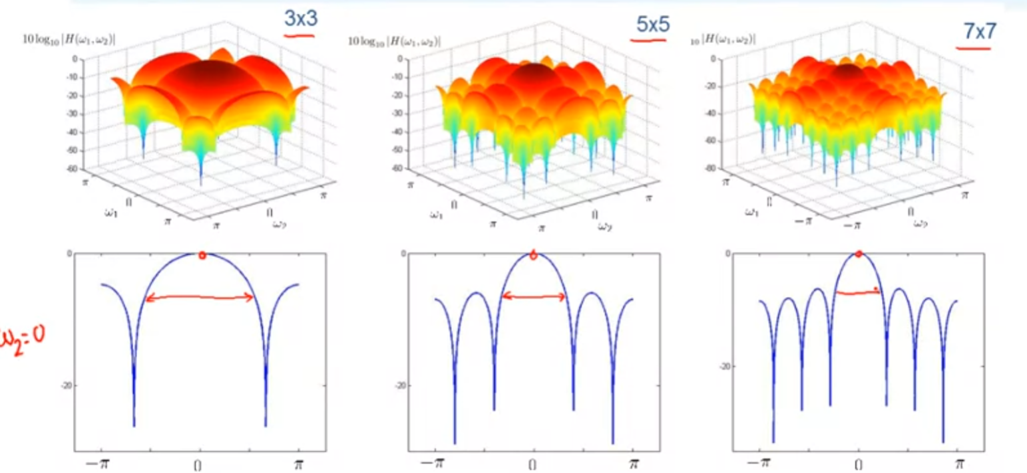

Noise image filtered with 3x3 filter:

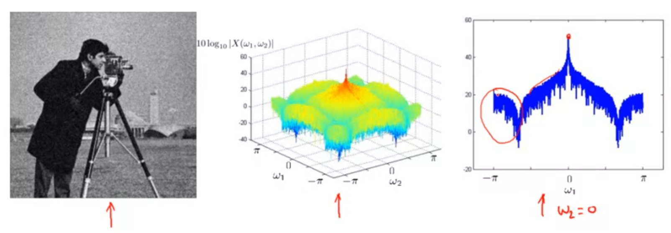

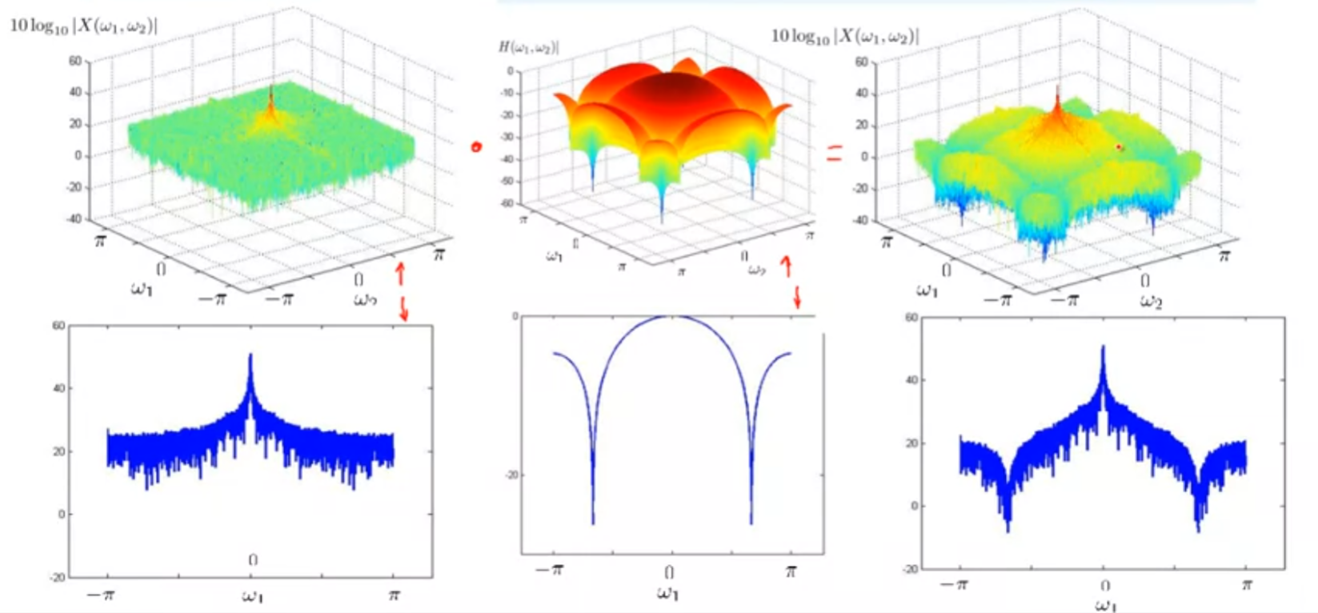

Noise image filtered with 5x5 filter:

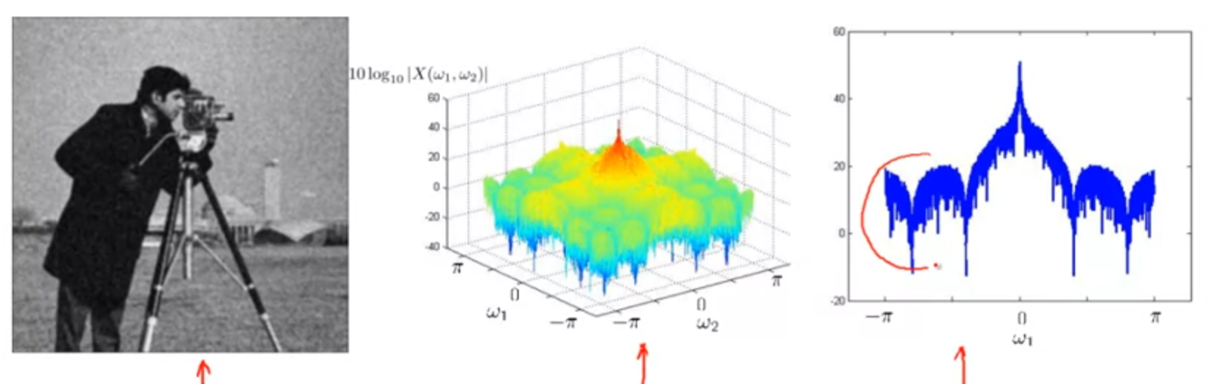

Noise image filtered with 7x7 filter:

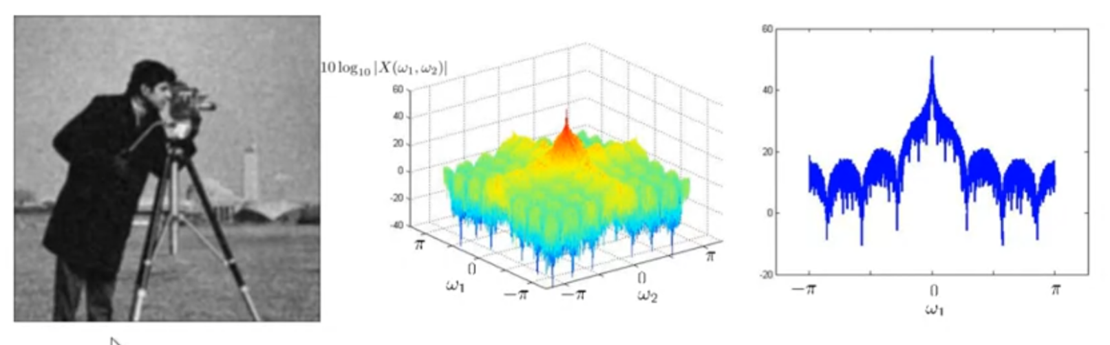

with more and more large filter, the result image looks rather blurry.

All images comparsion:

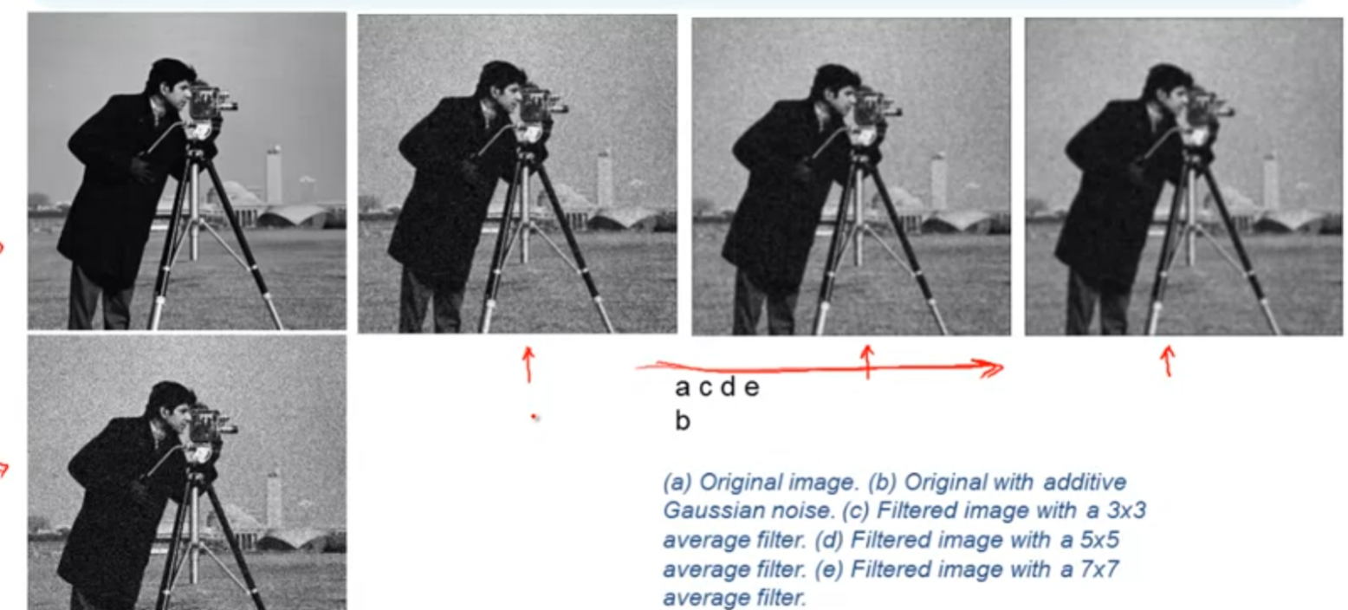

original, 3x3, 5x5, 7x7, noise. In this case, the 5x5 is the best choice since 3x3 makes not too much different than the noise image, and 7x7 looks too blurry.

Spatially adaptive noise smoothing:

Spatially adaptive filter: the filter removes noise in the flat regions while it let high frequency informaiton, edge pixel go unchange from the input to the output.

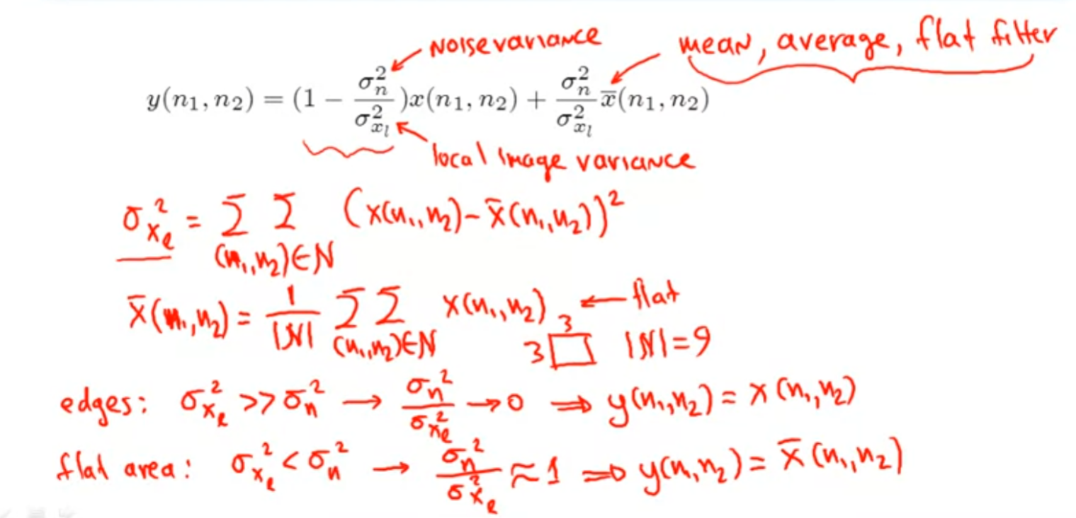

example:

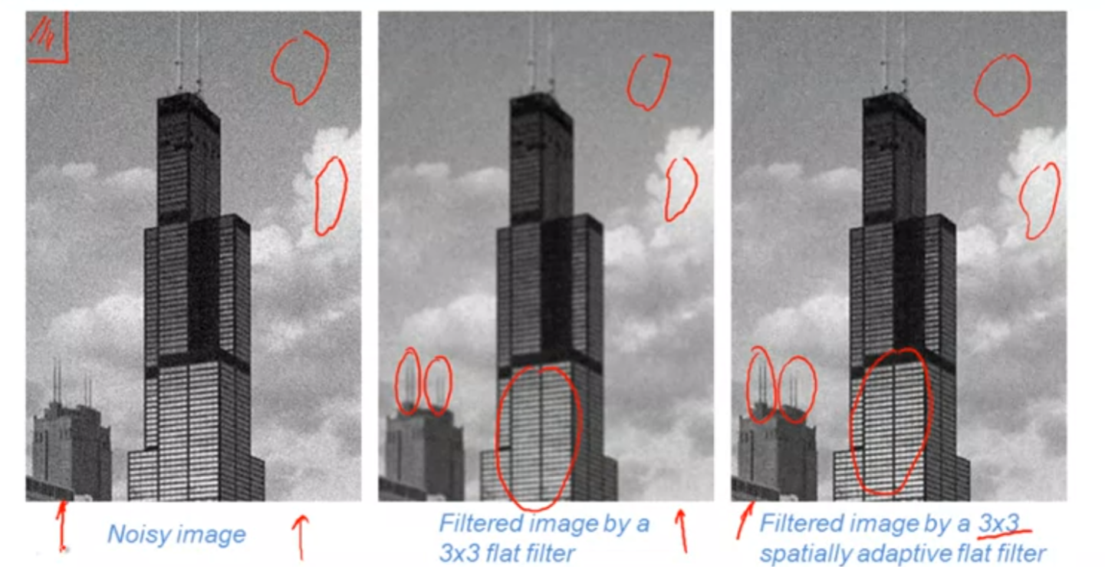

we can tell the image with 3x3 flat filter got blurry on the windows and cloud, but the image with 3x3 adaptive flat filter has no such problem, since the windows and cloud part are considered as edge pixels so they go unchanged.

## Spatial filtering(Non-linear noise smoothing)

Median Filtering: y(n1,n2) = median{x(n1-m1, n2-m2), (m1,m2) belongs N}, the median filter is non-linear, it is good for reducing the salt and pepper noise.

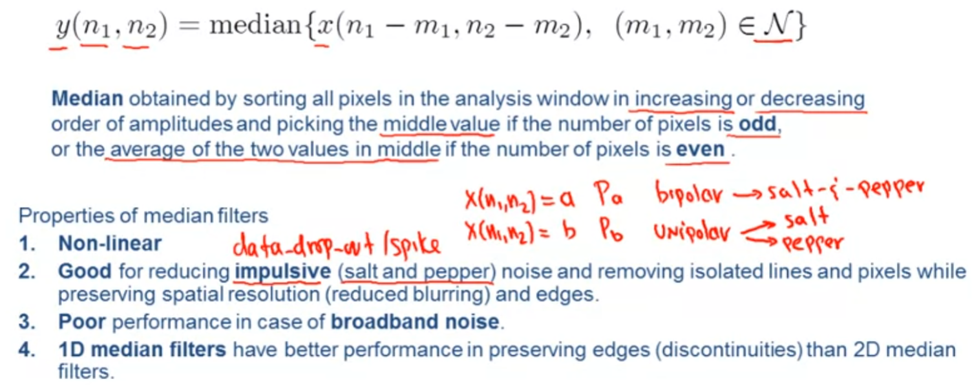

3-point median filter:

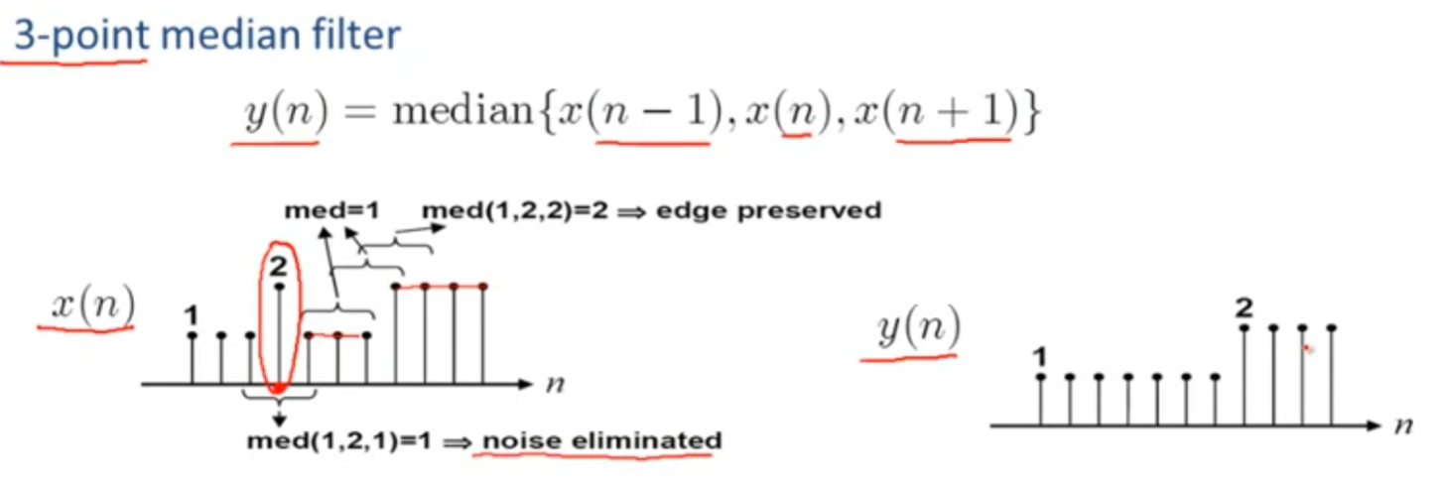

2D 3x3 median filter (filter image with vertical 1D median, filter result horizontal 1D median):

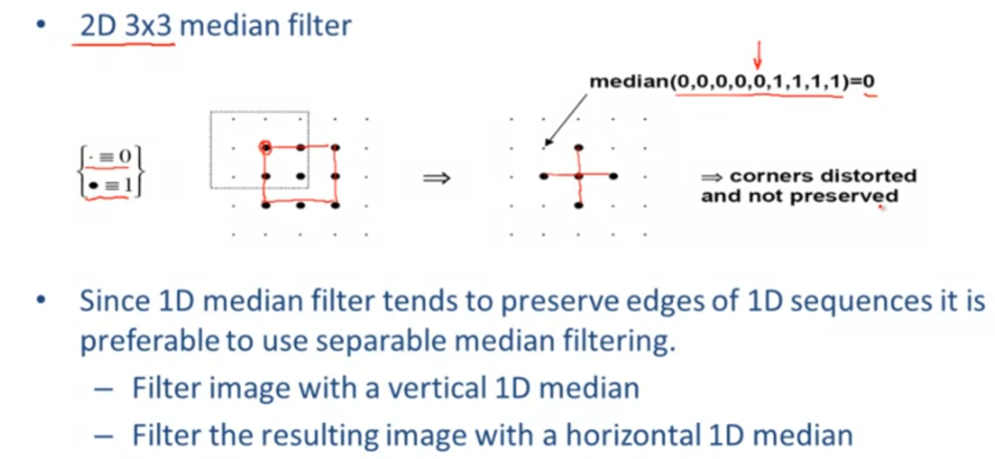

median filter example:

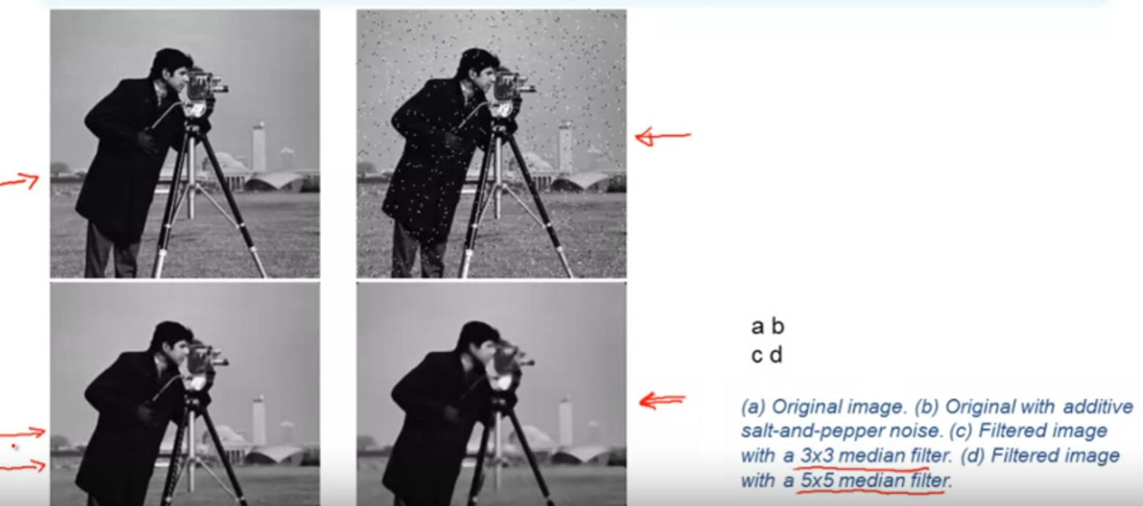

Order statistic filters:

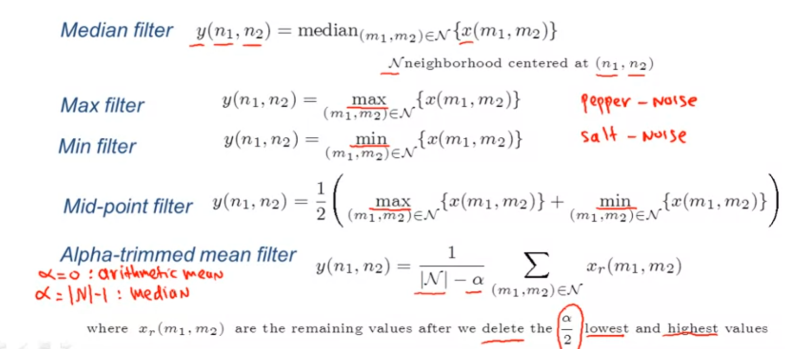

max filter are good for pepper-noise, min filter good for salt-noise, and for alpha-trimmed mean filter, for alpha=0 it become arithmetic mean filter, for alpha=|N|-1, it becomes median filter.

Mean filters:

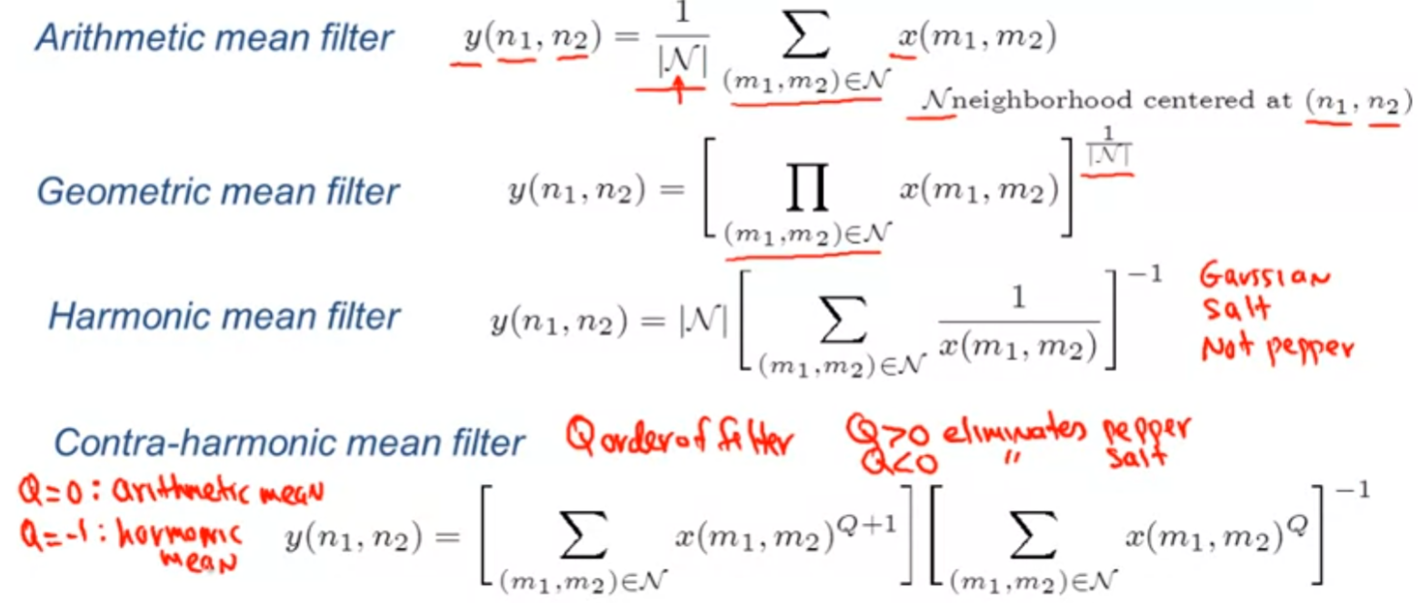

mean filters example:

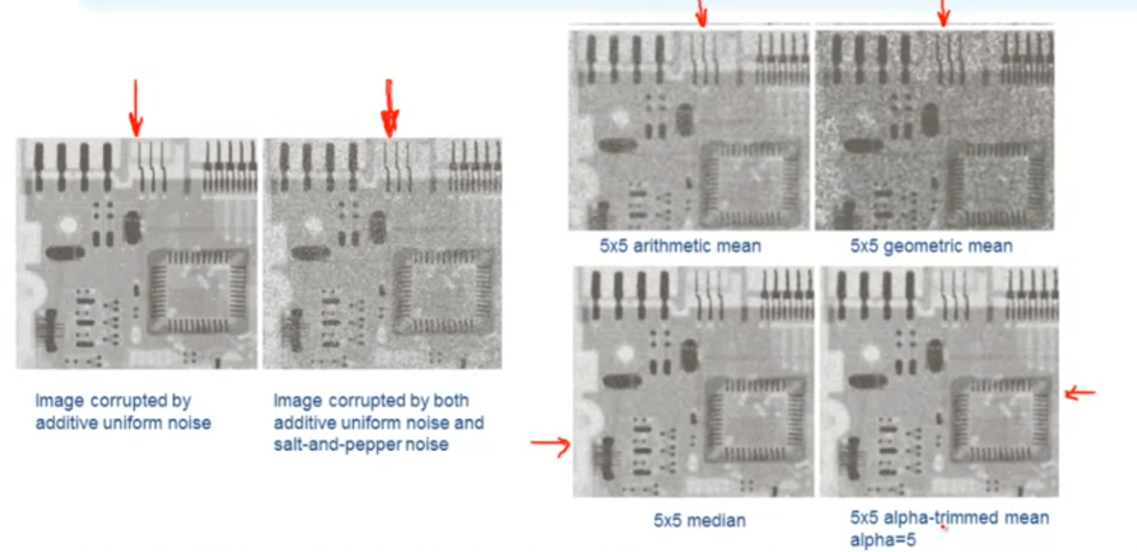

there is no guidelines says which filter with parameters is going to provide the better or best result, instead we need to try various filter, change their parameters appropriately to find the best match.

## Spatial filtering(Sharpening)

Sharpening: when things are too blurry it needs to sharpening

Unsharp masking and highboost filtering:

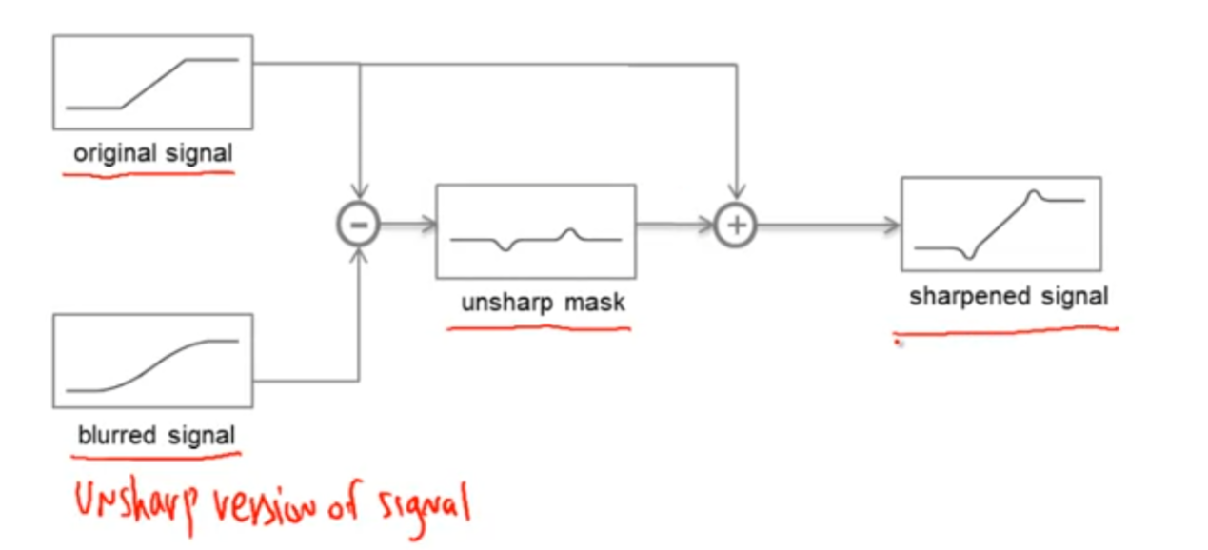

unsharp mask: y(n1,n2) = x(n1,n2) - xL(n1,n2)

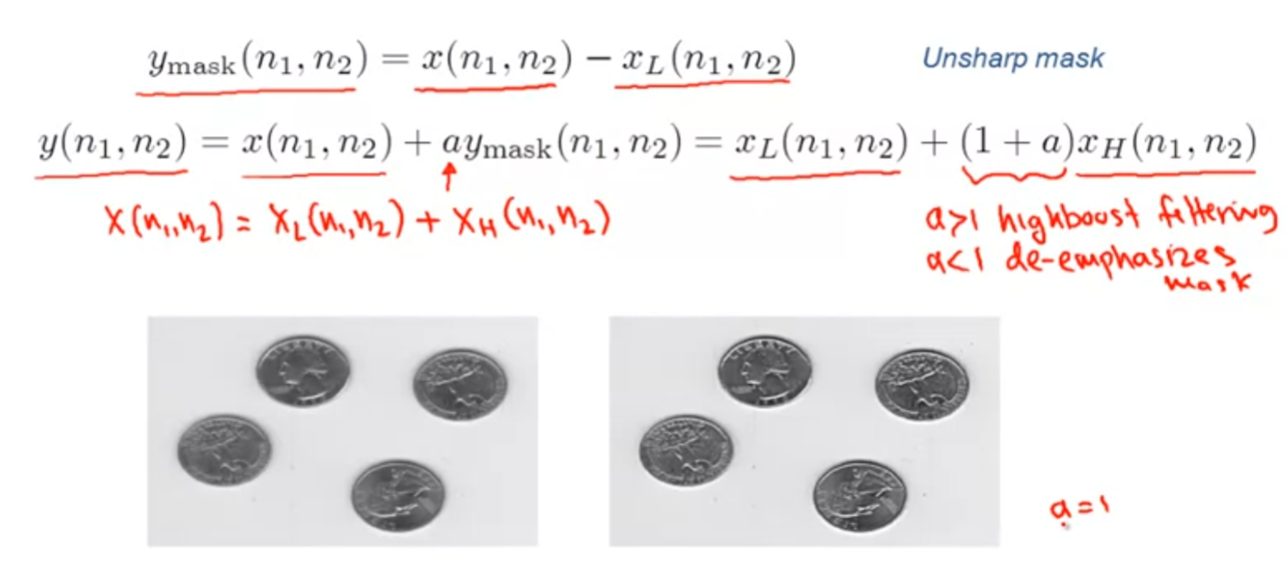

left is original image, right is result after applied the sharpening method with a=1

Sharpening spatial filters:

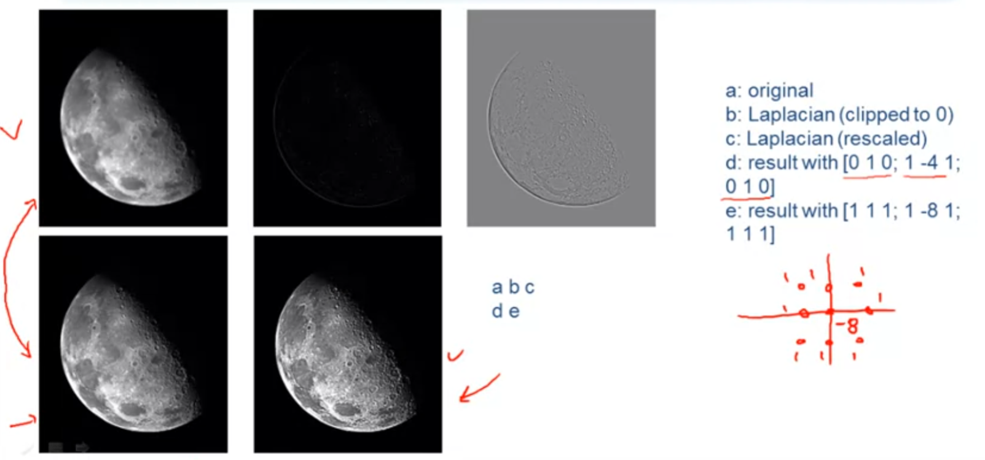

Laplacian of an image represents the high-frequency information of the image.

after sharpening the original image, the results are considerably more detailed and provide better visualization.

Combining Spatial Enhancement methods:

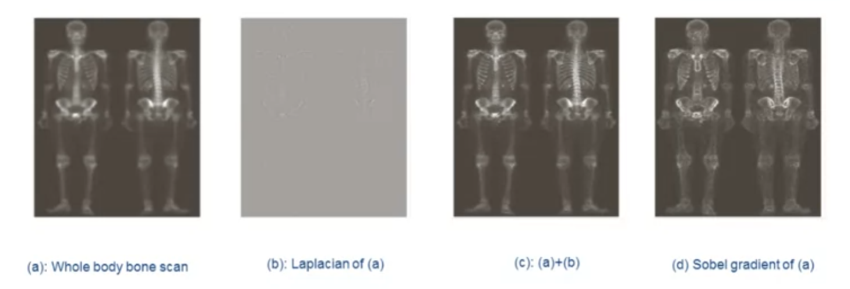

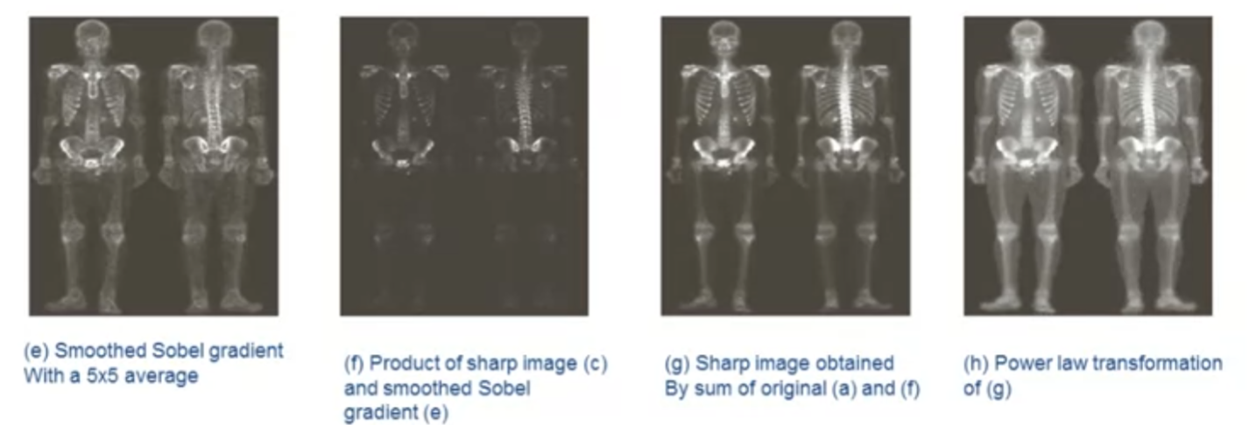

the original image looks blurry so we produced the Lapiacian of image and combined two of them, we smoothed the Sobel gradient of original image with a 5x5 filter and get the product of c and e, then sharp it, and finally applied power law transformation to it to get the result.

## Homomorhpic Filtering

motivation: image with a large dynamic range, e.g., a natural scene on a bright sunny day, recorded on a medium with a small dynamic range, results in image contrast significantly reduced especially in the dark and bright regions.

objective: reduced dynamic range & increase local contrast prior to recording it on medium with a small dynamic range.

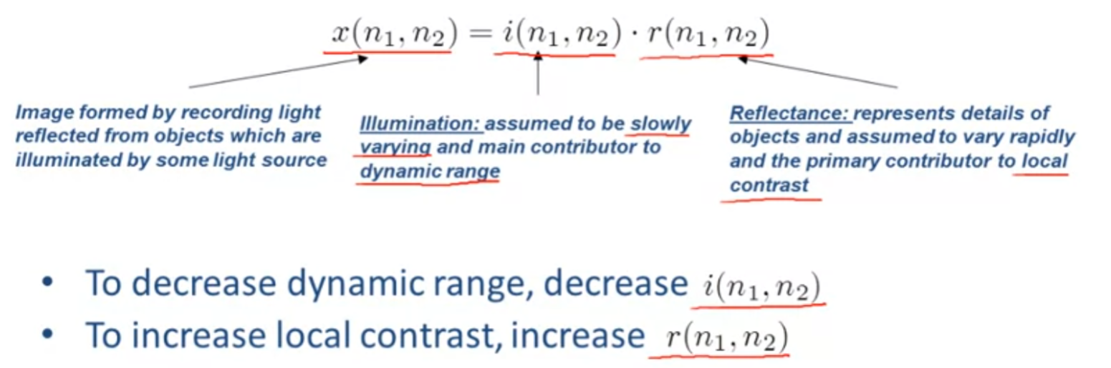

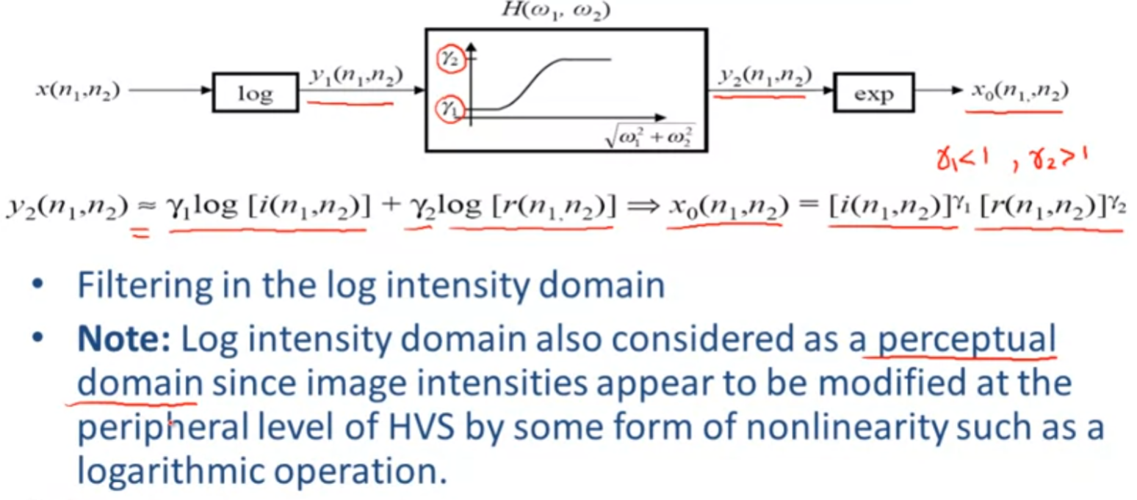

example of homomorphic processing:

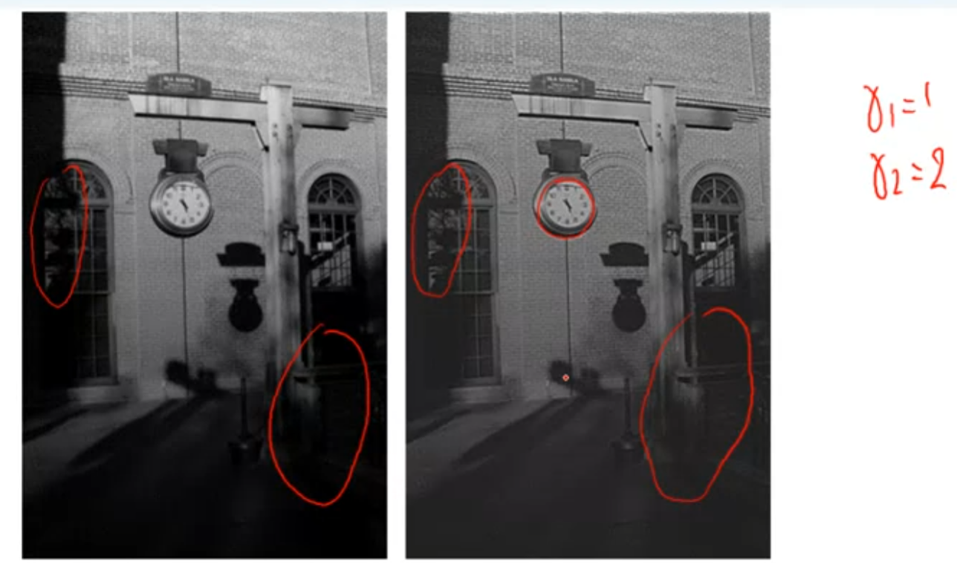

## Pseudo Coloring

Reason:

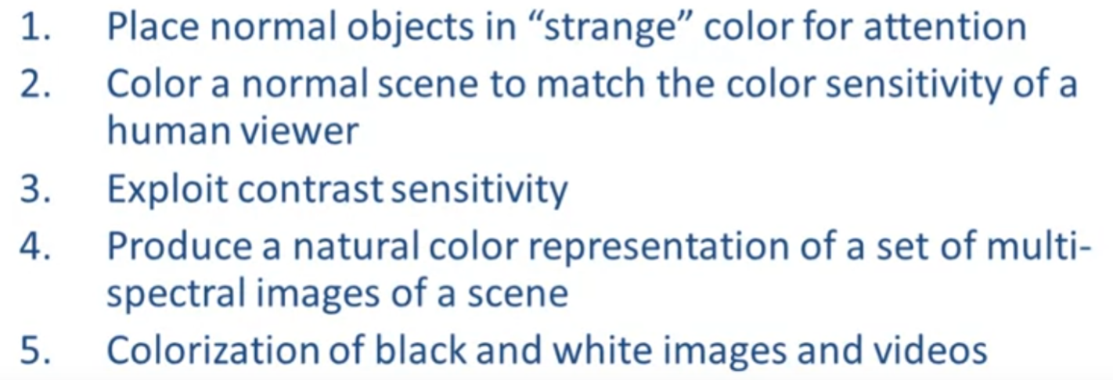

example:

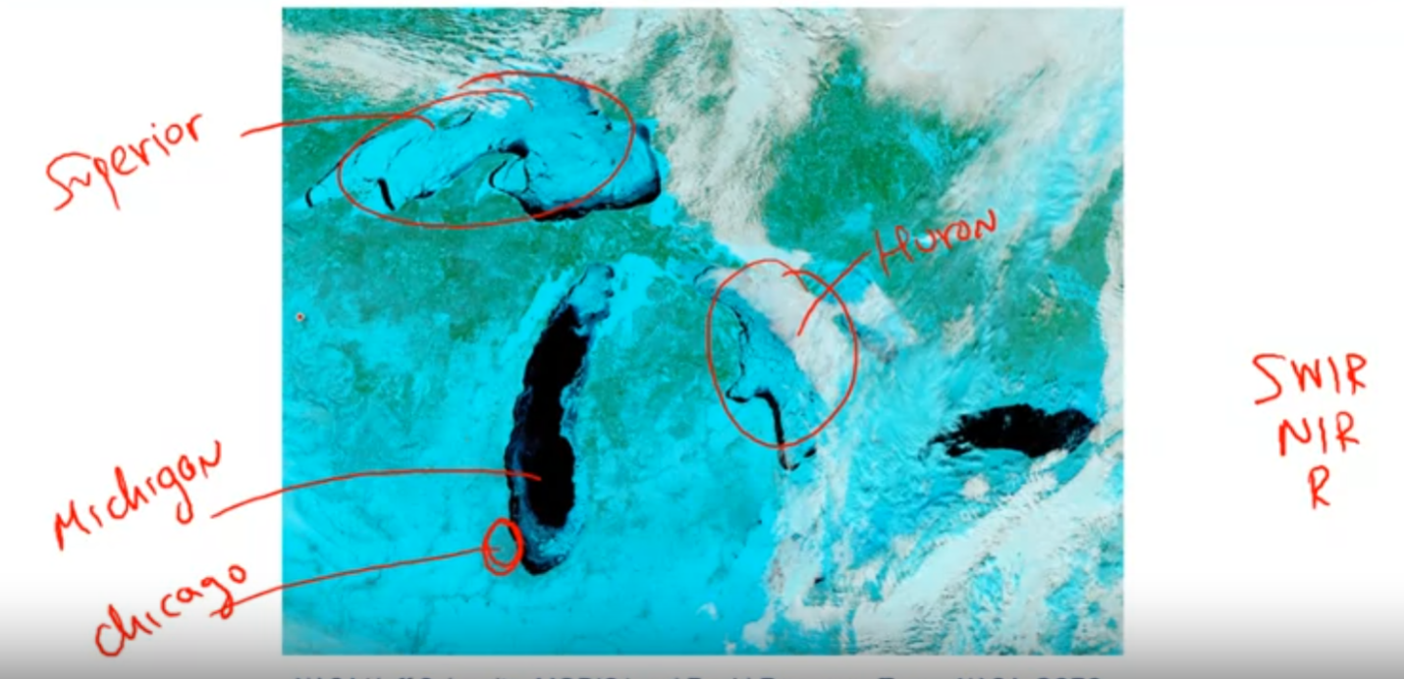

with the pseudo coloring, we are able to distinguish the ice/snow from cloud.

## Video Enhancement

Noise filtering: degradation model: g(i,j,k) = f(i,j,k) + n(i,j,k)

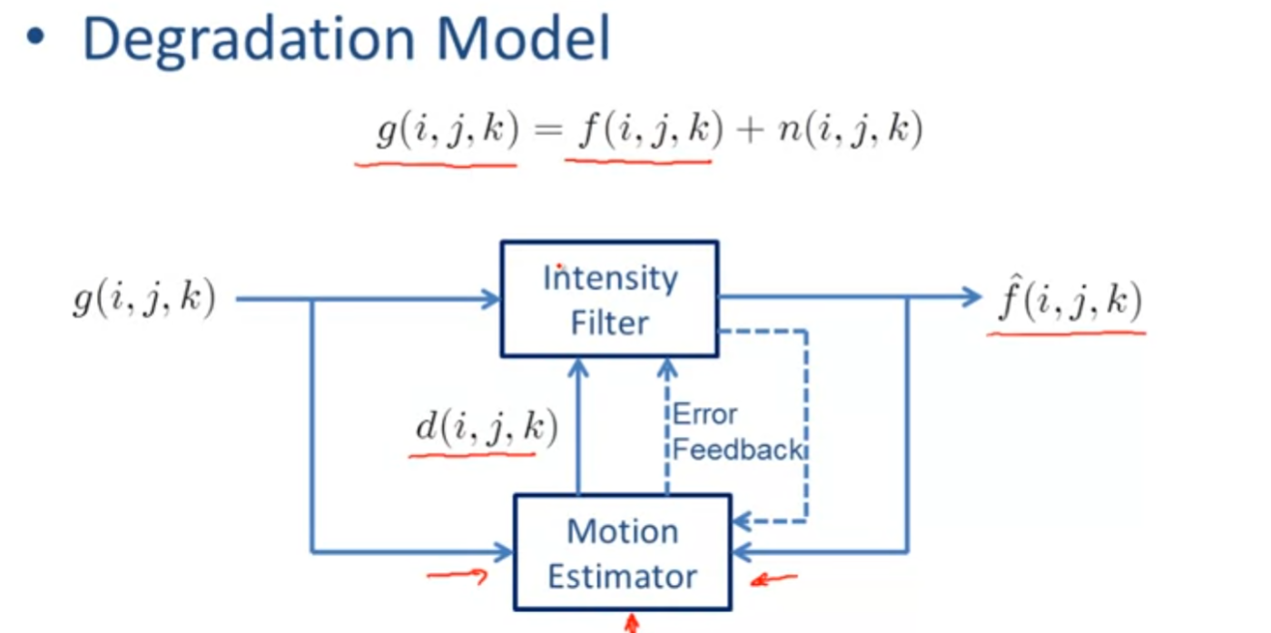

Non-MC Spatio-temporal filtering:

e.g. 3D kalman filter, order statistics based filters

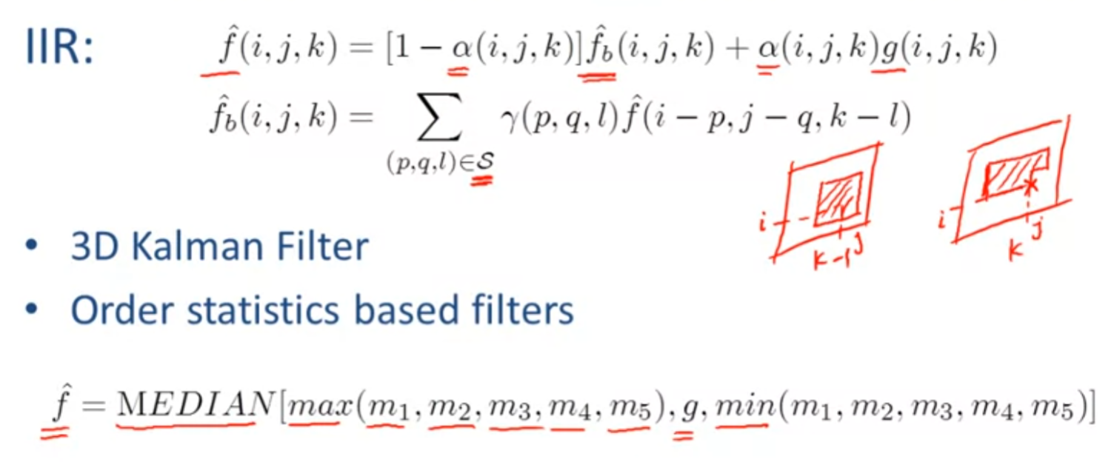

MC spatio-temporal filtering:

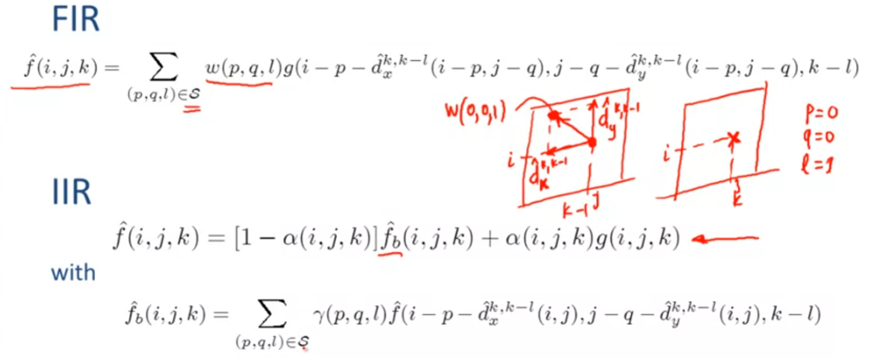

Enhancement of motion pictures:

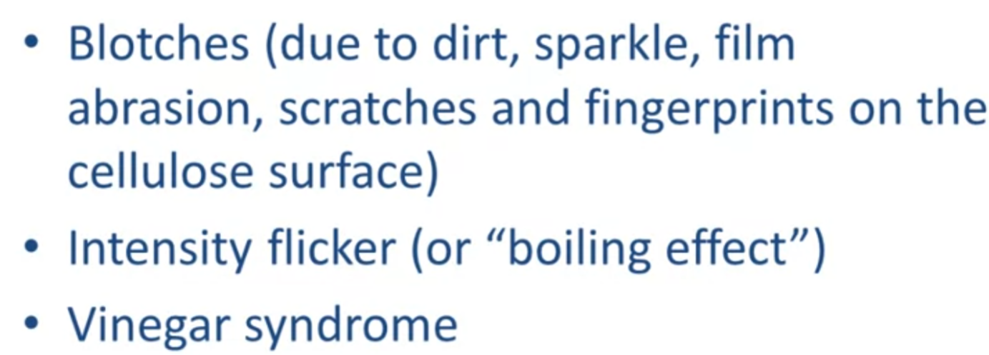

Blotch detection:

They occur only on one frame

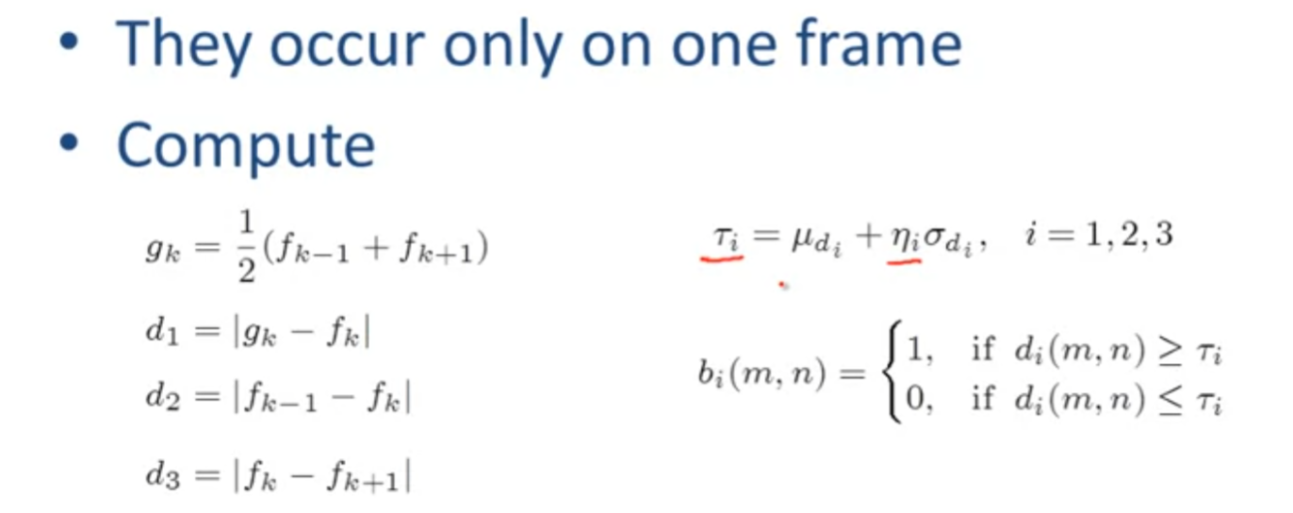

example:

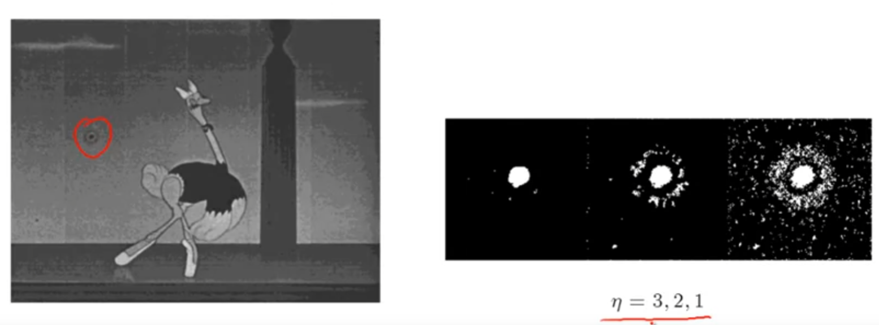

Blotch removal:

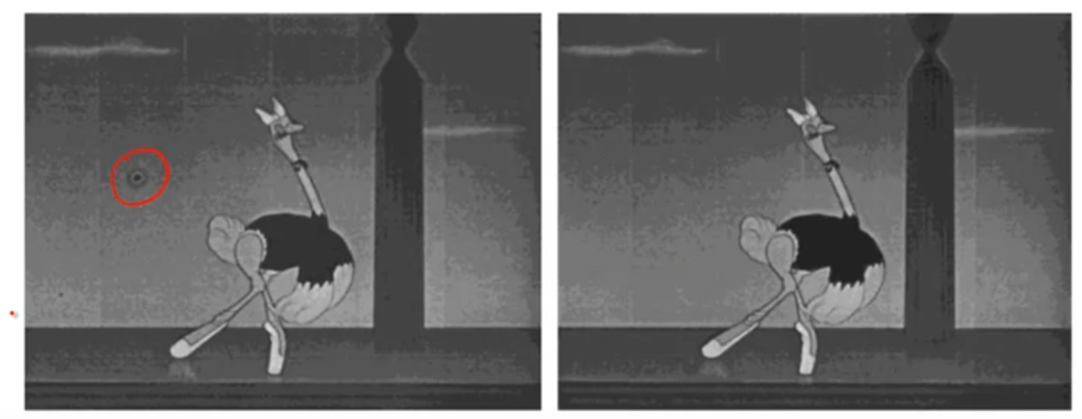

Motion-dependent filtering:

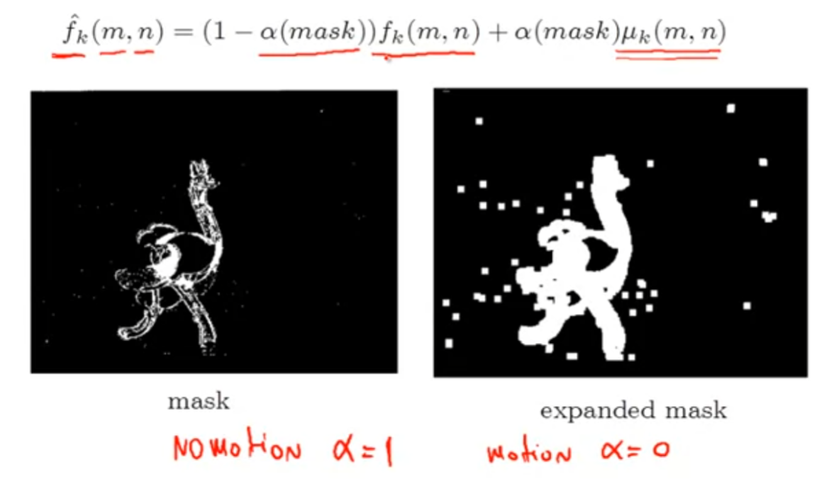

## Enhancement Summary:

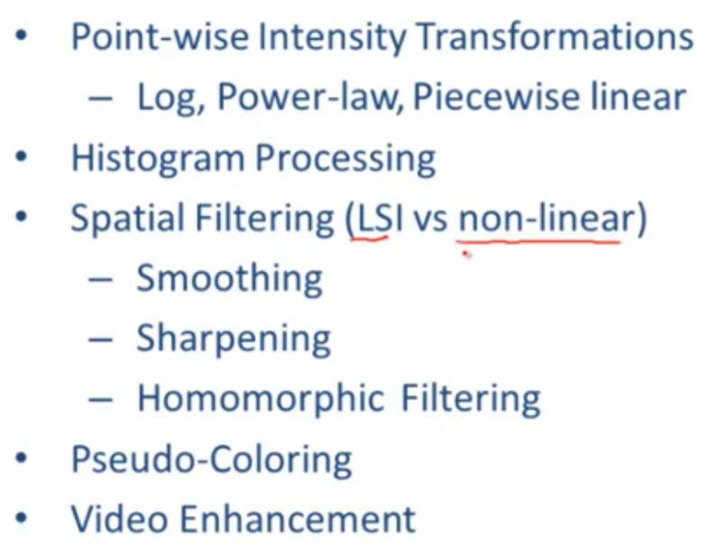

**Point-wise intensity transformation:** the manipulation and transformation of the intensity of the original image with the aim of increasing its usefulness such that the processed result image is considerably better visualization.

1. Negative transformation
2. Log transformation
3. Power-law transformation
4. Contrast stretching
5. Dynamic Range expansion
6. Intensity-level slicing
7. Bit-plane slicing

**Histogram Processing:** the result will provides better visualization than the original image, and considerably more information that can be observed in the processed image. Histogram processing is processing through the histogram of the image(histogram: a chart of how pixels colored).

1. Histogram equalization(make image neither too bright nor too dark)
2. Local histogram equalization

**Spatial Filtering Smoothing:** objective is to process smooth onto the image such that to remove the noise on the image(additive broadband, salt and peper noise).

1. Linear Noise smoothing(process through LSI system)

i. Flat filter

ii. Spatially adaptive filter

1. Non-linear noise smoothing

i. Median filtering(good for salt-pepper noise, poor for broadband noise)

ii. Order statistic filter

iii. Mean filter

**Spatial Filtering Sharpening:** when things are too blurry we will need to apply sharpening process to make image clearer.(Sharpening spatial filter)

**Homomorphic Filtering:** reduce the dynamic range and increase local contrast prior of image to recording it on medium with a small dynamic range.

**Pseudo Coloring:** place the original image in “strange” color to highlight the attention part.

Video Enhancement: detect blotch and remove blotchs on the motion picture.

1. Non-MC Spatio-Temporal filtering
2. MC Spatio-Temporal filtering
3. Motion-Dependent filtering

## Week5 Homework

1. The main difference between image enhancement and image restoration is the fact that the degradation model must be known in latter. TRUE
2. 

Log transformation is to make an image look brighter.

1. 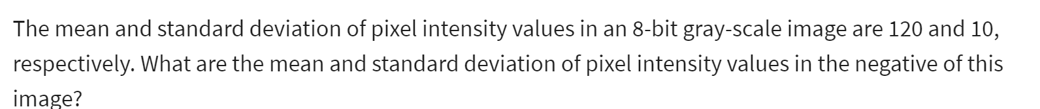

negative of image, neg = T(original) = (L-1) - original; e.g. 8-bit image, L = 2^8 = 256

mean of matrix = sum(all elements) / number of elements

variance = sum((element - mean)^2) / number of elements

standard deviation of matrix = square root of variance

for negative image, mean should be L-1-original, in above case is 256-1-120 = 135. SD should be the same since the negative image remain same intensity.

1. 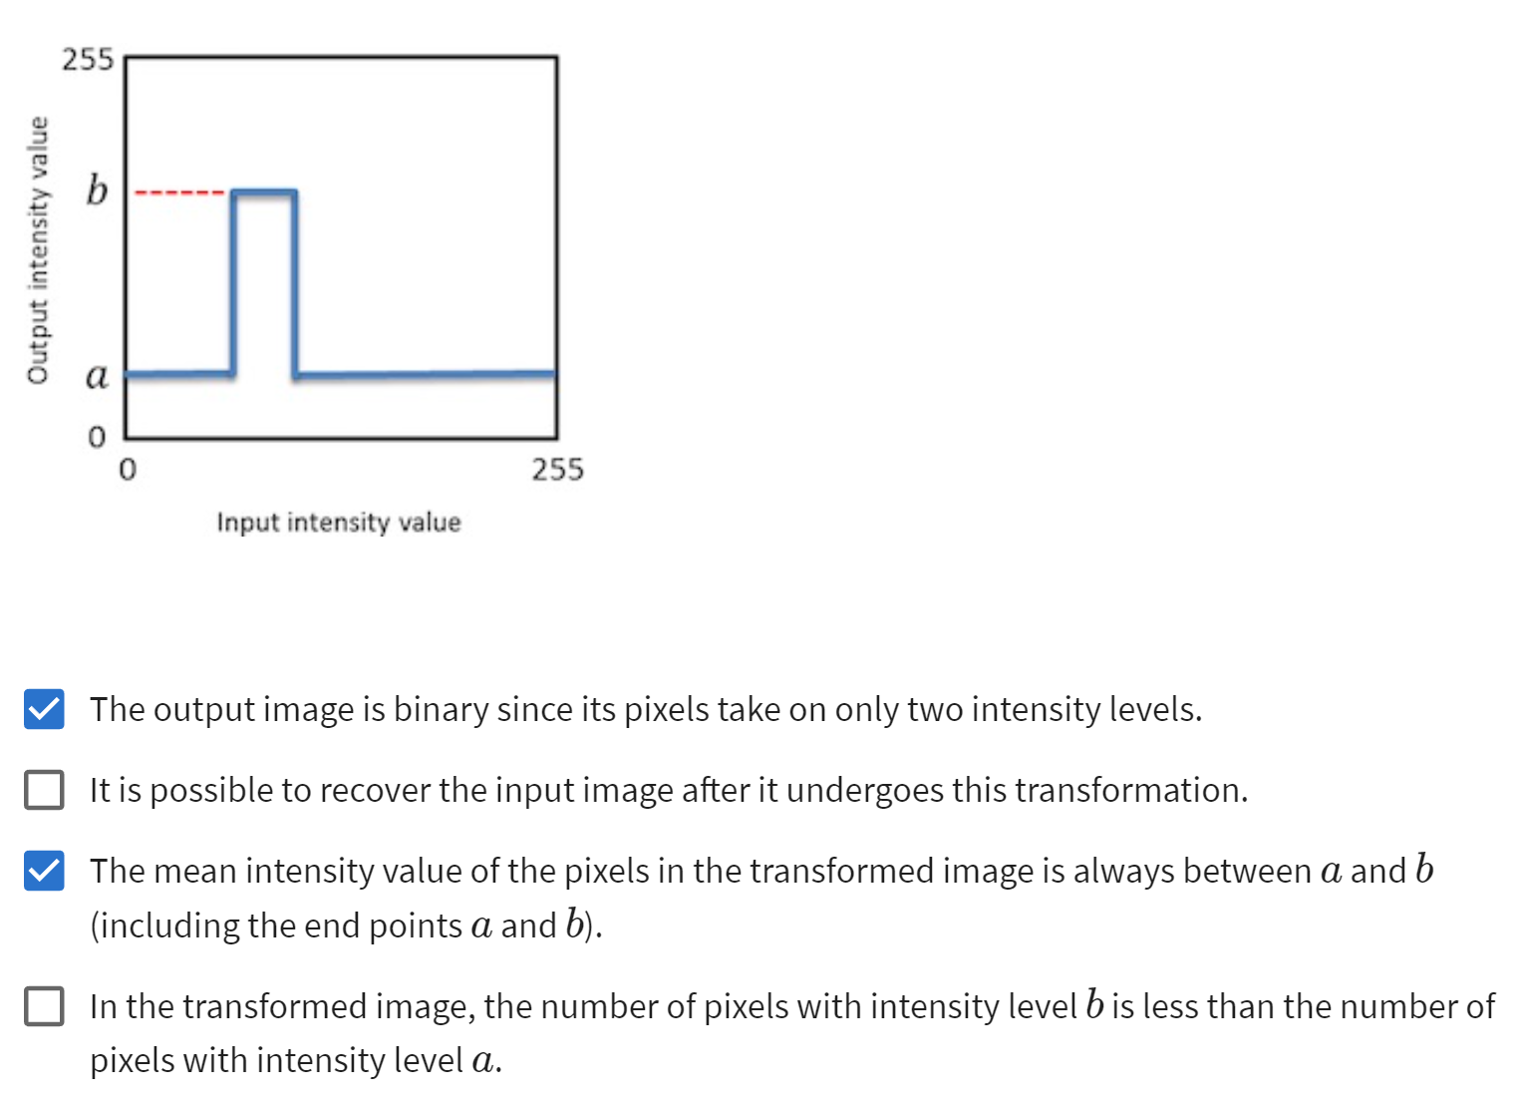
2. 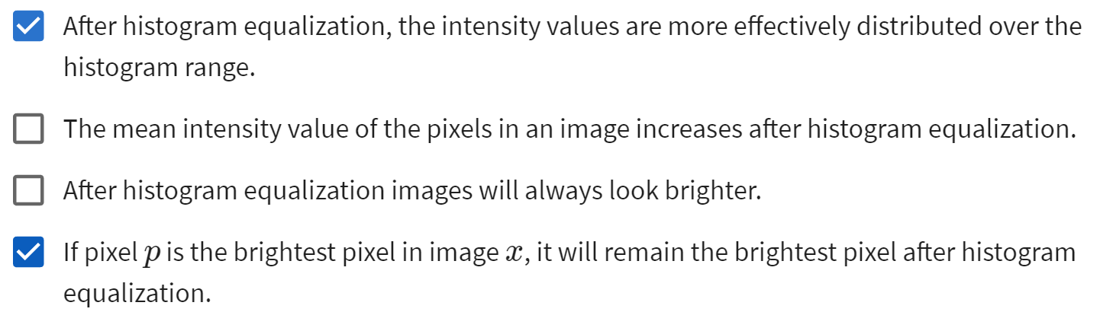
3. 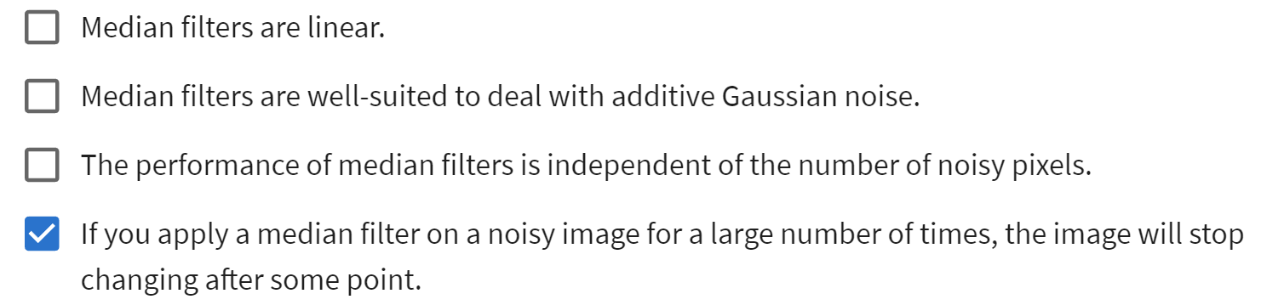

## Example of Image and Video Recovery

Defocussing:

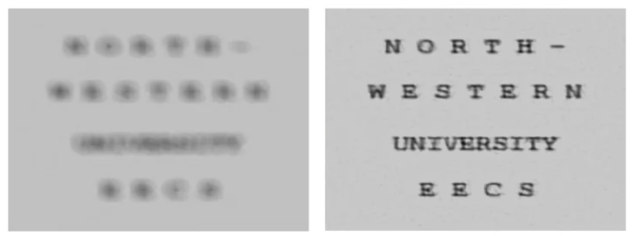

Cross-channel degradation:

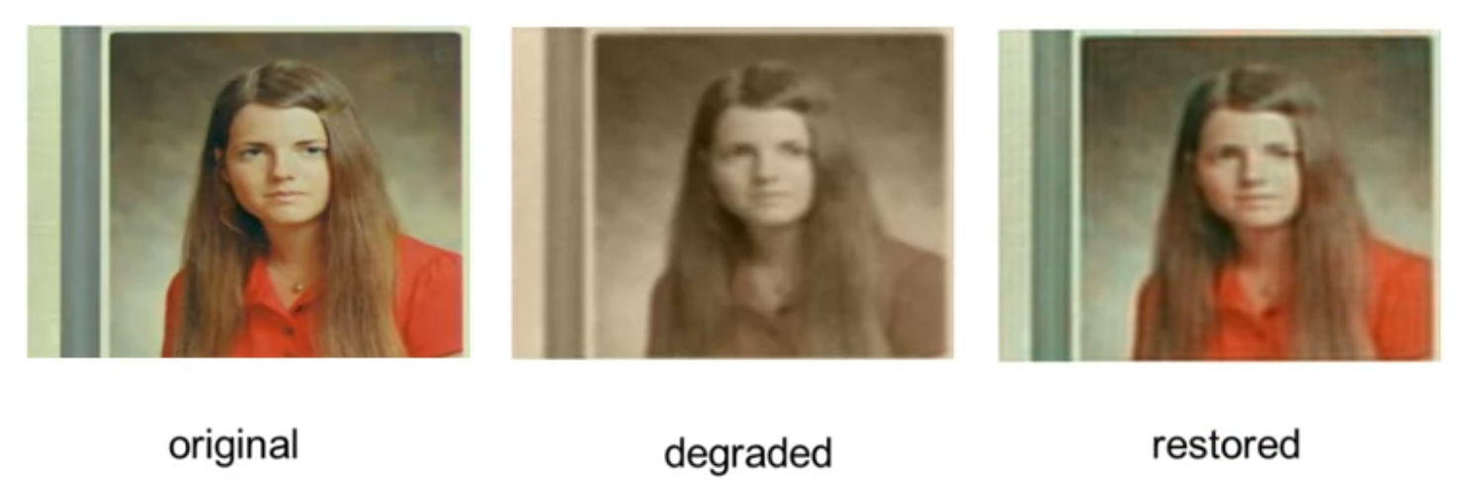

Degraded images:

Some blurred image due to motion between the camera and the scene, the motion compensation system failed and therefore this blurred image was acquired.

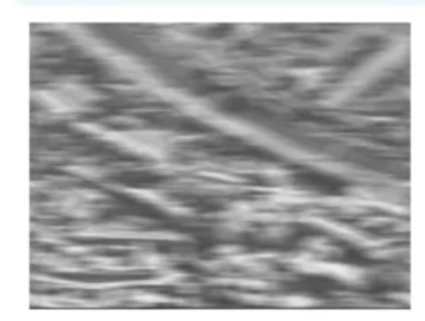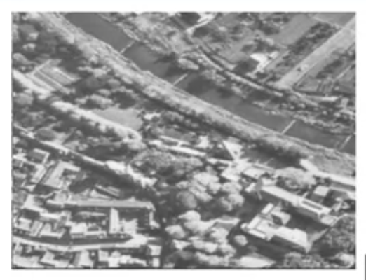

Other examples: super-resolution, tracking blurred object etc.

Sources of Degradation

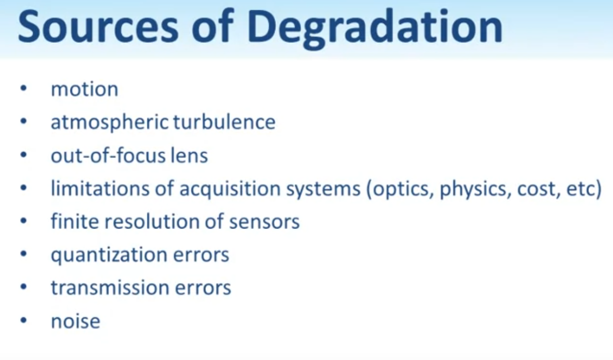

Forms of the Recovery Problem

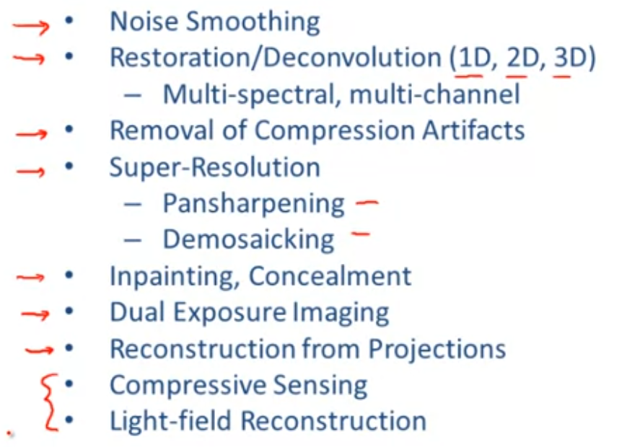

Some of above example are just single image but some are multiple observations involved such as the dual exposure imaging or the super-resolution.

Image recovery application:

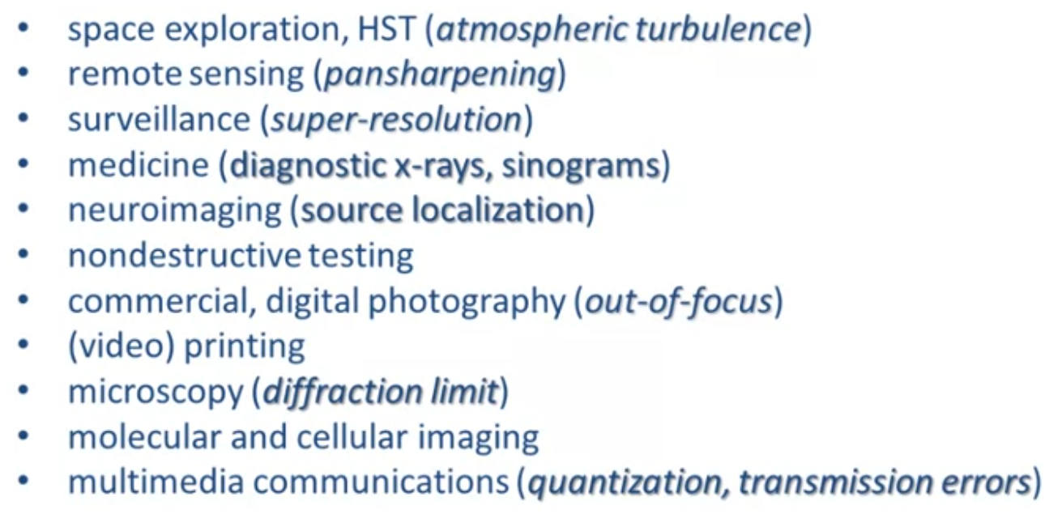

thus we see that image recovery is a very very rich field there is a lot more applications in the real world we could involved such technology.

## Image Restoration

Inverse Problems:

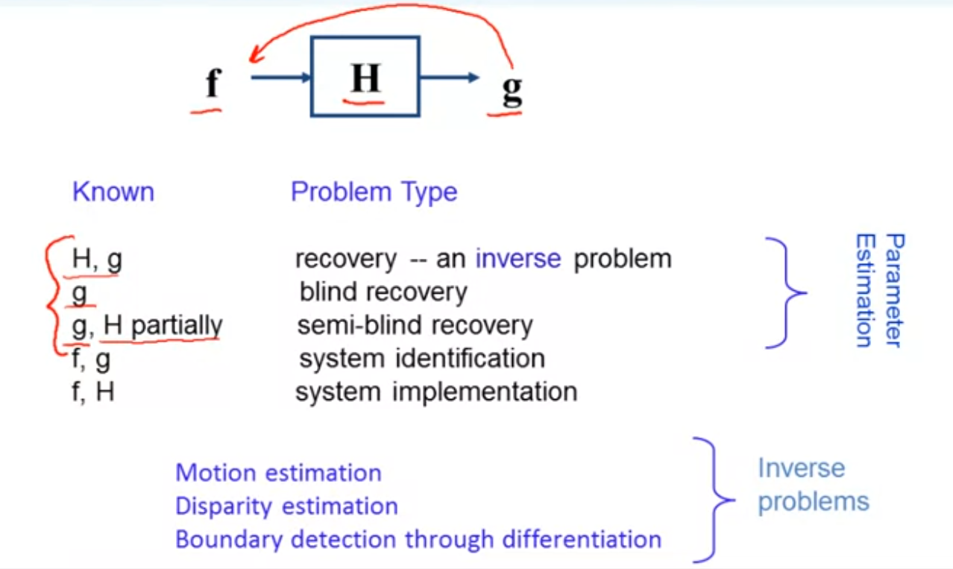

when H,g remain unknown, to find f, we are reaching an inverse problem.

Degradation/Restoration system

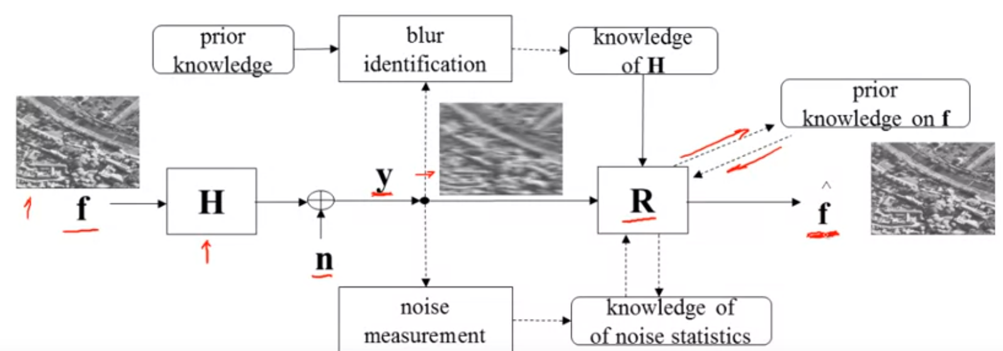

the point is to design a system R that can recover the blurry image and procedure an estimated image which is as close as possible to the original image, and prior knowledge is the most important part in designing such a system.

The major difference between image enhancement and image restoration is image restoration requires modeling of the degradation process.

Degradation model:

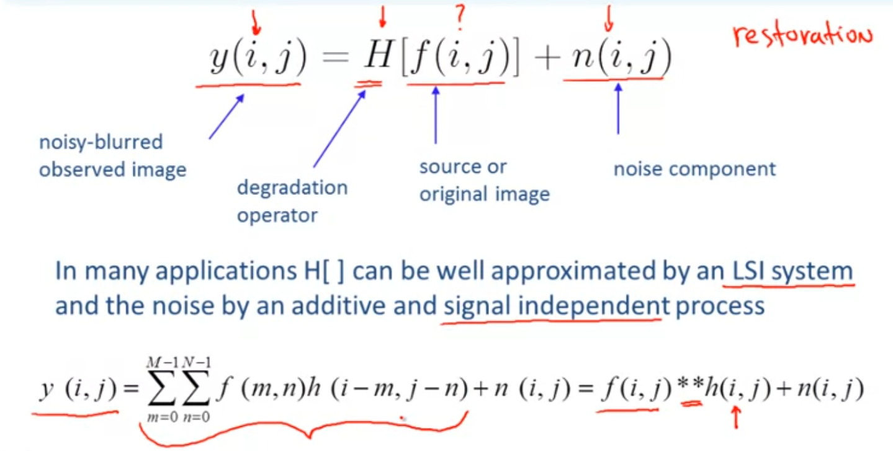

in this particular incarnation, solving for f(i,j) given the impulse response h(i,j) of the system, and the available data y(i,j), becomes now a deconvolution problem.

Representative degradation:

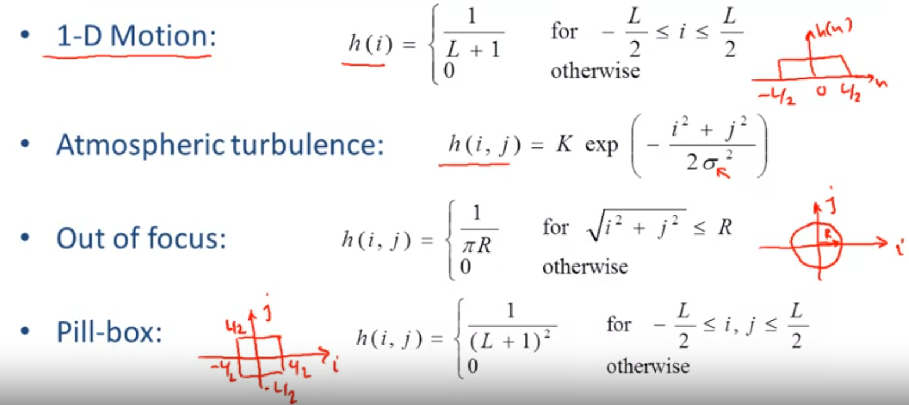

Objective degradation/restoration metrics:

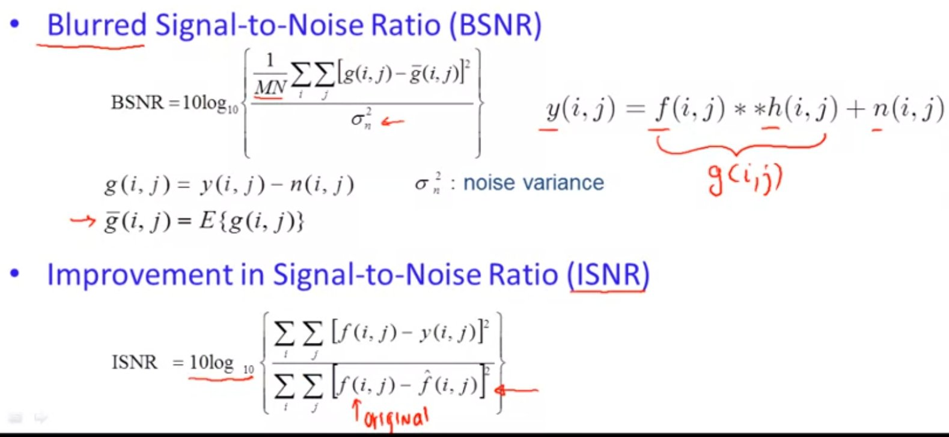

## Matrix-Vector Notation for Images

Vector notation for images:

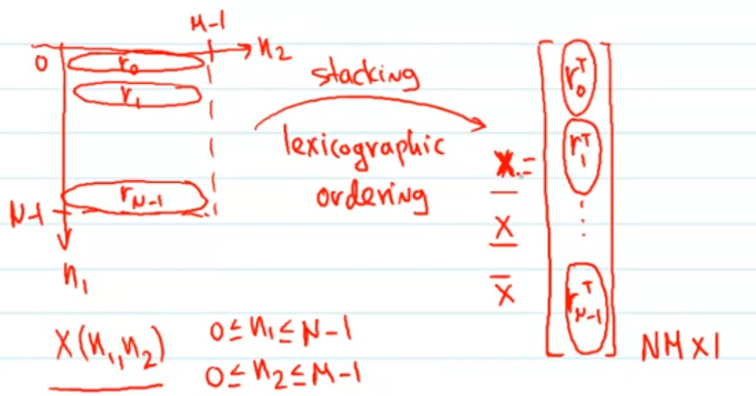

the n x m image is now coverted into n*m x 1 vector, this is the process of stacking an image into a vector.

Matrix-vector Notation:

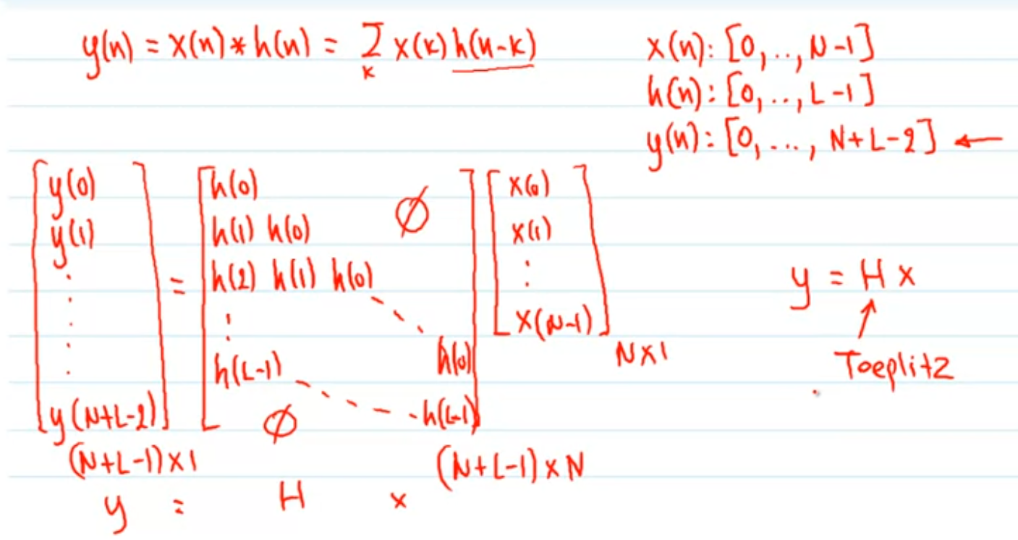

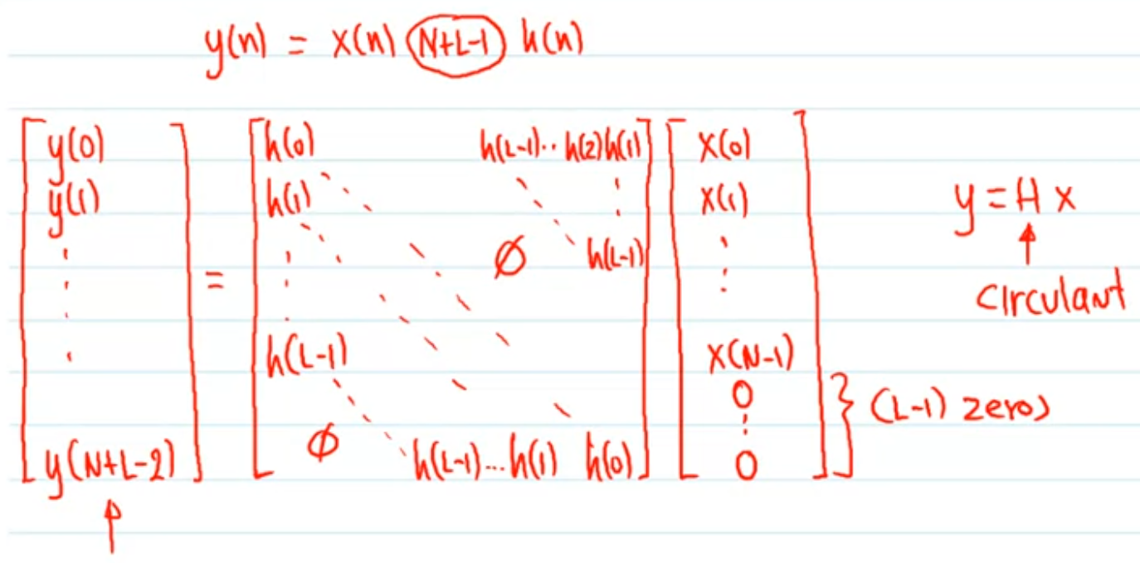

Eigen-values/vectors of circulant matrices:

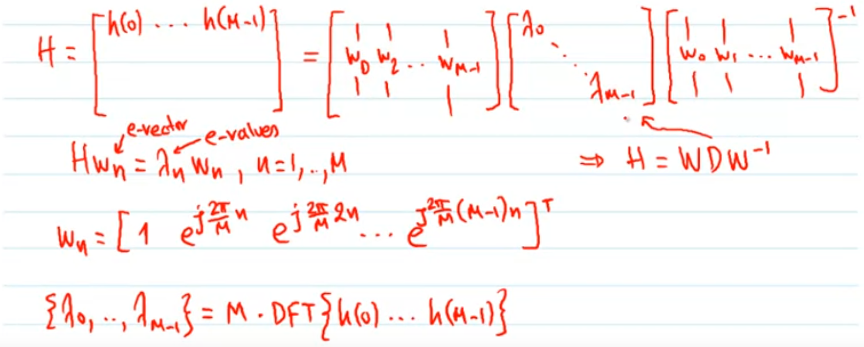

eigen-vectors = wn = [1, e^..., …]^T; eigen-values = lambda

since Hw = lambda * w, then H = lambda * w * w^-1, thus:

original matrix H = [w0, w1, …, wm-1] * [diagonal matrix of eigen-values] * [w0, w1, ...]^-1

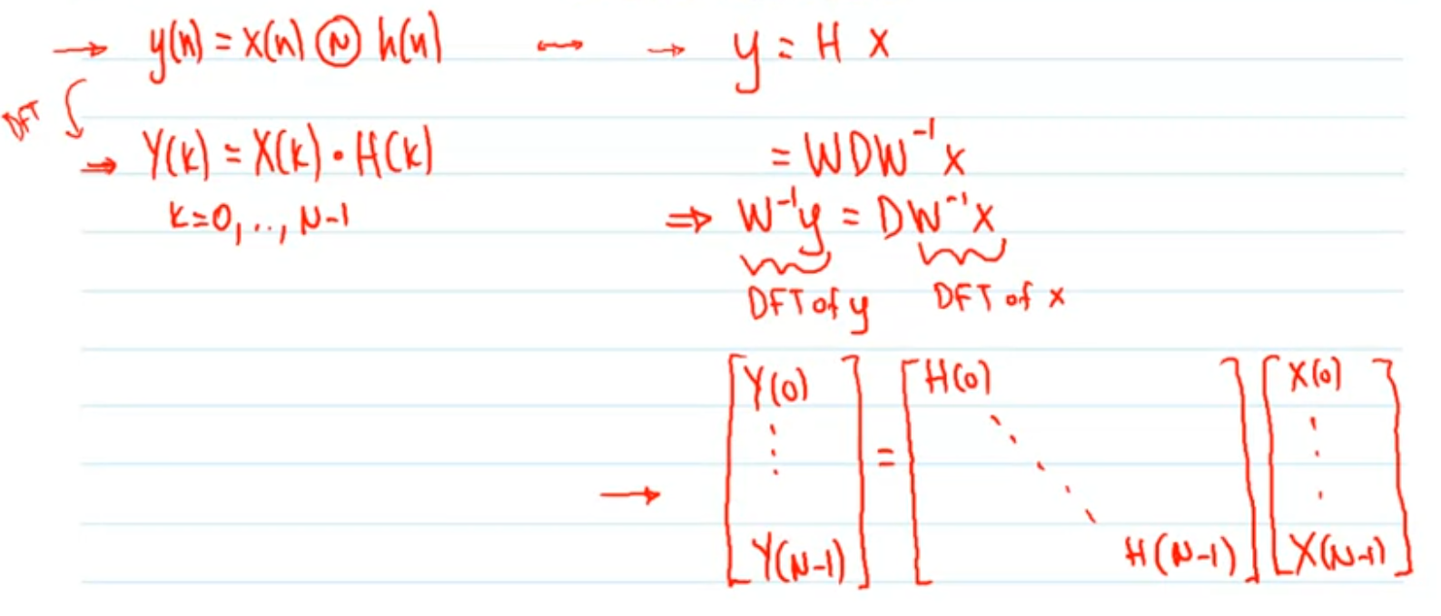

Here, w^-1 * y is the Discrete Fourier Transform of y, same for w^-1* x.

Matrix-vector notation:

Combine the above, we can come up with the followings

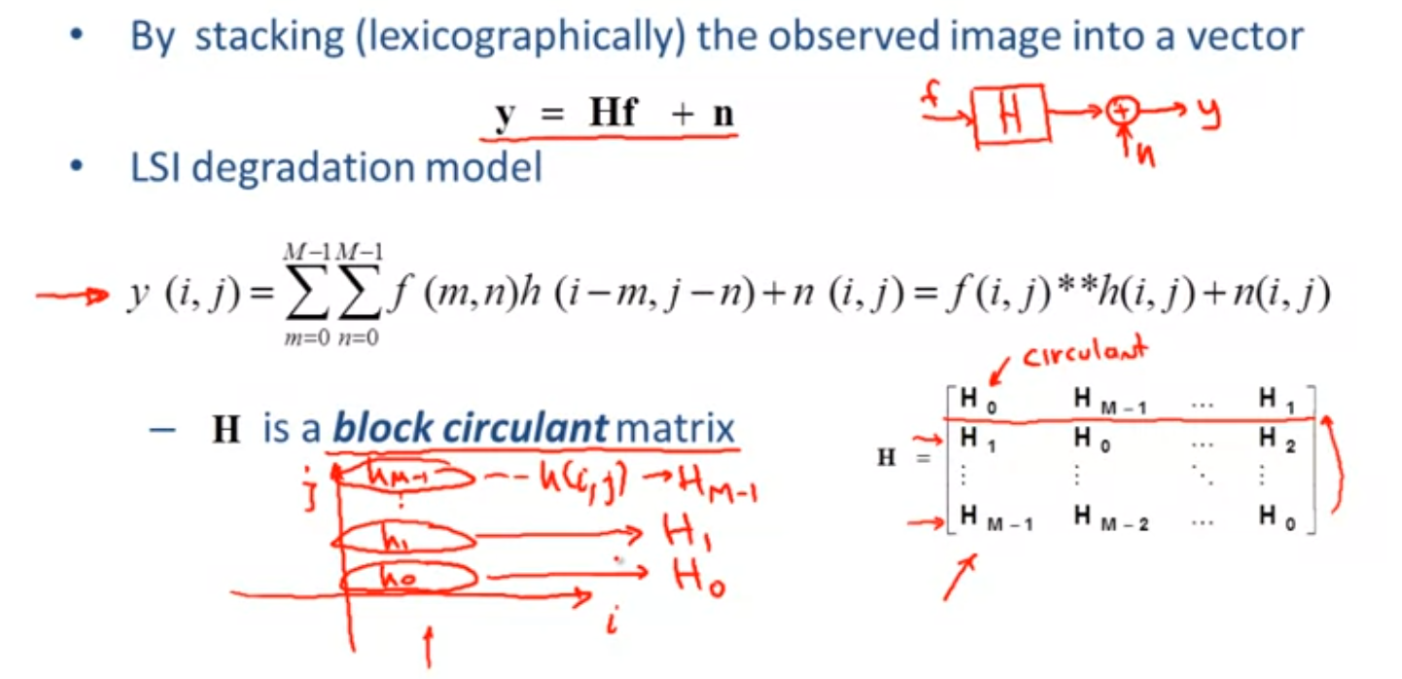

Spectral properties of Block Circulant Matrices

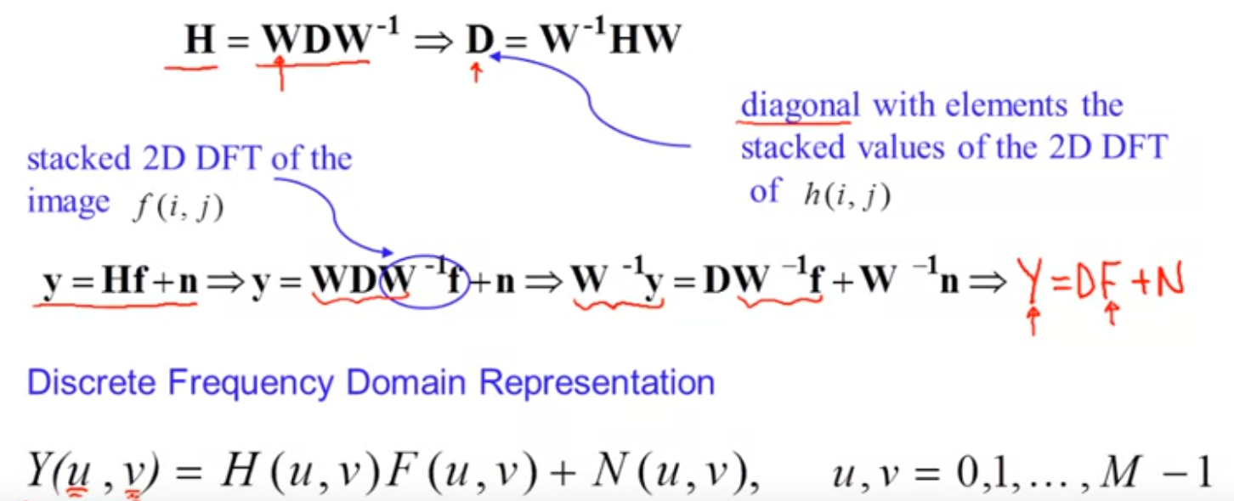

Elements of Linear Algebra:

let x = [x1, …., xn], then

L2 norm of x = x^T * x; L2 norm of y-Hx = (y-Hx)^T (y-Hx)

Gradient over function all over norm = [partial respect for (norm of x)^2]

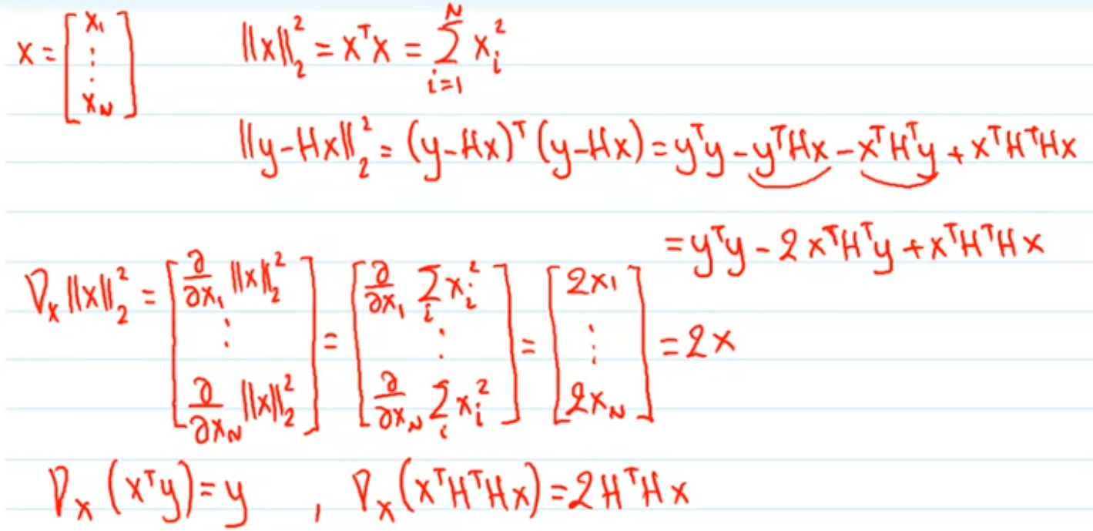

## Inverse Filtering

inverse filter:

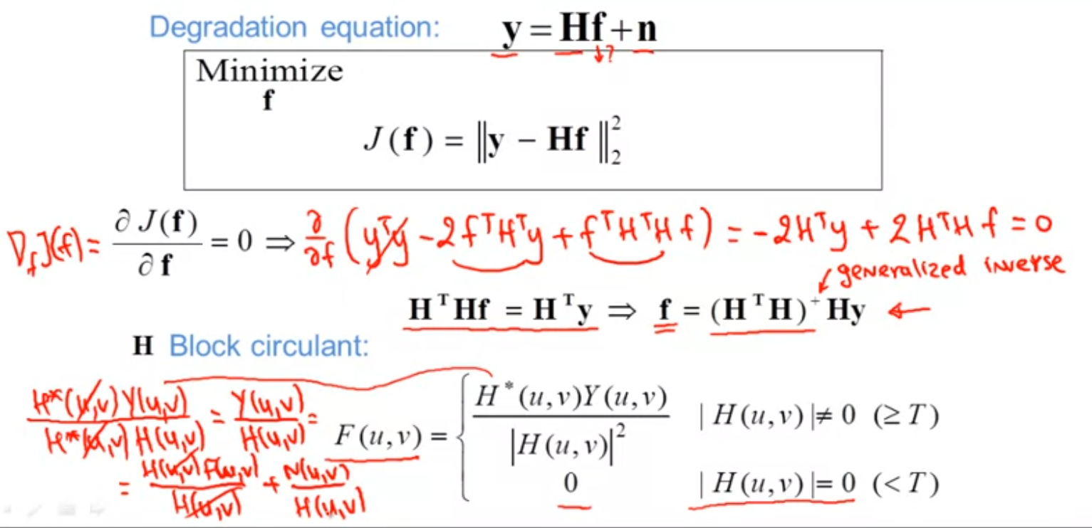

The use of a threshold in inverse filtering is mainly to control noise amplification.

1D motion blur example:

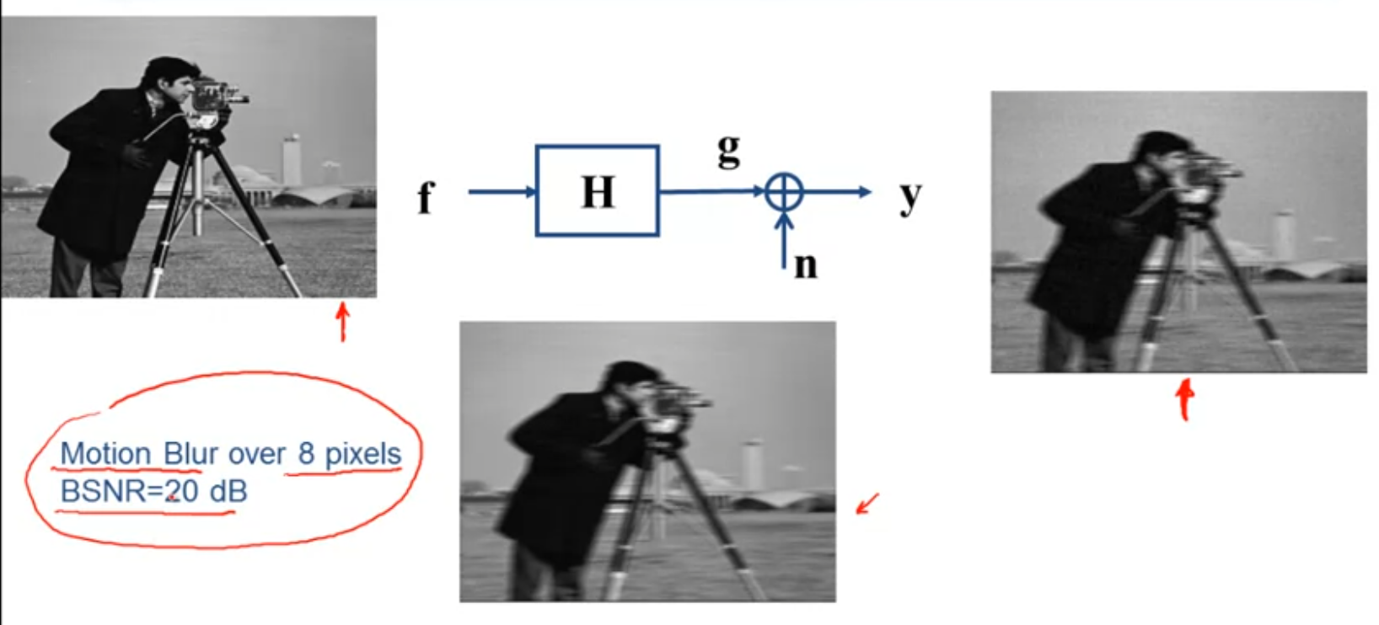

given y(the right blurry image) as observation, and without knowing system H(only know about description), we need to procedure an estimated image to original.

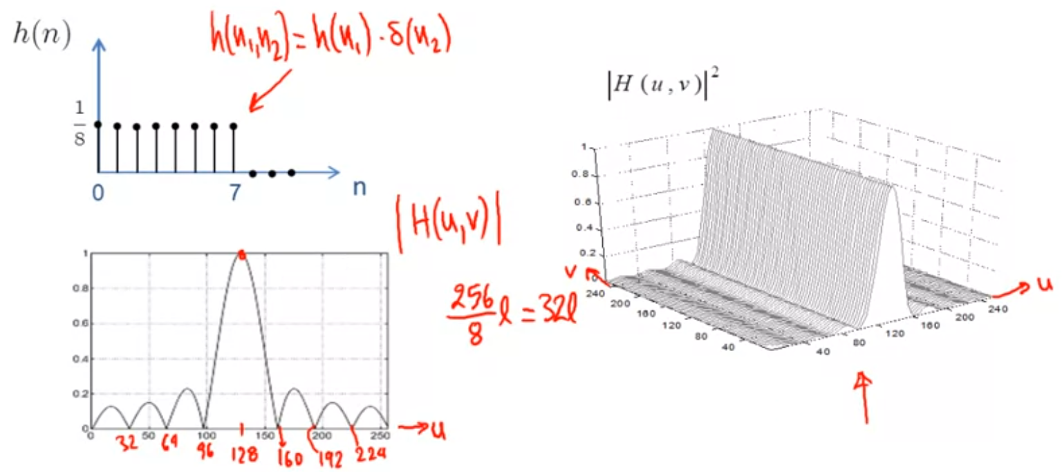

in above pic, graph below is the fourier transform of blurry image, the right graph is the frequency response of the system of the 1D motion blur and this is what we need to invert. Once we invert the shape and this will give us the inverse filter.

Thresholded inverse filter:

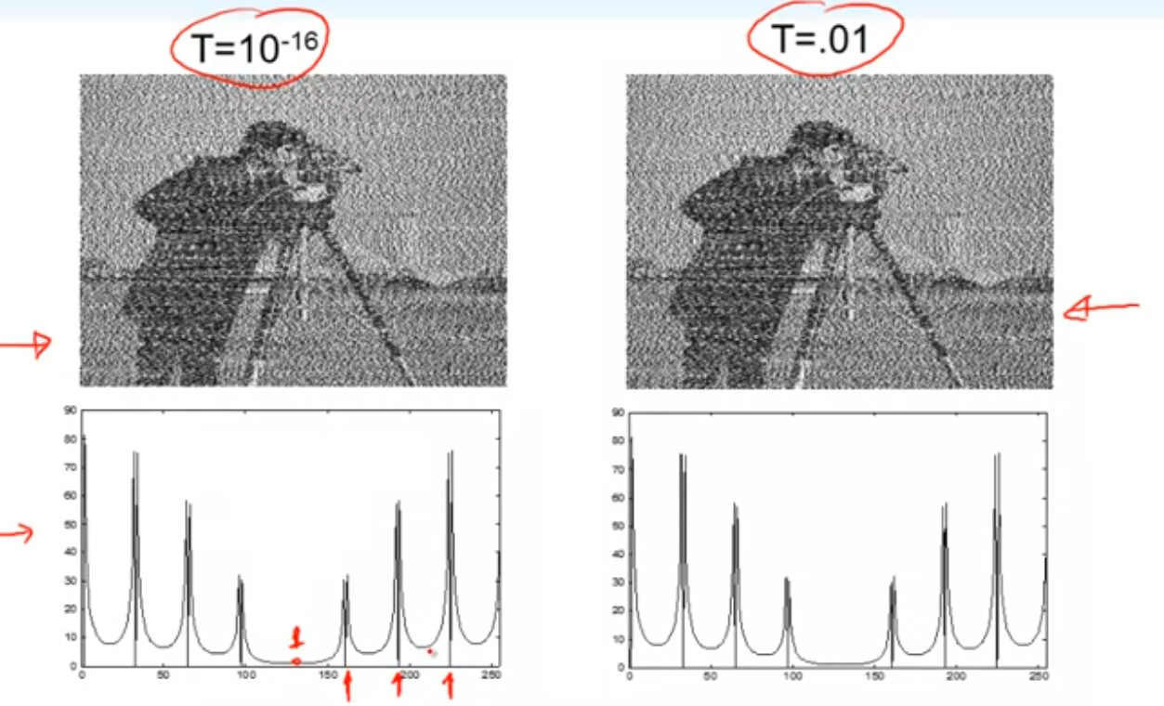

and if we keep incresing the value T, in the case we could get an acceptable result

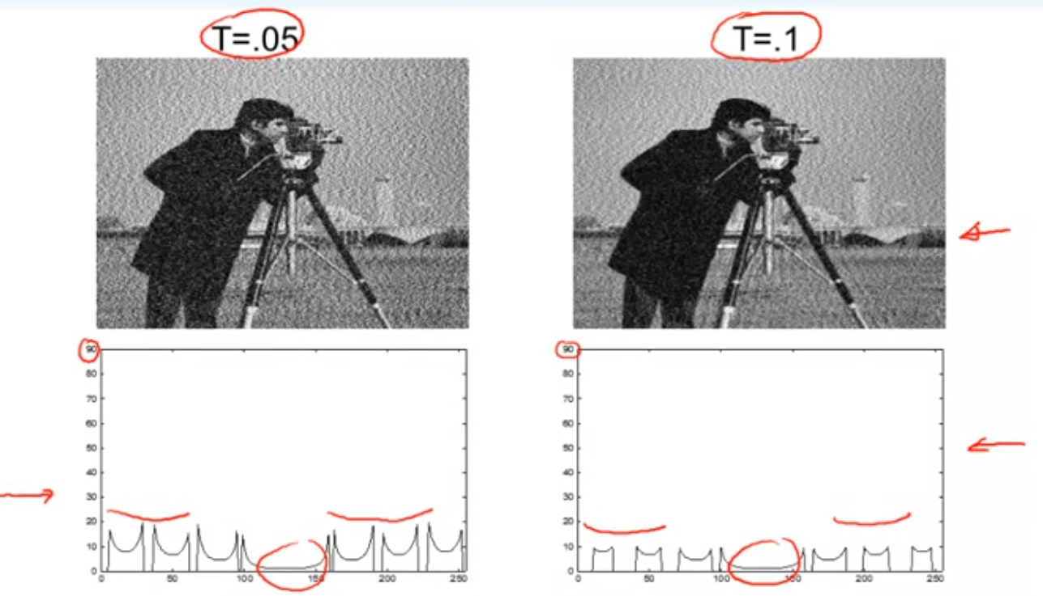

if we increase the value of the threshold even further, the noise is even more controlled

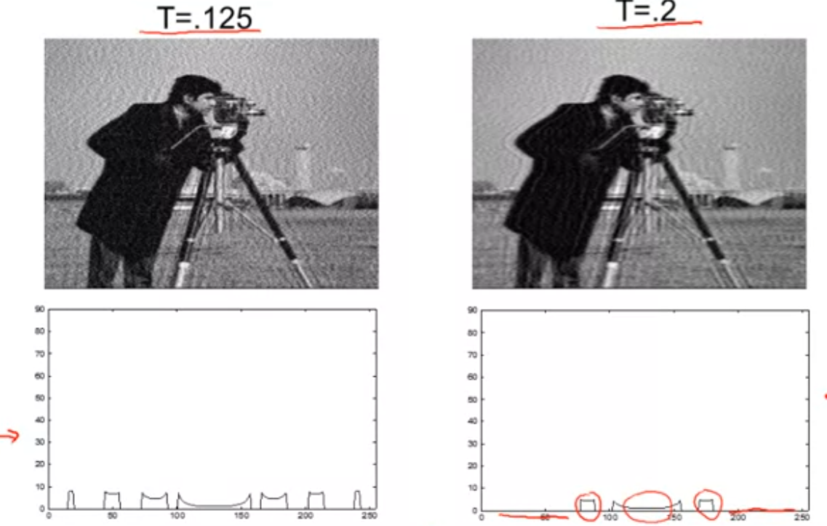

## Constrained Least Squares(CLS) Filter

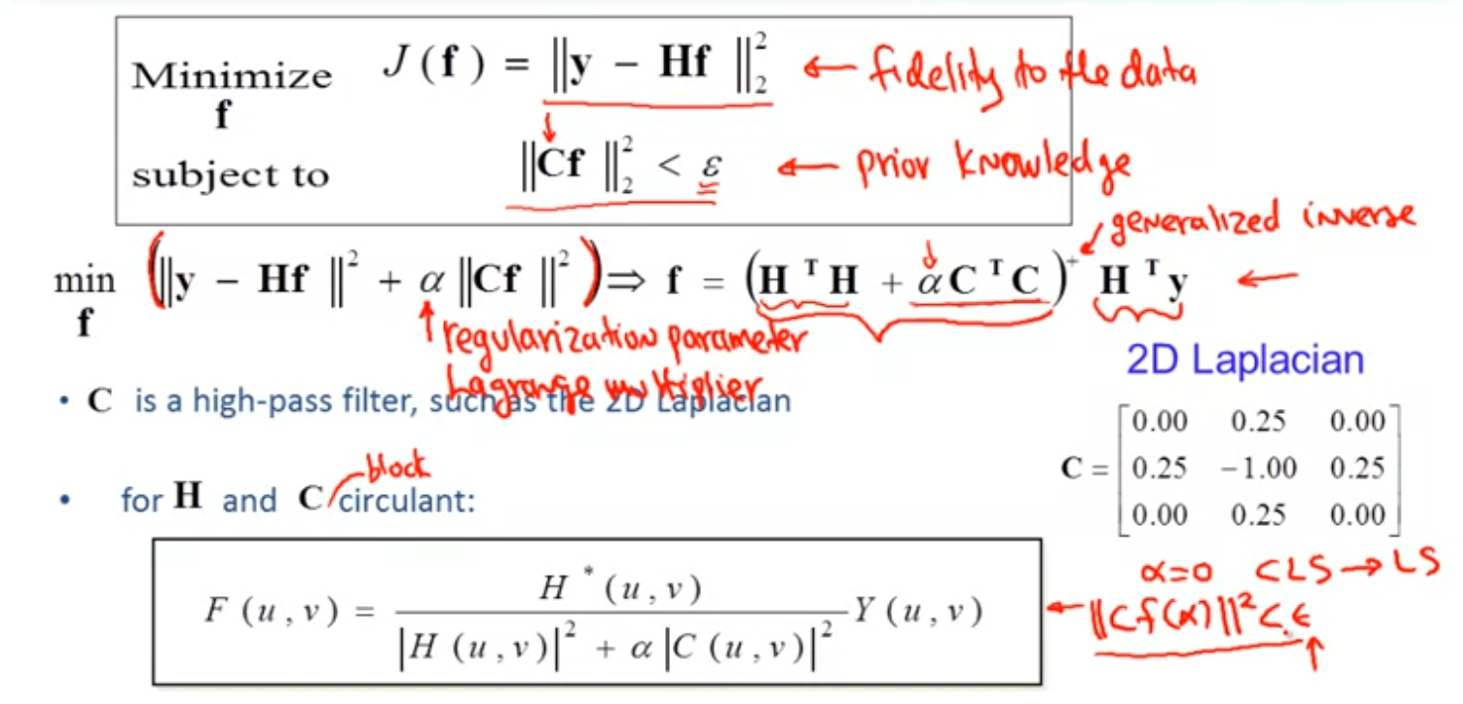

The two terms in teh CLS filter formulation represent the fidelity to the data and the prior knowledge about the image.

Fequency Responses:

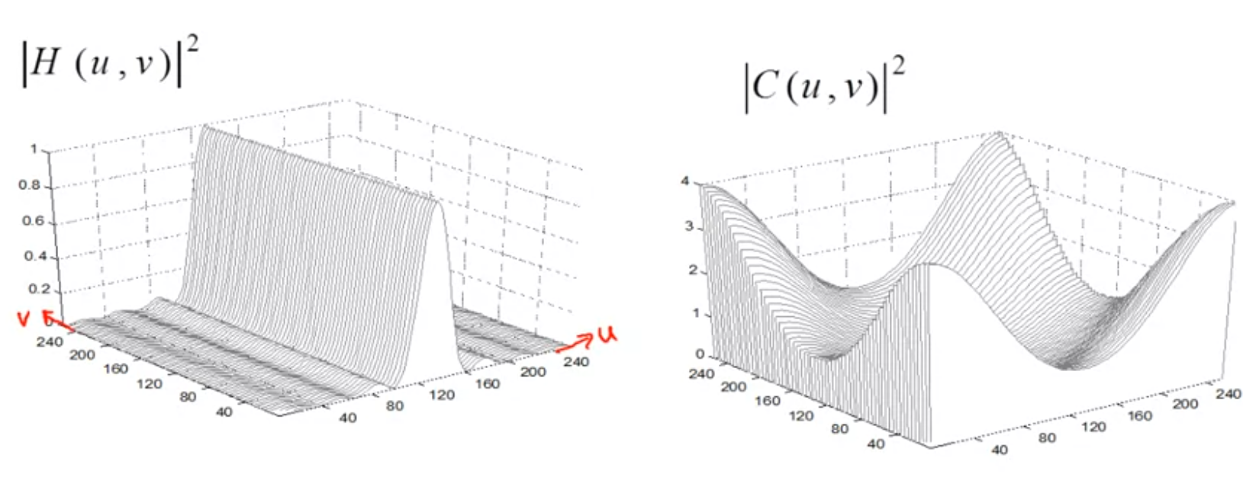

left is frequency from previous example, right is the filter, and when we constrained them

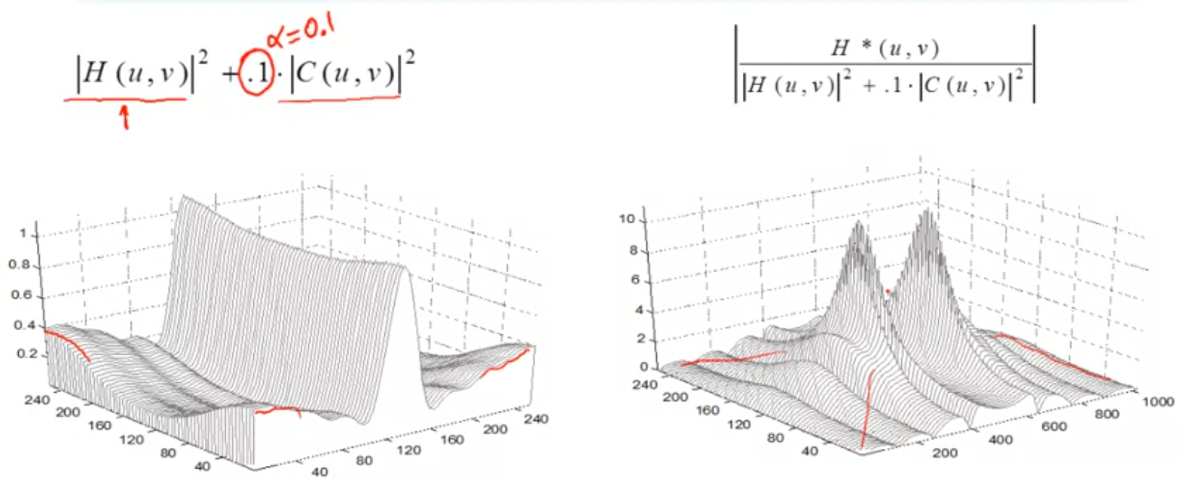

if we change the value of alpha to 0.01

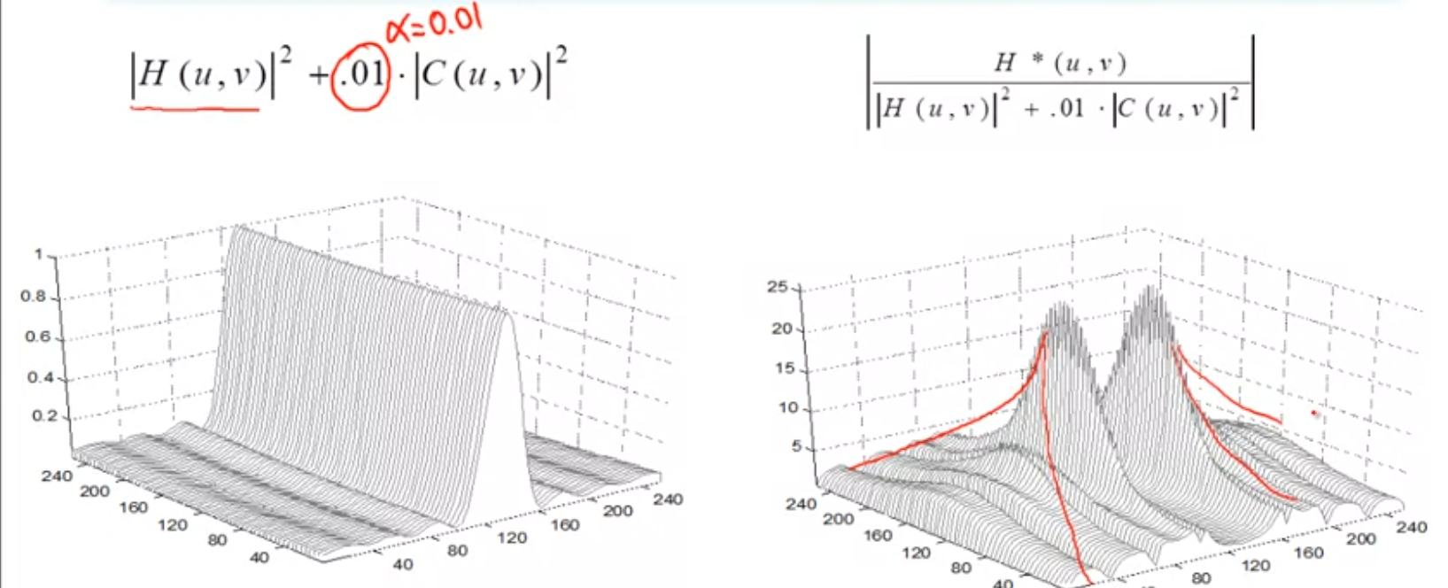

compare those results:

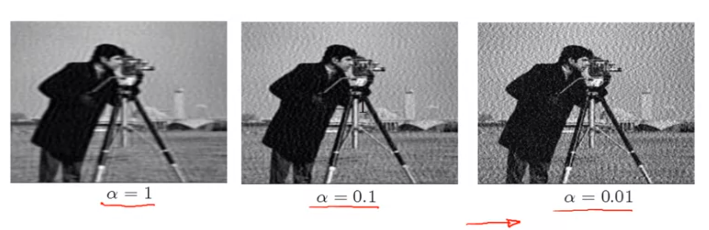

we could tell as alpha increasing, the solution become more and more smoother.

Effect of Regularization Parameter in CLS algorithm

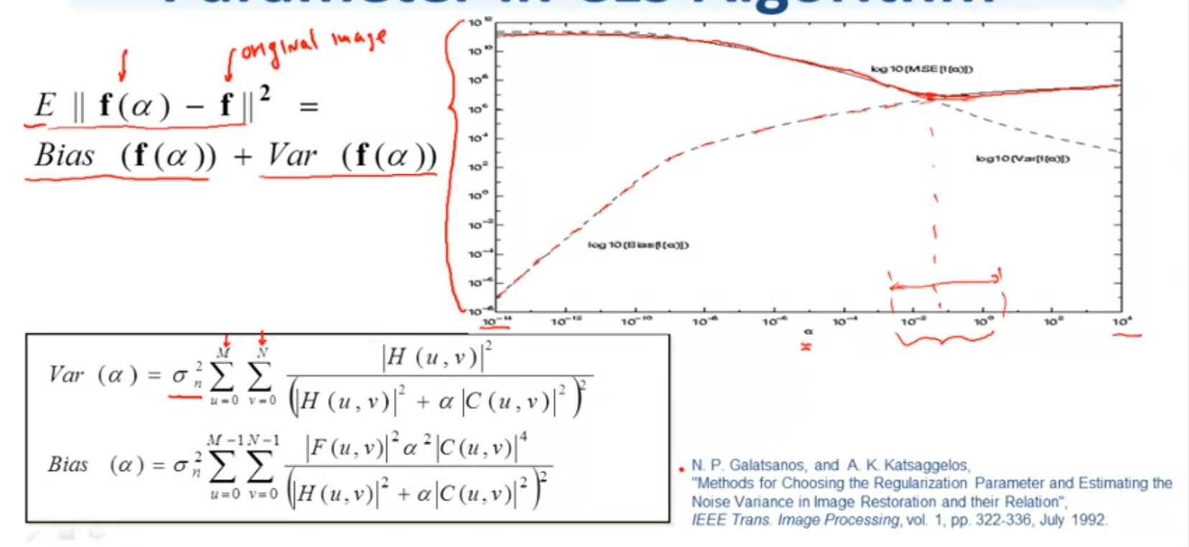

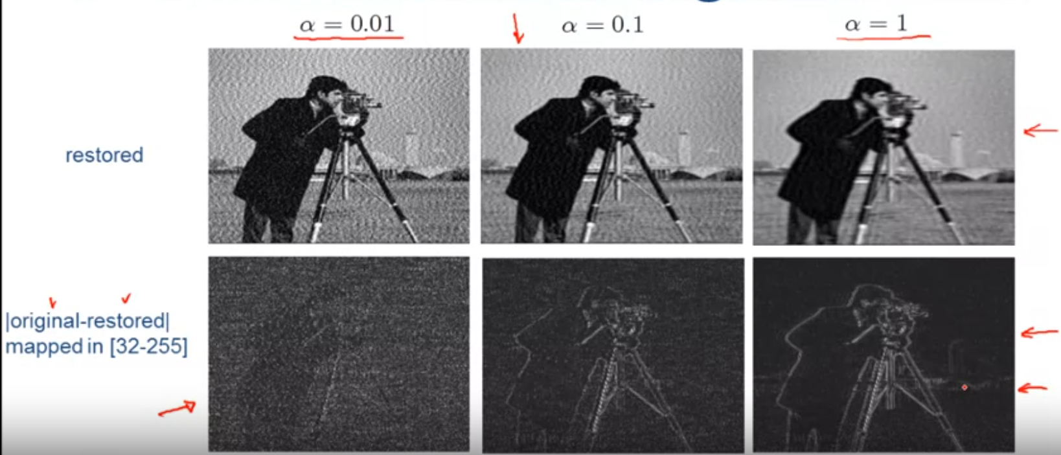

Regularization Parameter Choice:

Knowledge of the noise variance; Visual Inspection; The L-curve; Generalized cross-validation

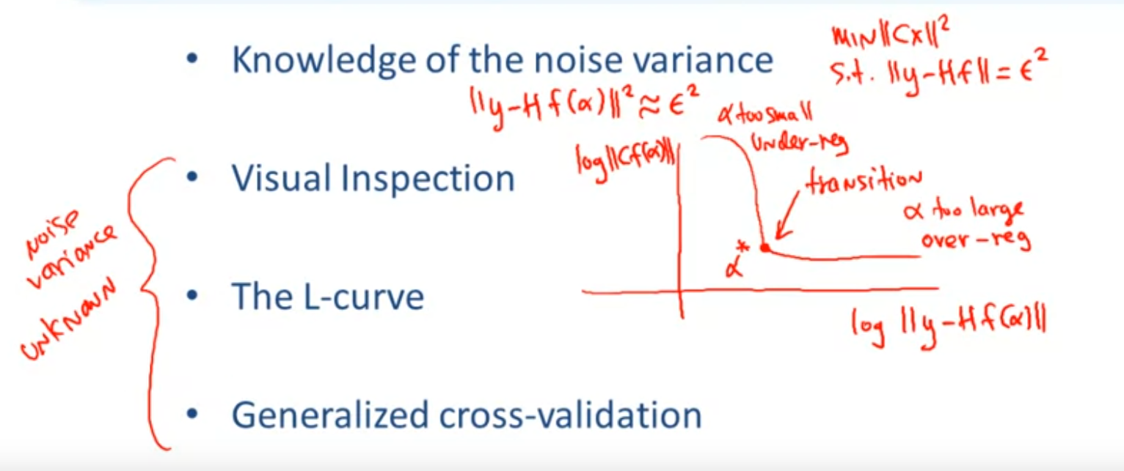

Non-Quadratic Regularization:

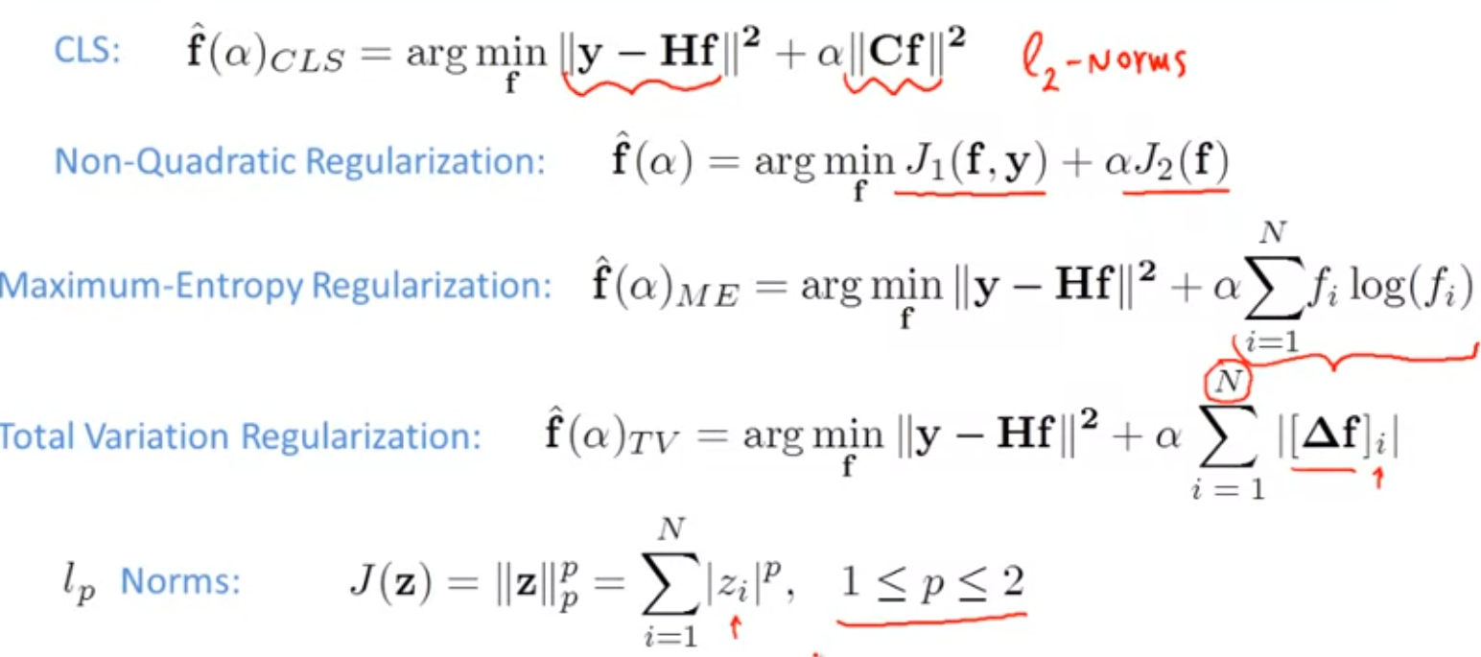

## Set-Theoretic Restoration Approaches

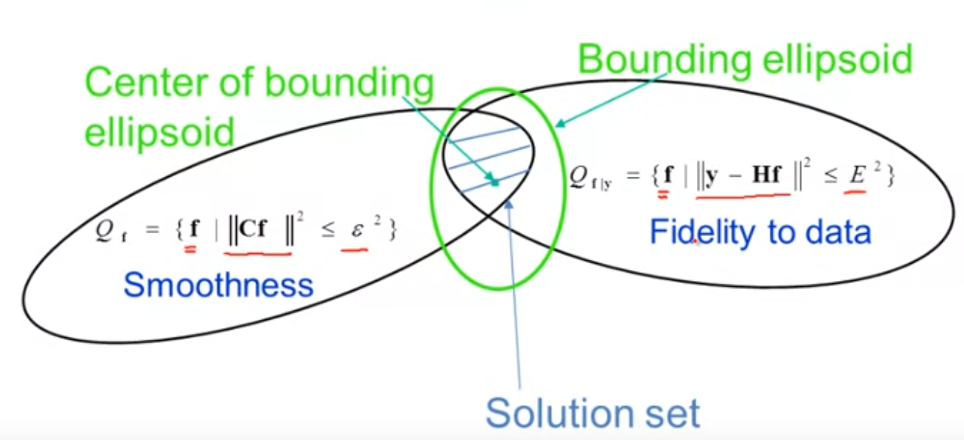

looking for an image that has both properties, it’s smooth and satifies the fidelity to the data, so it belongs to the intersection of these two convex sets. One approach to find the solution is to bound the intersection by another ellipsoid, and choose the center of this ellipsoid as solution.

POCS algorithm:

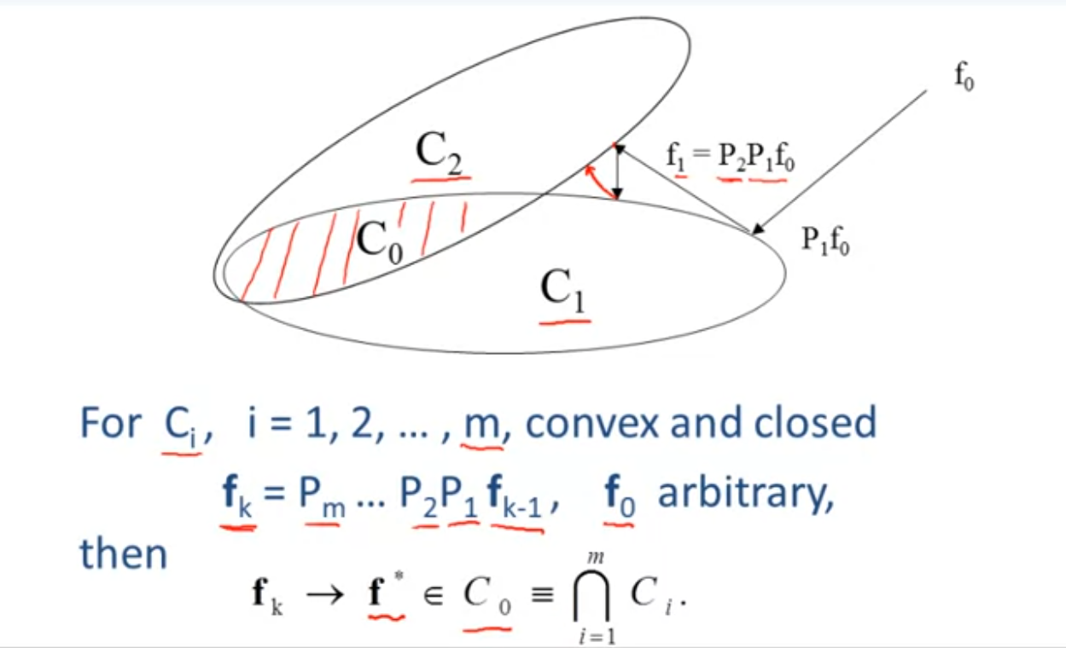

P1f0 is the point f0 projection onto C1, and f1 is the projection onto C2, we keep founding those projection and after so many iterations the final solution f* is going to be the intersection C0 of m.

Set Theoretic Restoration approach:

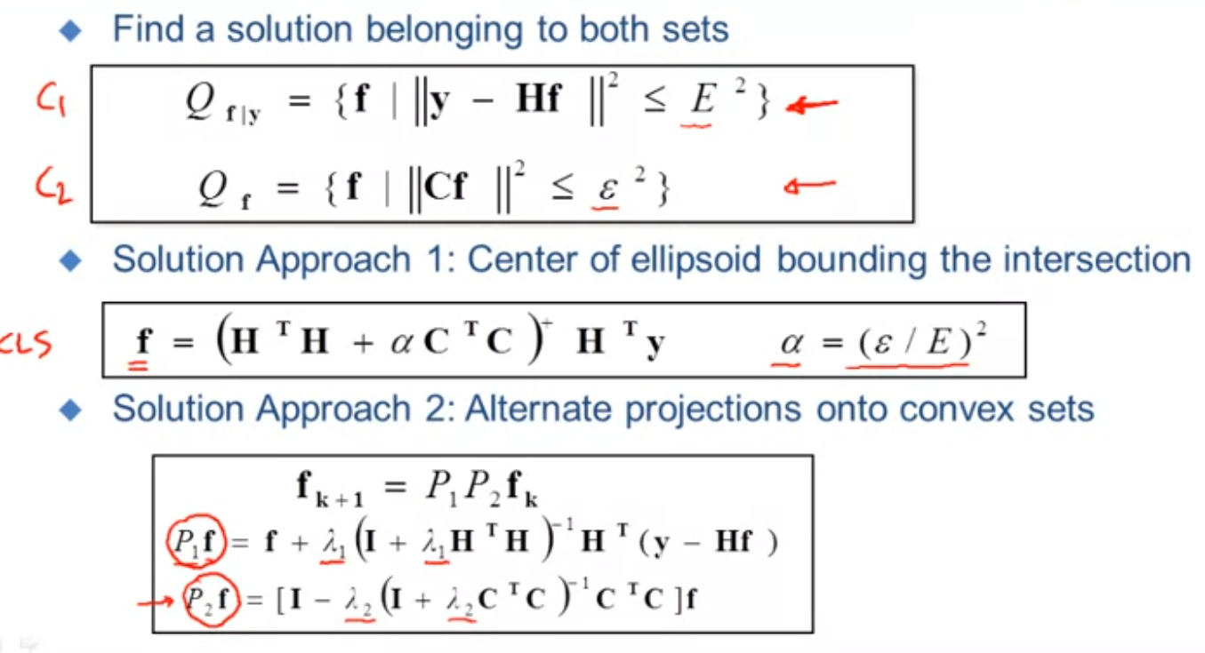

## Iterative Restoration Algorithms

Benefits of iterative image restoration algorithm:

1. An iterative algorithm may require less memory than its non-iterative counterpart(if there exists one).
2. An iterative algorithm provides a means to monitor the solution as the iteration progresses.
3. The number of iterations can be used to control noise amplification.

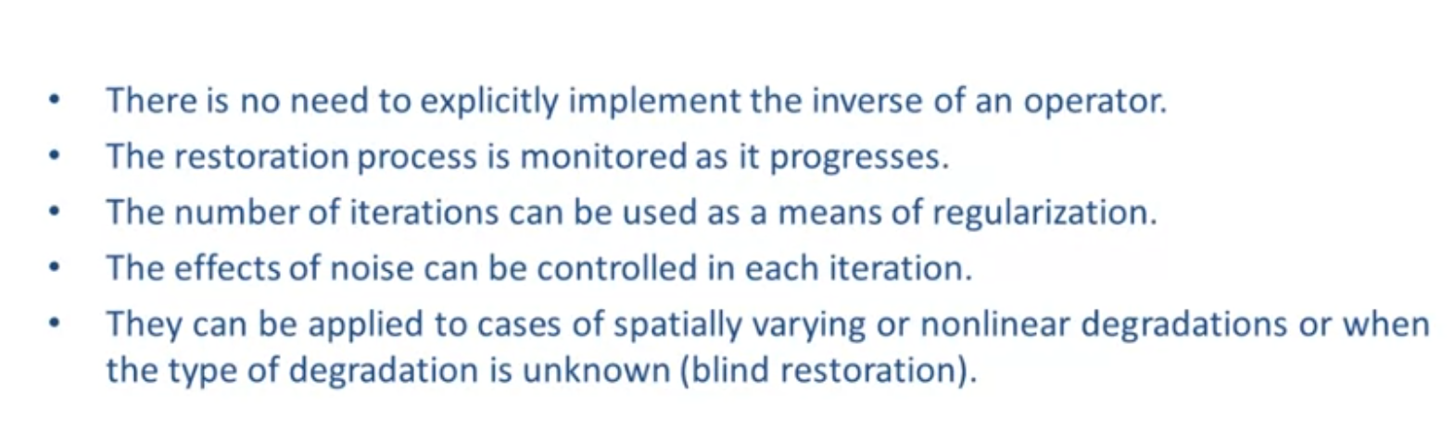

Basic Approach:

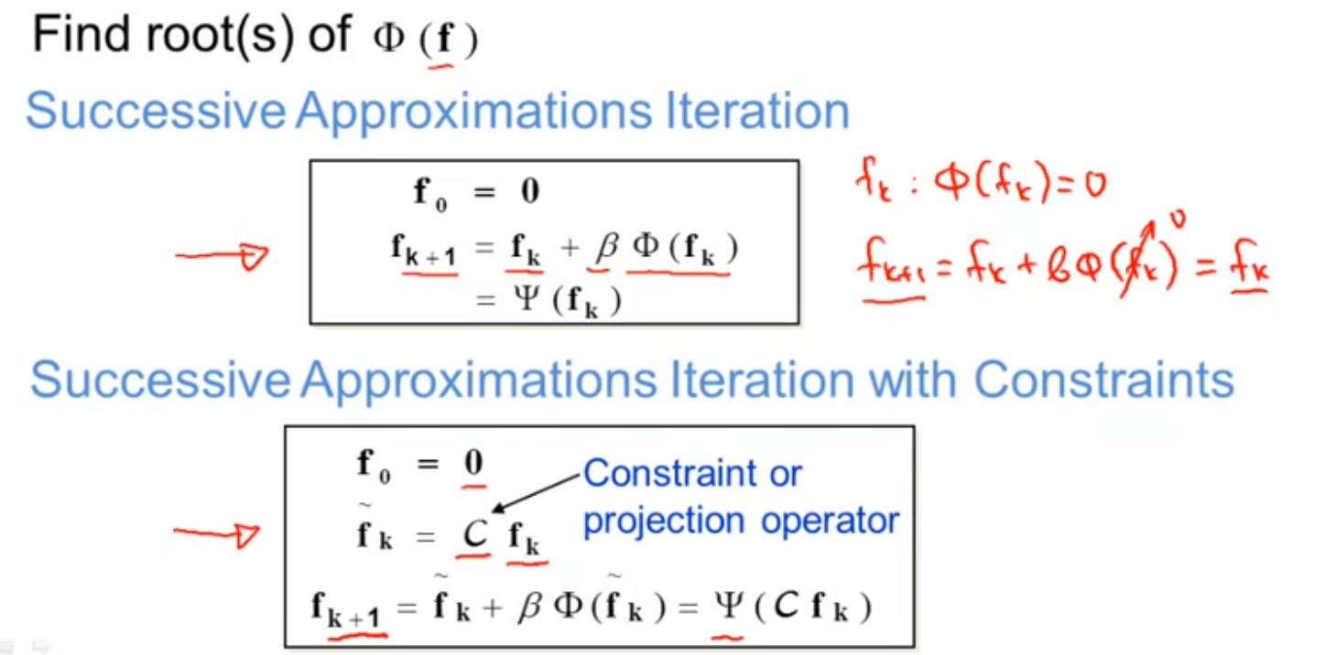

Basic Iteration:

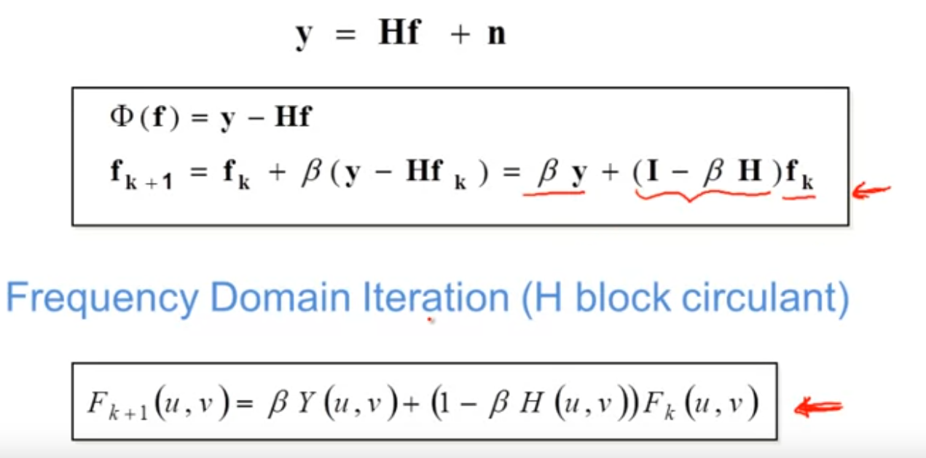

Convergence

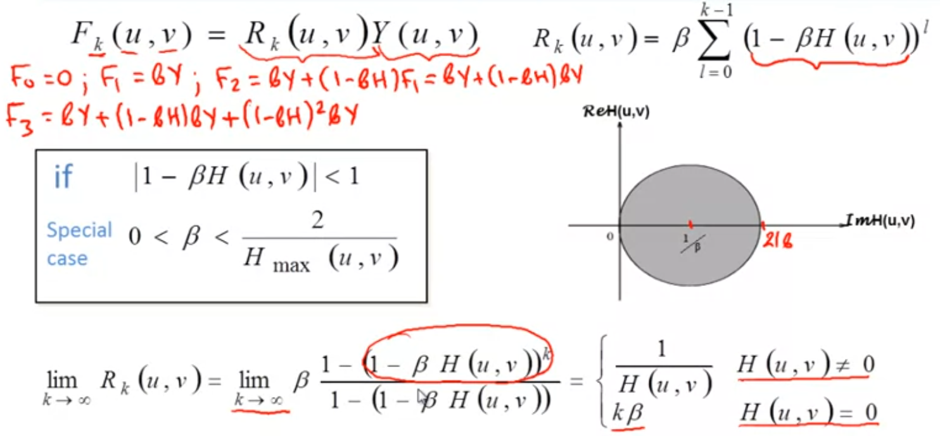

## Iterative Least-Squares and Constrained Least-Squares

LS iteration:

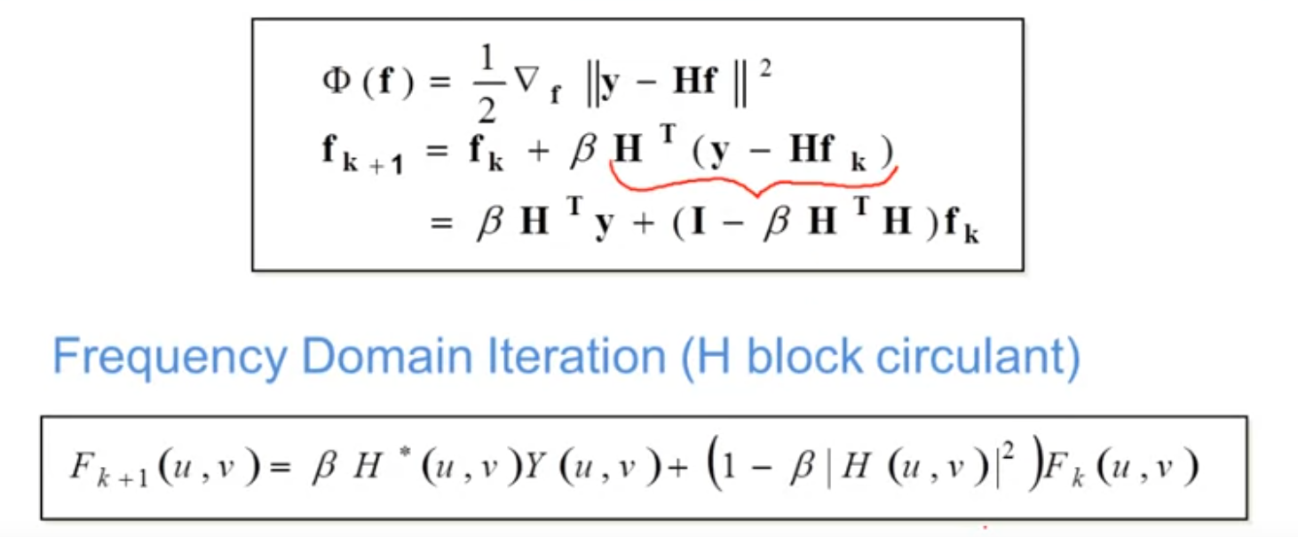

Convergence

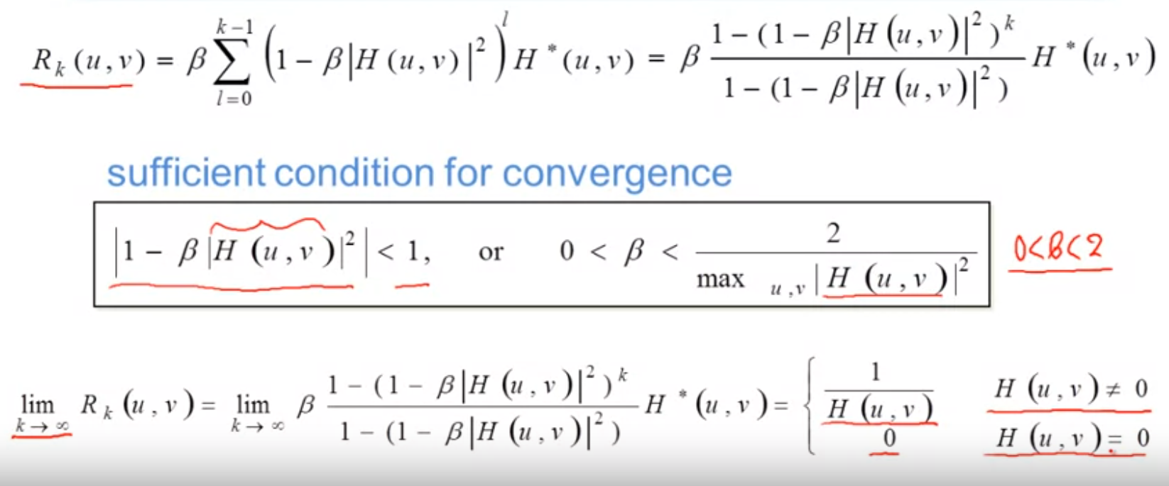

Residual Error

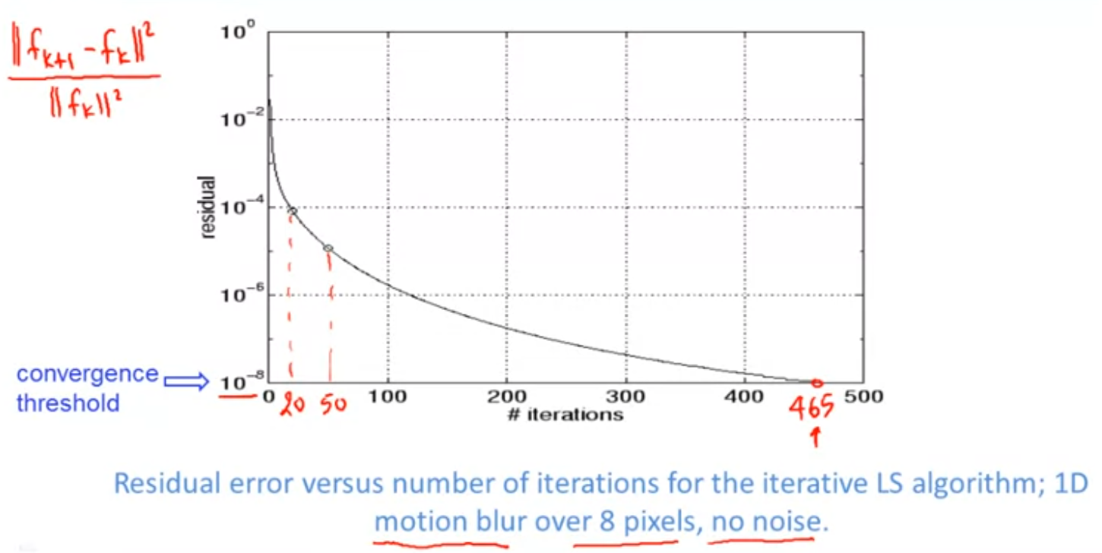

example

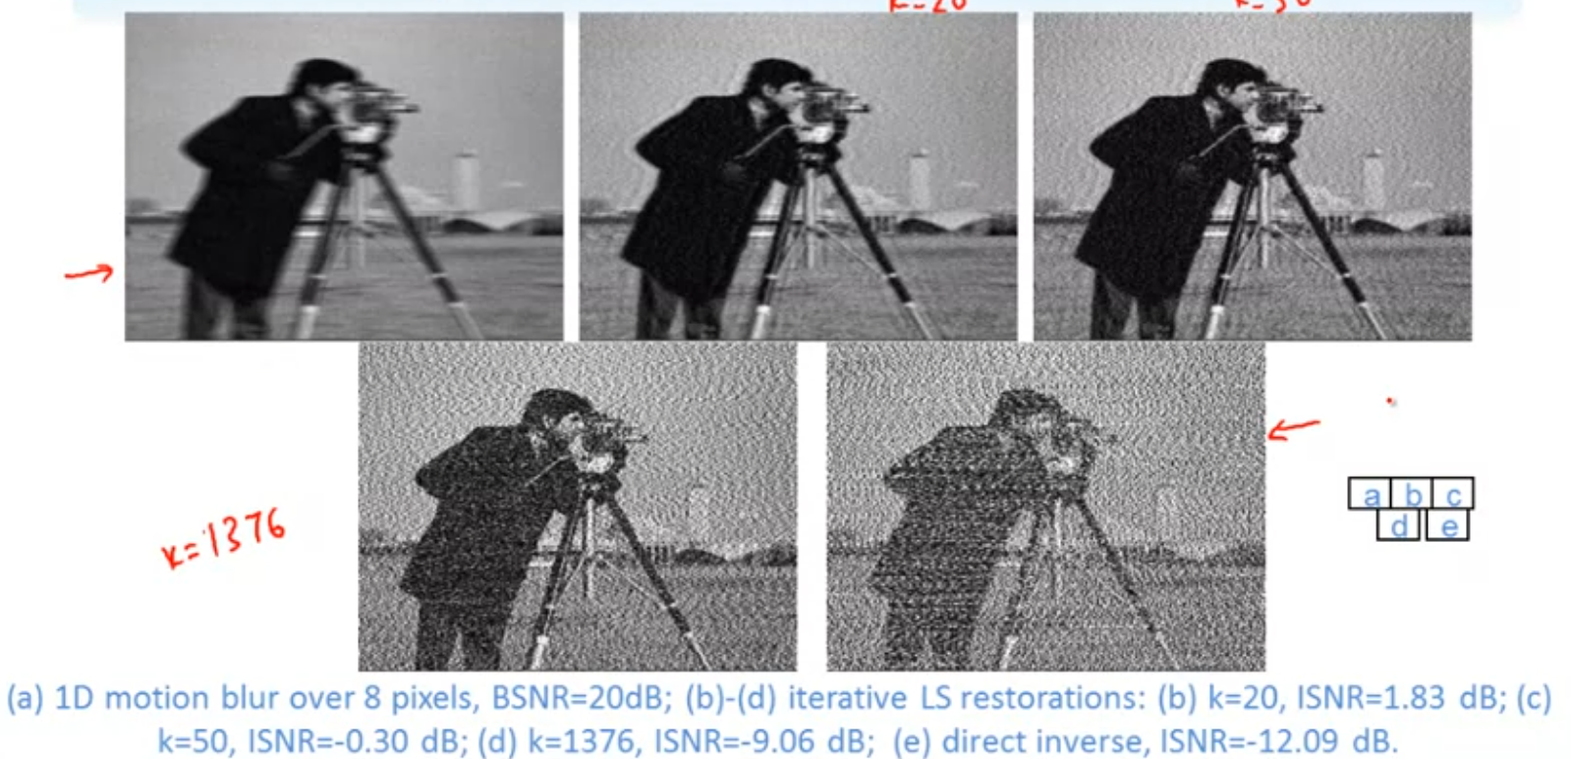

CLS Iteration:

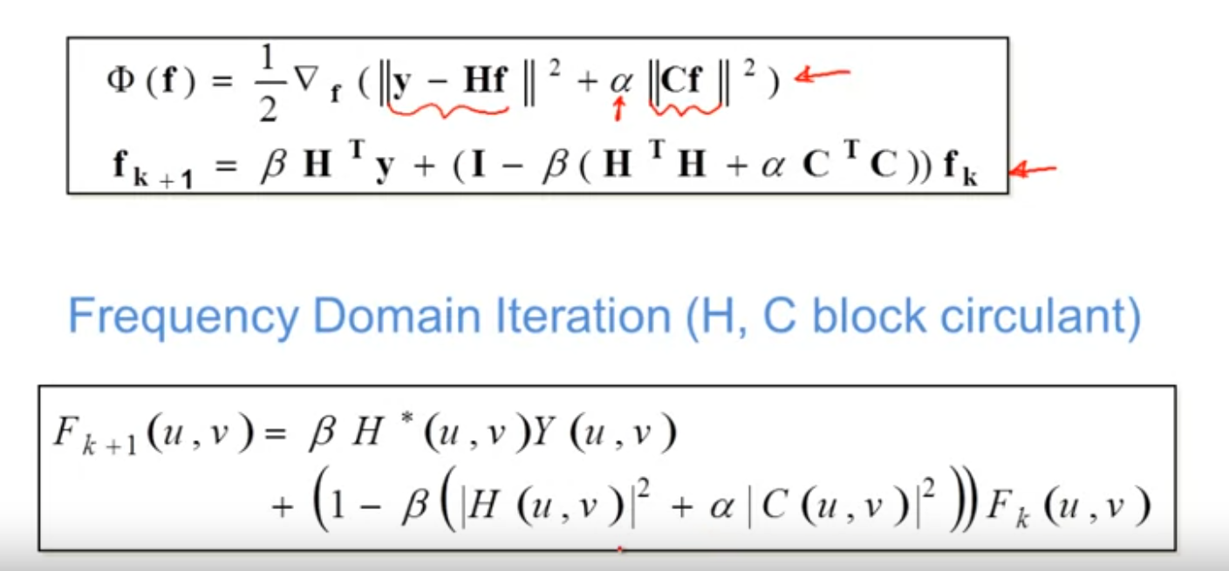

Convergence

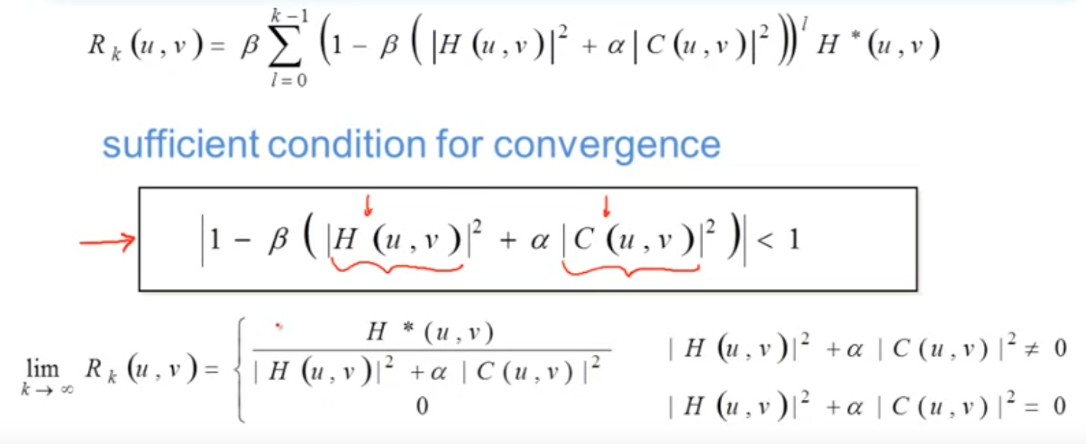

example

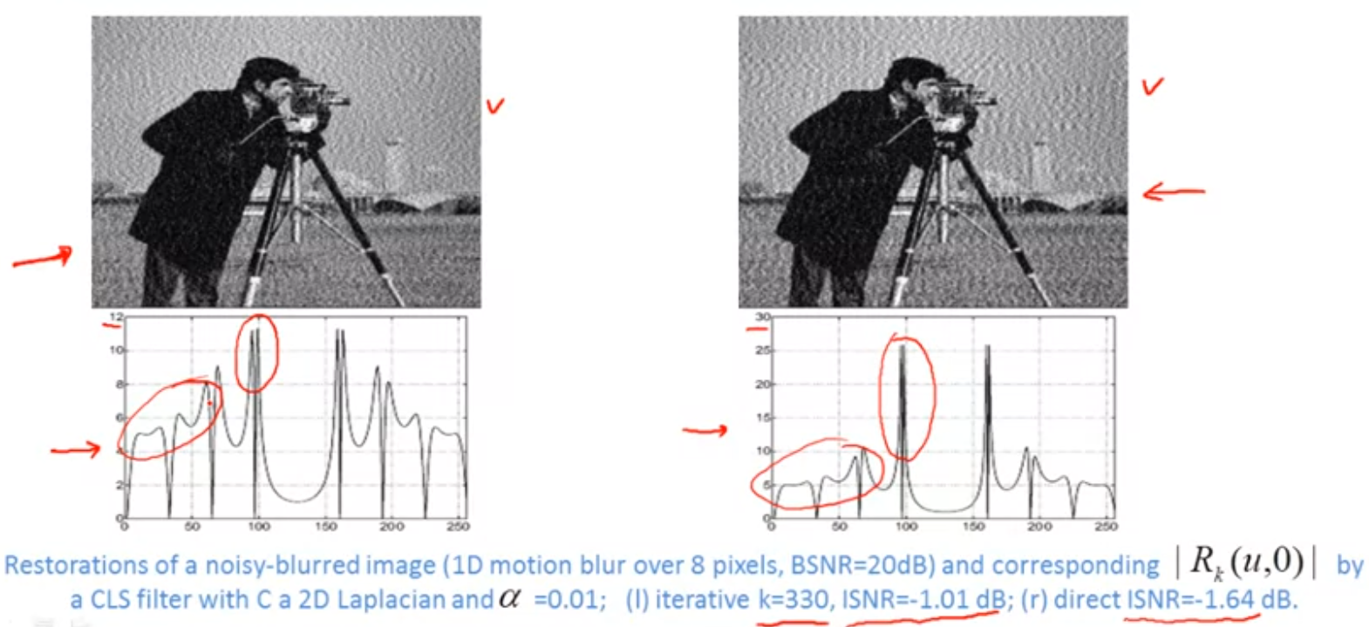

## Spatially Adaptive Algorithms

Spatially adaptive CLS iteration

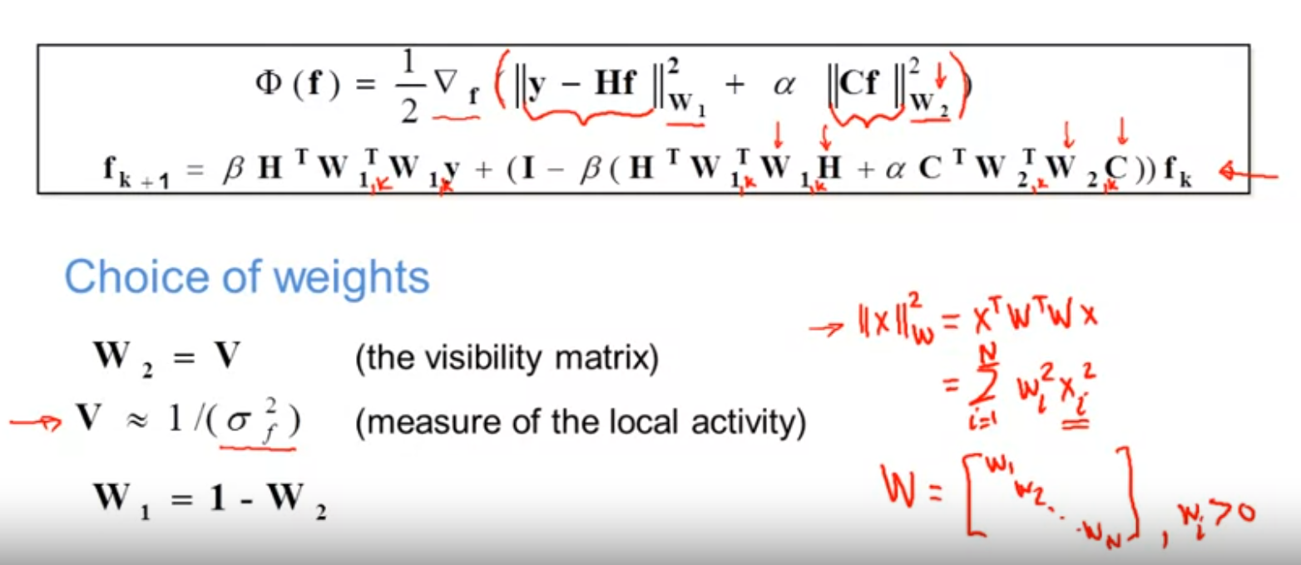

example:

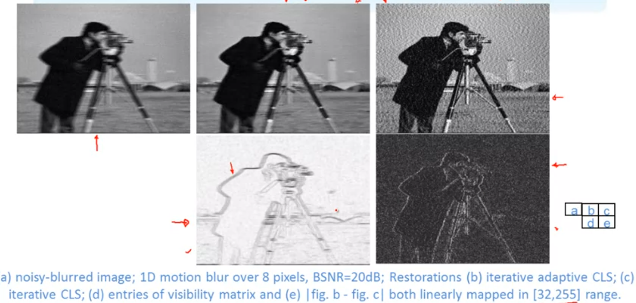

Positivey Constraint:

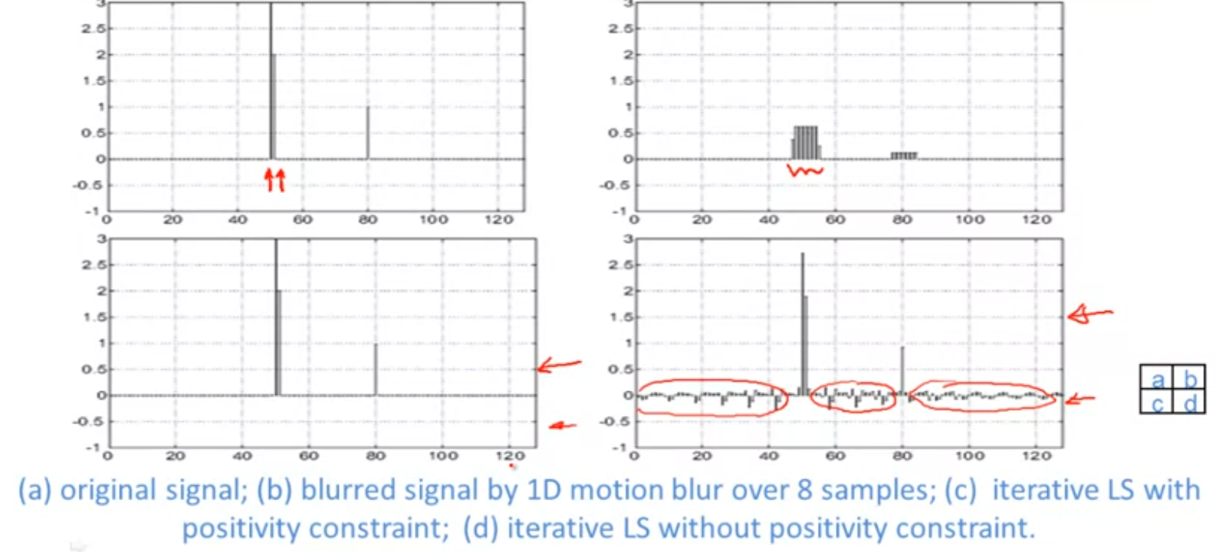

Ringing Artifacts:

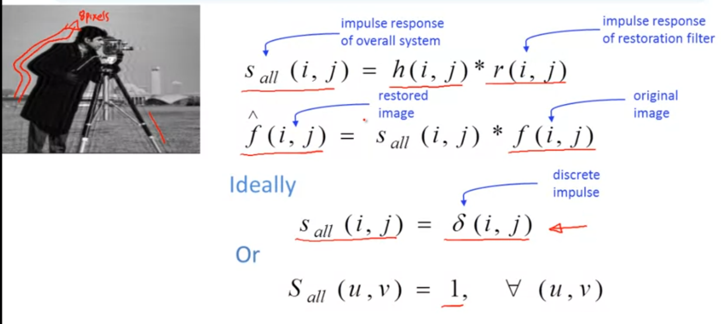

example:

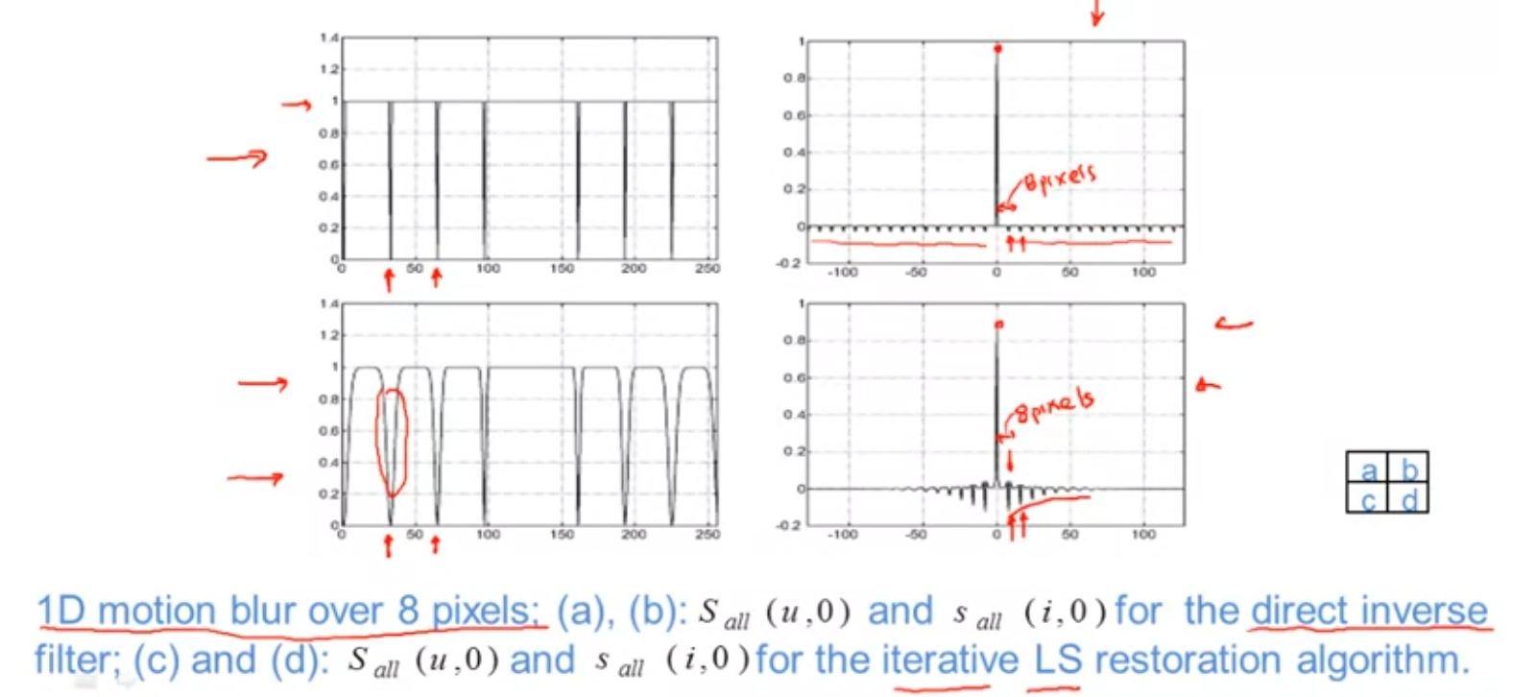

## Week6 Homework

1. Applied to a blurred input image, deblurring algorithms A and B result respectively in output images with 20dB and 25dB of ISNR (improvement in signal-to-noise ratio). Which algorithm is better in terms of restored image quality? B
2. Without regularization, we can still solve an image restoration problem and obtain good quality results since the restored image will preserve the fidelity to the data. False
3. 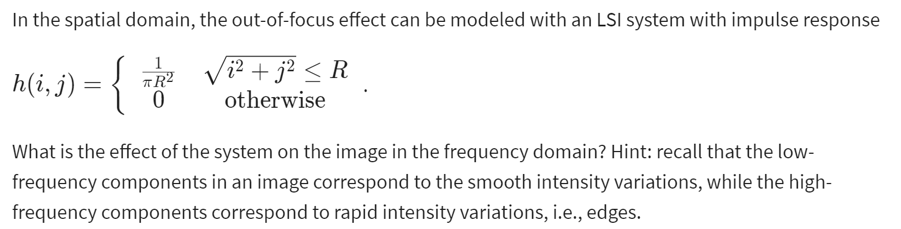

Mainly high frequency components get suppressed.

1. 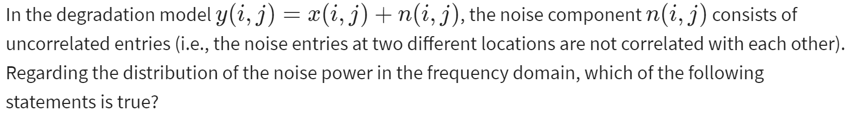

Noise power will be uniformly distributed over all frequencies.

1. 
2. Equation of ISNR:

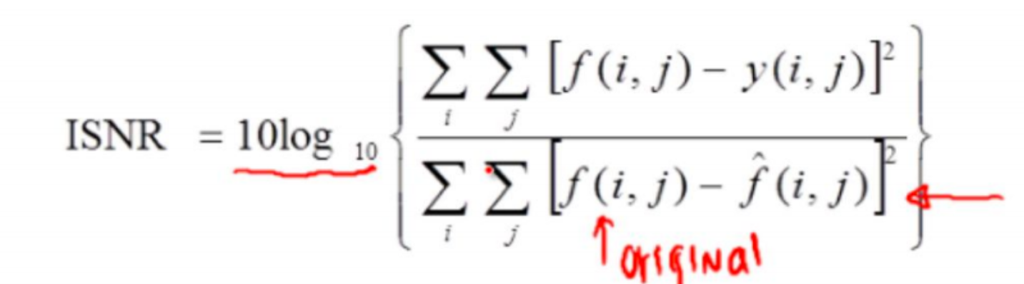

f represents the original image, y represents the noisy image, and f^ represents the restored image.